# SURANA COLLEGE

## DEPARTMENT OF COMPUTER SCIENCE

#16, SOUTH END ROAD BANGALORE



A PROJECT REPORT ON

## **SURANA PLACEMENT CELL**

## WHICH IS A BONAFIDE WORK OF

### 

### **YASHAS KV [19KXSB7117]**

Students of Bachelor of Computer Science submitted in partial fulfilment of the requirement of the award of

DEGREE IN B.C.A prescribed by BANGALORE UNIVERSITY 2021-2022

Mrs. RASHMI ESHWAR Dr. A SRINIVAS

(PROJECT GUIDE) HOD (COMPUTER SCIENCE)

EXAMINER

# SURANA COLLEGE

## DEPARTMENT OF COMPUTER SCIENCE

#16, SOUTH END ROAD BANGALORE



A PROJECT REPORT ON

## **SURANA PLACEMENT CELL**

## WHICH IS A BONAFIDE WORK OF

## 

### **YASHAS KV [19KXSB7117]**

Students of Bachelor of Computer Science submitted in partial fulfilment of the requirement of the completion of

DEGREE IN

BACHELOR OF COMPUTER APPLICATIONS

Under the Guidance of

**Mrs.Rashmi Eshwar**

(Asst. Professor)

|  |  |  |
| --- | --- | --- |
| SL.NO | Content |  |
| 1 | **Chapter-1**   * 1.1 Acknowledgement * 1.2 Abstract * 1.3 Introduction   1. Problem statement   2. Objective   3. Scope of the project   4. Methodology (SE models)   5. Description of the report * 1.4 Summary |  |
| 2 | **Chapter-2**   * 2.1 Overview of framework (including h/w & s/w) * 2.2 Description of technology used |  |
| 3 | **Chapter-3**   * 3.1SRS document |  |
| 4 | **Chapter-4**  **Design & name of project**   * 4.1 General constraints * 4.2 Development methods (model & dfd) * 4.3 Architectural strategy * 4.4 Error detection and recovery * 4.5 Data storage management * 4.6 System Architecture |  |
| 5 | **Chapter-5**   * **Data Dictionary** |  |
| 6 | **Chapter-6**   * 6.1 Programming language & platform selection * 6.2 Difficulties encountered & strategy used |  |
| 7 | **Chapter-7**   * 7.1 Test environment * 7.2 Unit testing * 7.3 Integration testing * 7.4 System testing |  |
| 8 | **Chapter-8**  Conclusion  Future enhancement  Reference |  |

**CHAPTER 1**

**1.1 ACKNOWLEDGEMENT**

The development of the project has been quite challenging and is it has been sincere effort to bring this project to its completion. The successful completion of this project wouldn’t have been possible without the continuous support and encouragement of many. We make use of this opportunity to thank all those who helped us in bringing out this project. We would like to express our gratitude to **DR Bhaskar Reddy C .M** , honorable principal, for giving us all the facilities for the completion of the project. We would like to take this opportunity to acknowledge enthusiastic sustain to **Mr. A Srinivas** (Head of department) for granting us permission to carry out this project work at college. We sincerely thank our guide **Mrs. Rashmi** and all teachers for their constant help for our project during the course of this pandemic. Our project wouldn’t have made it this far if not for the online courses and tutorials from which we have learnt so much. We also thank all our friends for their valuable suggestions and encouragement.

**1.2 ABSTRACT**

Campus Recruitment or selection system aims at providing the compatibility to simplify the process of placement for students. This system that consists of a student login, Co Ordinator login and an admin login This is beneficial for college students and for the college placement officer. The software system allows the students to create their profiles and upload all their details including their marks onto the system. The Co Ordinator can add job which is sent by the admin. The admin can check each student details, approve the student and check the student resume and can remove faulty accounts. The software system allows students to view a list of jobs. The admin has overall rights over the system and can moderate and delete any details not pertaining to college placement rules.

**1.3 INTRODUCTION**

Now days we all are using the internet to do multiple things like booking, academic search, blogging , apply for any job, etc. This system can be used as an application to manage student information to related placement. The system handles student as well as co-ordinator data and efficiently displays all this data to respective sides. This System do all work regarding placement like collecting student data, Authenticate & approve the student profiles. Proper login with time & role based secured access is provided to Admin, Co-ordinator and students. Students signup should be able to upload their information in the form of a Resume. Admin can access, view information of the users and prepare for the placements. One of such system which is of major importance is placement automation for campus recruitment. This project is aimed at developing a web application for the Placement Department of the college.

**1.3.1 PROBLEM STATEMENT:**

This project is aimed at developing an online application for the placement department of the college. Once you open this web application at the front end all the schedule/event are available to everyone. The administrator is the master user; He gets the most number of priorities than the other users. The different functions involve the case of an administrator are deleting and approval. The administrator can view and approve the various application forms. Students can very flexibly view job details, and apply to vacancies by opening the form link given. Students can access relevant resources placed online for them.

**1.3.2 OBJECTIVE:**

Development of rich web based Campus Placement System for College. Online Campus Placement System is developed for smooth working of Human Resource Departments. College and students can get benefited through this system. This Software is fully integrated with Student and College Relationship Management and developed in a manner that is easily manageable, time and cost saving that shows relieving one from manual works. Online Campus Selection provides automated technical screening, intellectual evaluation, electronic mail integration to conduct recruitment. This feature's helps in many ways like saving cost, time and paper work, this shows the paperless environment, unlimited custom and reports.

**1.3.3 SCOPE OF THE PROJECT:**

This system automates the Selection process activities that the HR Department has to perform prior to and after the actual act of selecting the students. This system helps in various ways such as saving time and cost of selecting Students and companies. That set of concepts is used to build a system for easily Communication between students and jobs available and admin can get required eligible students.

**FEASIBILITY STUDY:**

After doing the project campus placement system, study and analyzing all the existing or required functionalities of the system .The next task is to do the feasibility study for the project. All projects are feasible given unlimited resources and infinite time. Feasibility study includes consideration of all the possible ways to provide a solution to the given problem .The proposed solution should satisfy all the user requirement and should be flexible enough so that, future change can be easily done based on the future upcoming requirement.

**ECONOMICAL FEASIBILITY:**

This is a very important aspect to be considered while developing a project. We decided the technology based on minimum possible cost factor.

1.All hardware and software cost has to be borne by the organization.

2.Overall we have estimated that the benefit the organization is going to receive from the proposed system will surely overcome the initial costs and the later on running cost for system.

**TECHNICAL FEASIBILITY:**

This included the study of function, performances and constraints that may affect the ability to achieve an acceptable system. For this feasibility study, we studied the complete feasibility to provided in the system. As described in the system requirement specification (SRS) and checked if everything was possible using different type of frontend and backend platform.

**OPERATIONAL FEASIBILITY:**

No doubt the proposed system is fully GUI based that is very friendly and all input are taken all self-explanation.Beside a proper training has been conducted to know the ease of the system to the user so that they comfortable with there new system.

A. Resume Building: Standardized format will be provided and student can use it to generate their resume. All students information will be available in the database. This information can be extracted automatically from the database for generating standard resume. This simplifies and speeding up the process of resumes building.

B. Add job: The Co Ordinator can post the job details given by the admin. Student can apply for the job based on their course. The admin can view the students who have applied for the job.

C. Analysis of Placed students: The admin can add the students placed and view the total number of placed students.

D.Change Password: Students and Co-ordinators can change the passwords for the security.

1.3.4 METHODOLOGY

THE WATERFALL MODEL

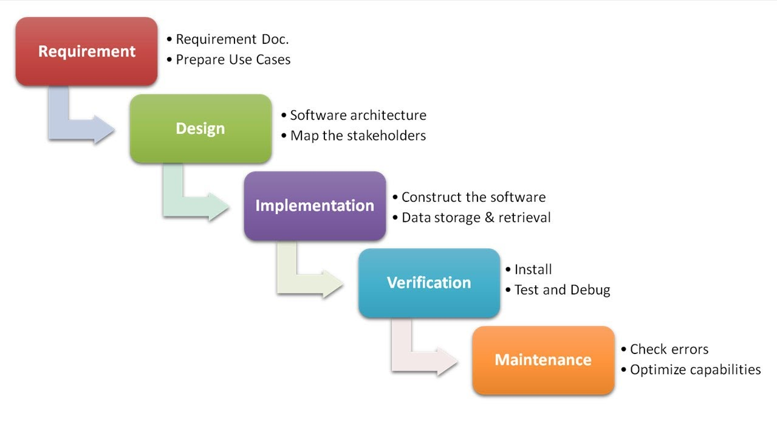

1.4 SUMMARY

The purpose of the summary is to present a brief description about the application developed for the students to apply for the respected job through this website. The main aim of the project is to design and develop a user friendly Web application for students to apply for job easily.

**CHAPTER 2**

(OVERVIEW)

**2.1 Overview of the project:**

Student:

It is a campus placement portal web application with the user-friendly interface ,the new student needs to register in this website with the email and password which is encrypted and stored in the database.The student can change his/her password using his /her registered email.

Co-ordinator:

Co-ordinator is added by the admin based on his Mobile Number. The Co-ordinator can add jobs based on his course. The co-ordinator can change his/her password using his email-id.

Admin:

Admin can view the details of the student and company. Admin can add the new co-ordinator and placement available . Admin is the one who is responsible for managing the portal and view the details.

**SYSTEM SPECIFICATIONS**

**Hardware specification:**

Processor : AMD Ryzen 5 5600H with Radeon Graphics

Clock Speed : 3.30 GHz

System bus :64 bits

RAM :8GB of RAM

HDD :256 GB

Laptop :HP Pavilion Gaming Laptop 15-ec2xxx

**Software specification:**

OS :WINDOWS 11

Front End :J2EE

Back End :MySQL

Web Server :GlassFish Server

**2.2 Description of the technology:**

Java programs run on the J2EE Framework, an integral component of

Windows that includes a virtual execution system called the common language

runtime (CLR) and a unified set of class libraries... Source code written in

JavaScript is compiled into an intermediate language (IL) that conforms to the

CLI specification.

• Language paradigms: Object-oriented program

• Software: Windows

**CHAPTER 3**

(SOFTWARE REQUIREMENT SPECIFICATION)

**CONTENTS:**

1. **Introduction**
   1. Purpose of the requirements document
   2. Scope
   3. Definitions, acronyms and abbreviations
   4. Overview of the remainder of the document

**2. General description**

2.1 Product perspective

2.2 Product functions

2.3 User characteristics

2.4 General constraints

2.5 Assumptions and dependencies

**3. Functional, Non Specific requirements ,Covering -Functional and Interface Requirements**

3.1 Requirement in structured natural language

3.2 Performance Requirement

3.3 External interface Requirement

3.3.1 Software Interface

3.3.2 Hardware Interface

**4.Glossary**

**1. Introduction**

1.1 Purpose of the requirements document:

Computer based information system are designed to improve existing system. It has user friendly interface having quick authenticated access to documents. It provides the facility of maintaining the details of the students. It will reduce the paper work and utilize the maximum capabilities of the Setup and organization as well as it will save time and money which are spending in making reports and collecting data. It can be accessed throughout the organization with proper login provided.

1.2 Scope:

This system automates the Selection process activities that the HR Department has to perform prior to and after the actual act of selecting the students. This system helps in various ways such as saving time and cost of selecting Students and co-ordinators. That set of concepts is used to build a system for easily Communication between students and co-ordinators can get required eligible students.

1.3 Definitions, acronyms and abbreviations:

* SDK: A software development kit (SDK) is typically a set of software development tools that allows for the creation of applications for a certain software package, software framework.
* Overlay: An Overlay on the SDK is a block of code that we rewrote because the initially SDK was not enough or complete.
* Software: A computer program/application.
* Hardware: An electronic component referring to something link to the computer.
* HTML: Hyper Text Markup language (HTML) which is a programming language with markers.
* CSS: Cascading Style sheets tells how HTML elements are to be displayed on screen, paper, or in other media

1.4 Overview of the remainder of the document:

This document includes three main chapters

The first describe the working of our software and explain most of the development.

The second one is about specific requirements, covering functional, non-functional and interface requirements.

The third one is about the evolution of our product.

**2. General description**

This part will describe in general our software and how we made it. We will see also the interaction with users and the dependencies.

2.1 Product perspective:

Our software is divided in three main different parts:

The first one is about the student how he create the account and apply for the job.

The second part is the co-ordinators module how he adds the job based on his course.

The third part is the admin who can handle both student and co-ordinator details.

2.2 Product functions:

The main functions of our application are can be divided in 3 different parts:

* Student module
* Co-ordinator module
* Admin module

**Student module**

* Request For Registration.
* Login to the Portal.
* View Job Details.
* Change Password
* Contact Us.

**Company module**

* Add jobs.
* Change Password.

**Admin module**

* Manage Admin User.
* Mange Co-ordinator.
* View Jobs.
* Manage Students.
* Manage Placements.

**FUNCTIONALITY PERFORMED BY CO-ORDINATOR USER:**

1.Company Login -This is the login form, from where co-ordinator can login into the system.

2.Add Jobs – The Co-ordinator can add the job based on his course.

3.Change Password- This is the change password module from where company change his account password.

**FUNCTIONALITY PERFORMED IN STUDENT USER:**

1.Student registration -Any student can register on website using registration module.

2.Student Login -This is the login form, from where student can login into the system.

3.View Jobs – The jobs can be viewed by the student based on his course and open apply by filling the form.

4.Change password- This is the change password module from where student change his account password.

**FUNCTIONALITY PERFORMED IN ADMIN USER:**

1.Add co-ordinator-The admin can add co-ordinator and the co Ordinator is instructed to add the jobs

2.View Student-The admin can view the student and can approve or delete the student and also view the resume.

3.Placement-The admin can add the placement and can also view the number of the students placed.

4.View job-The admin can view all the job from different courses.

2.3 General constraints:

The main constraint of our application is that the user also need to have a good internet connection.

2.4 Assumptions and dependencies:

In that way, we will assume that users have a good internet connection.

**3. Specific requirements, covering functional, non-functional and Interface requirements**

3.1 Performance requirement:

* Multiple users are supported by the server.
* Information is updated on serve bases and updating has the high priority.
* The response of user is answered back in a span of time by the software.

3.2. External interface requirements

3.2.1 User Interfaces:

Since our consideration is for common people, our software is as simple as possible. There are several kinds of the Graphic User Interface in our system.

3.3.2 Hardware Interfaces:

Our system can be input via several ways, such as URL.

3.3.3 Software Interfaces:

The software should be referred to other group's document (based on the platform design). In general, the software should be able to connect to all the devices, database, web servers.

3.3.4 Communications Interfaces:

All the communication is via internet, network communication, such as TCP/IP, etc.

**4. Glossary:**

* GUI: Graphic User Interface, a type of user Interface that allows users to Interact with the software through graphical Icons (e.g. buttons, etc.).
* URL: Uniform Resource Locator, an address to a resource on the Internet.
* URL parameter: Parameters whose values are set in a webpage's URL.
* Web API: An application programming interface (API) for either a web server.
* C#(C-Sharp): It is a programming language developed by Microsoft that runs on the J2ee Framework. It is used to develop web apps, desktop apps, mobile apps, games and much more.

**CHAPTER 4**

(DESIGN AND NAME OF THE PROJECT)

**DESIGN OF THE PROJECT**

Screenshot

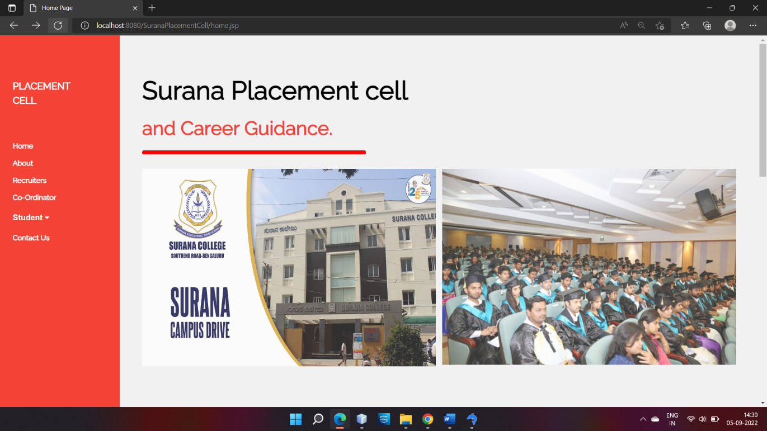

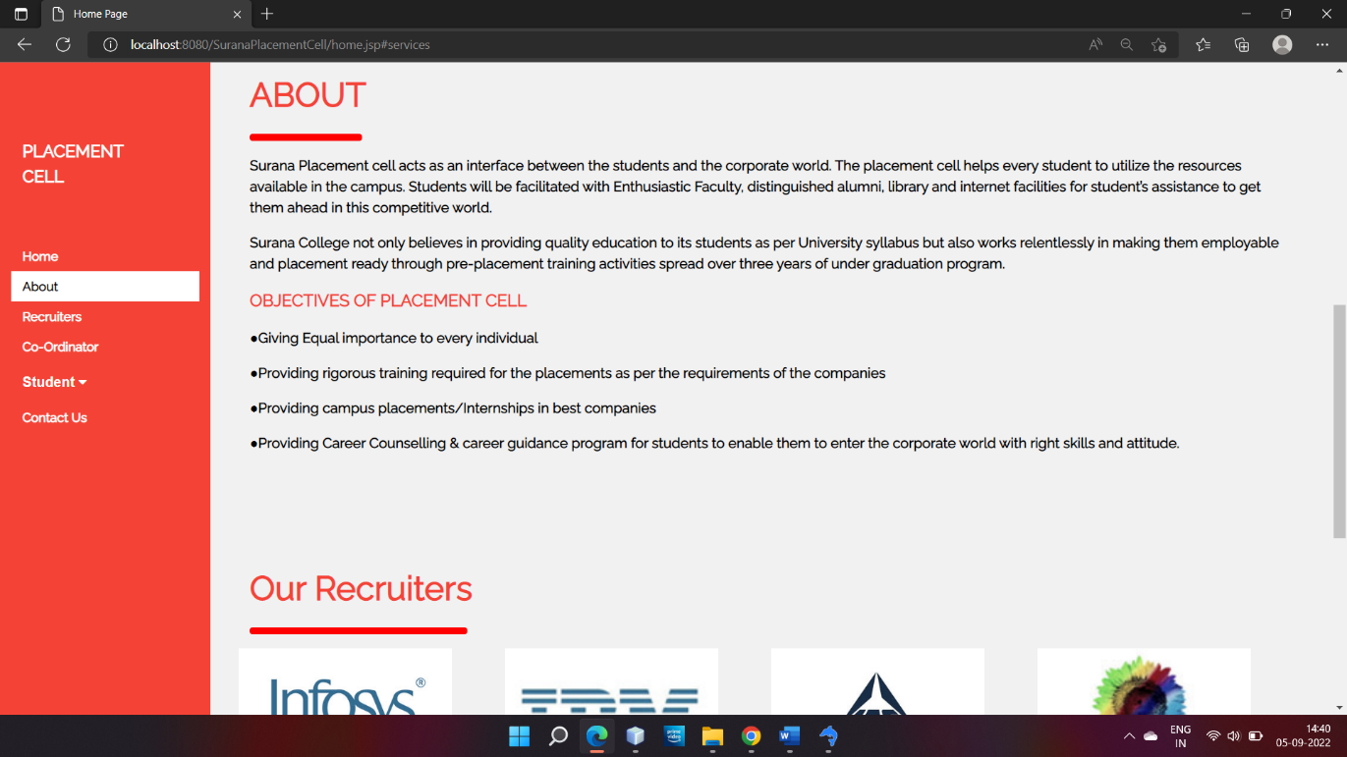

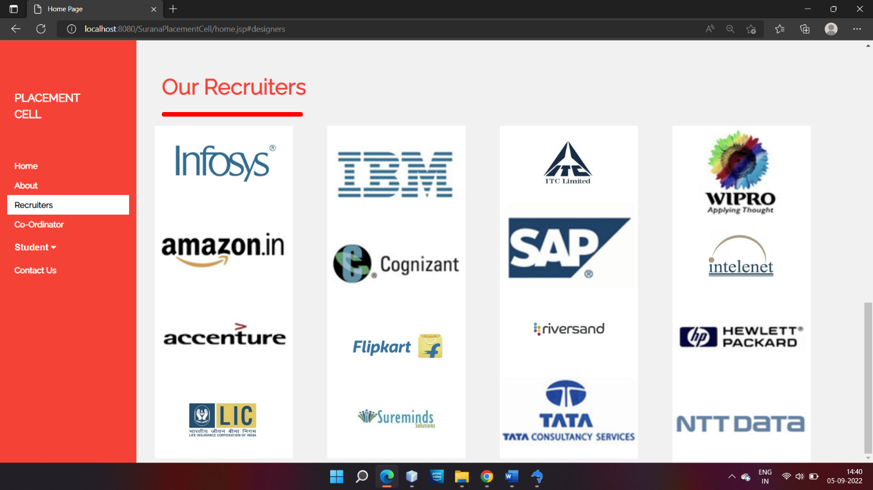

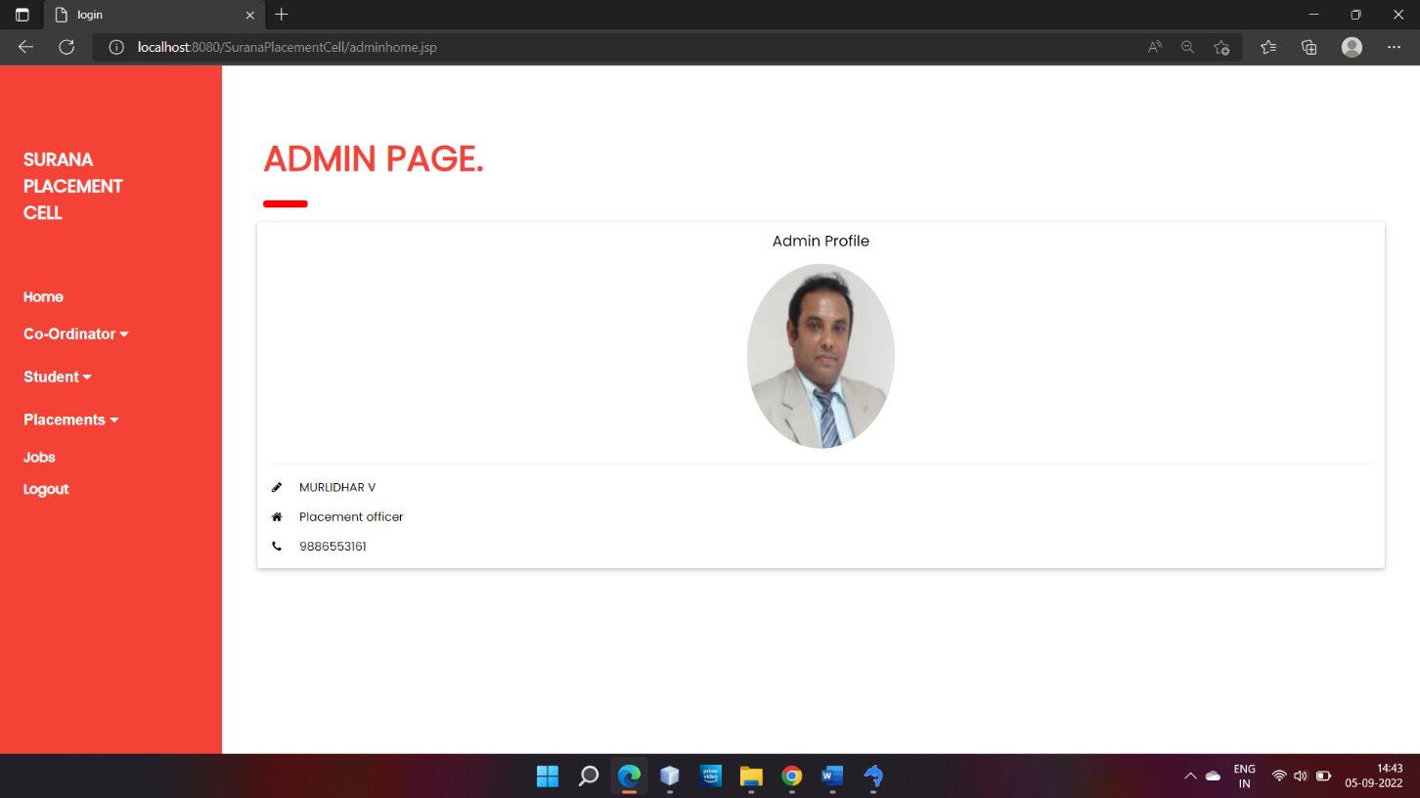

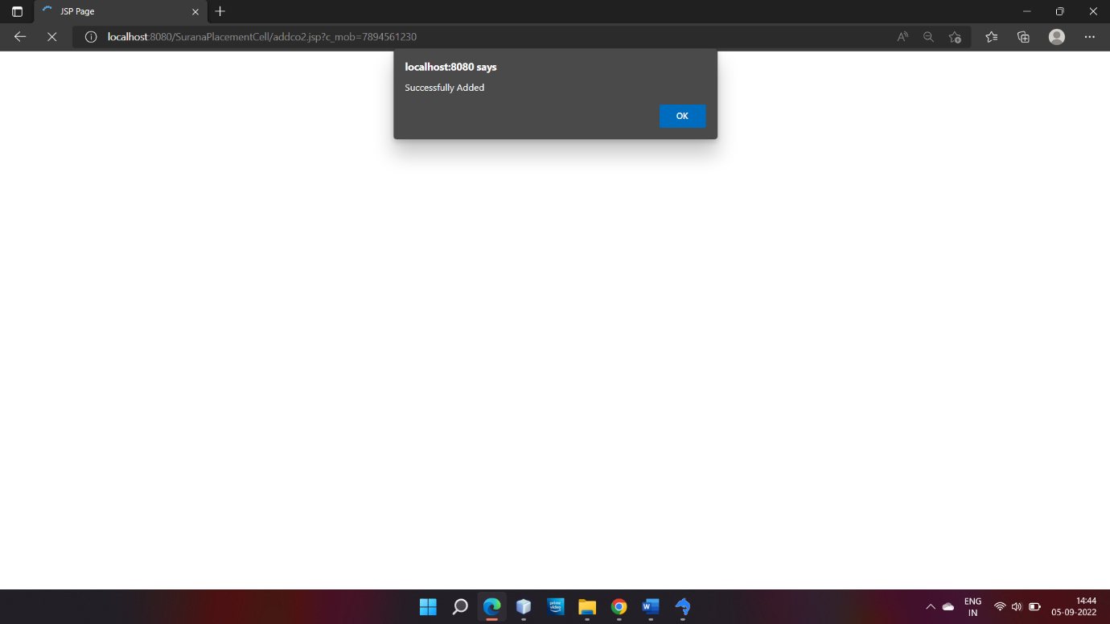

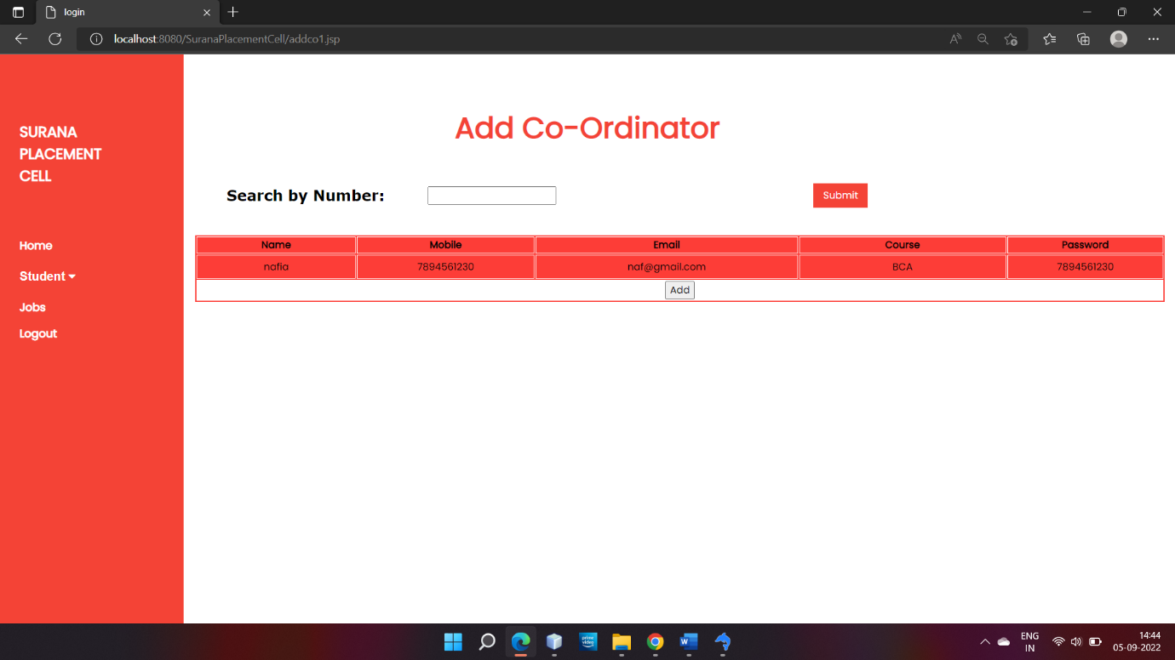

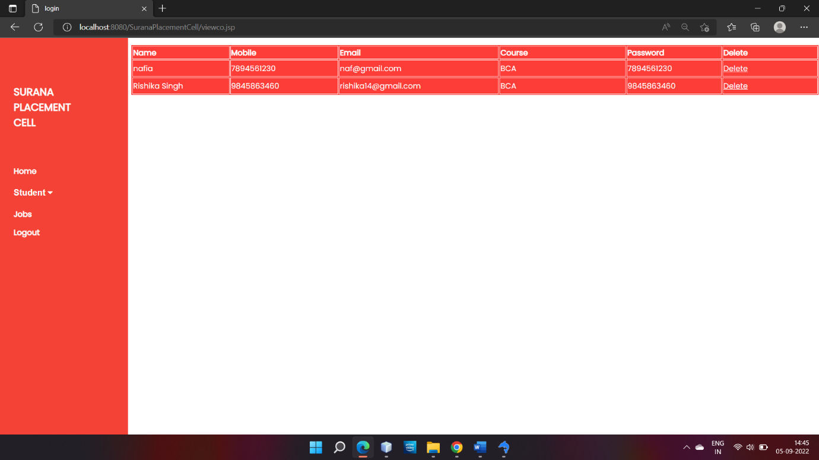

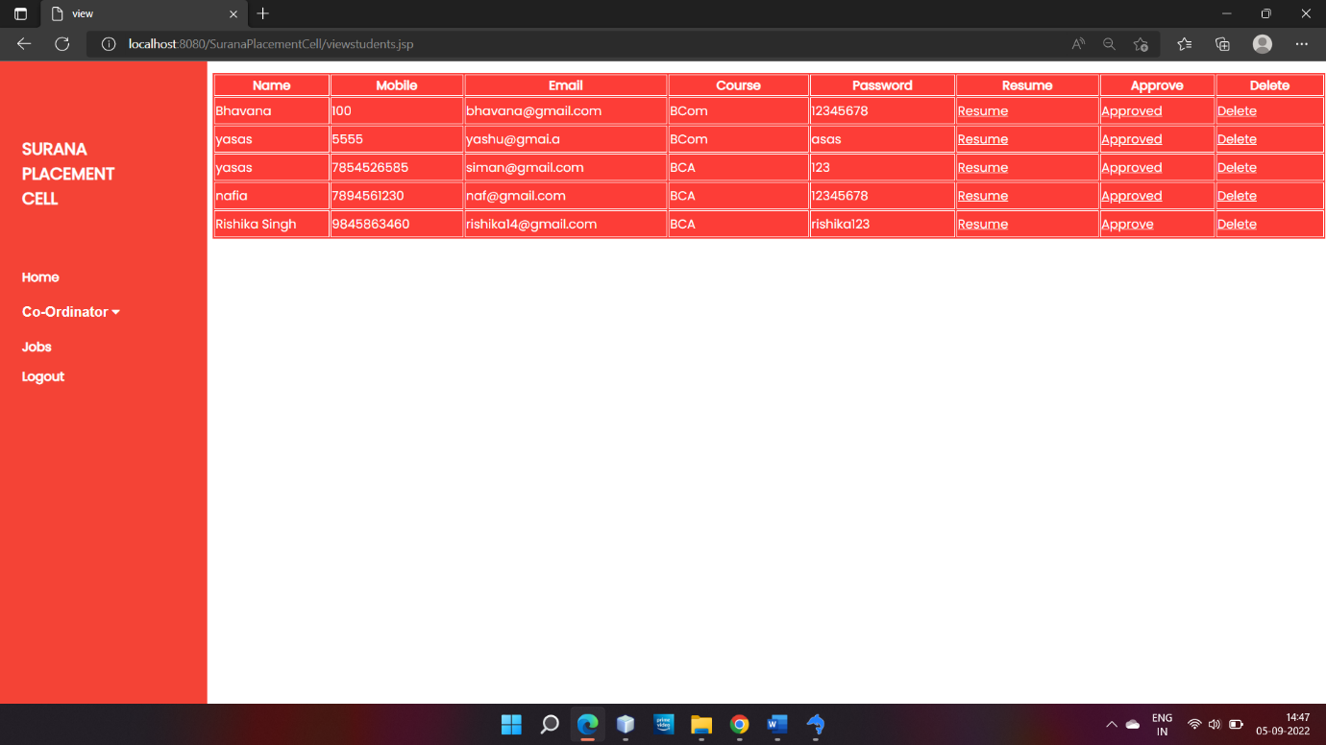

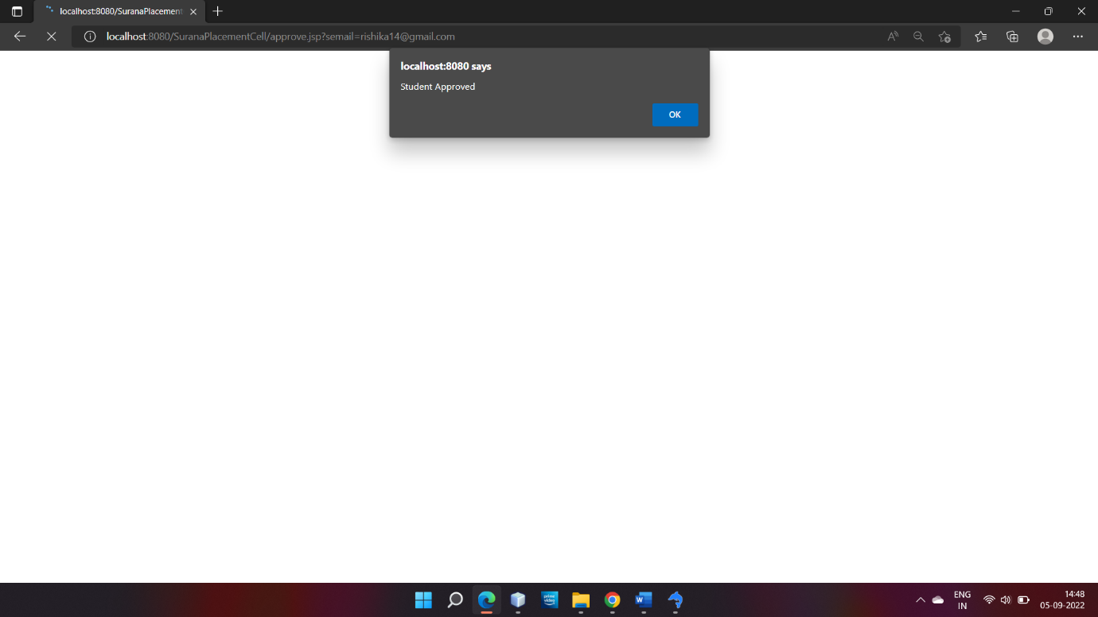

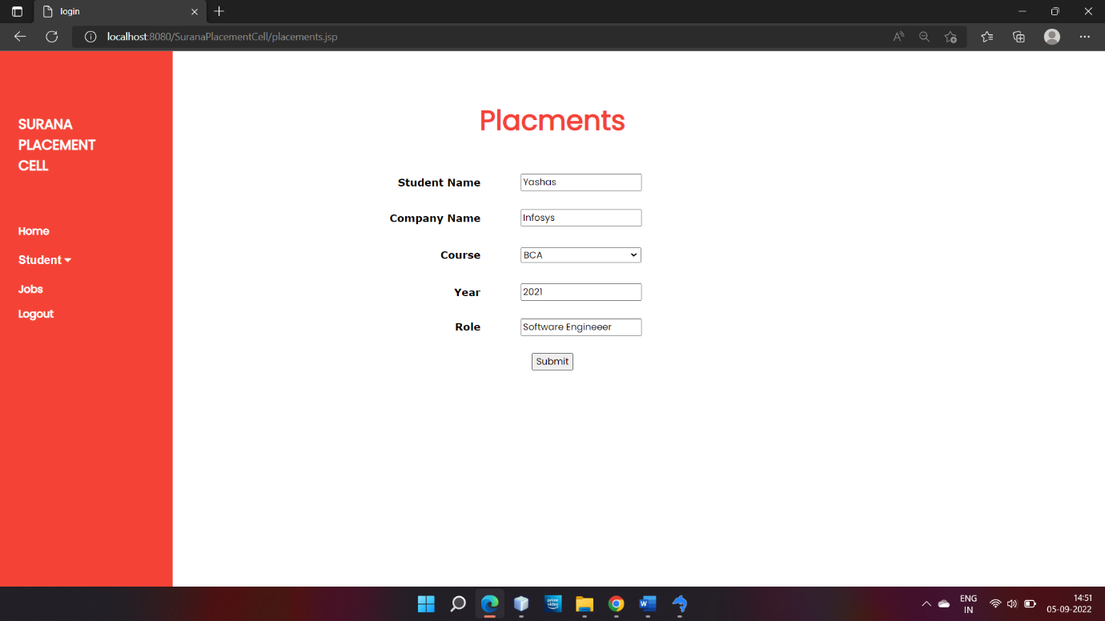

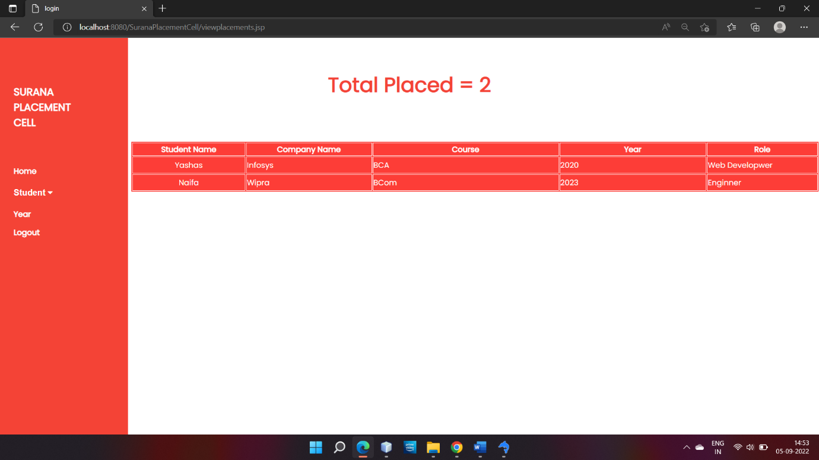

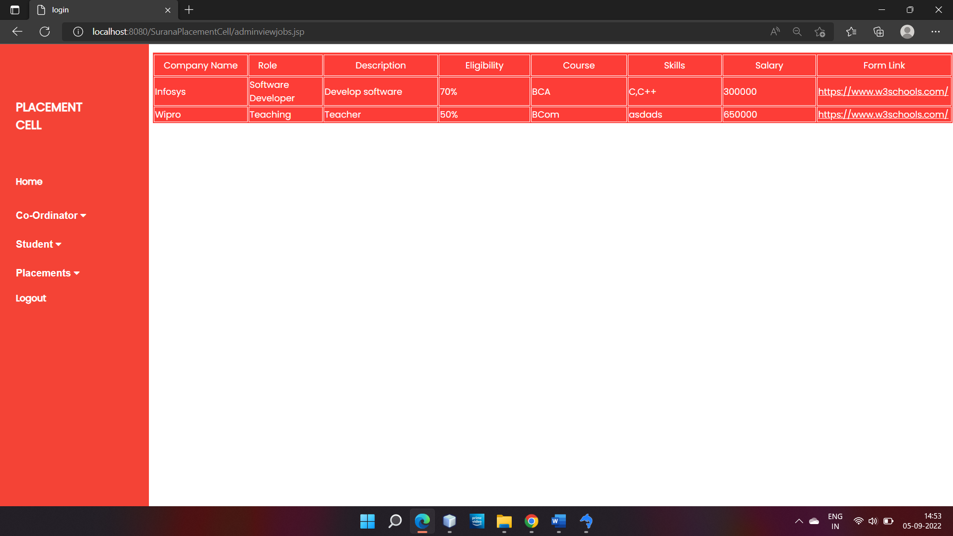

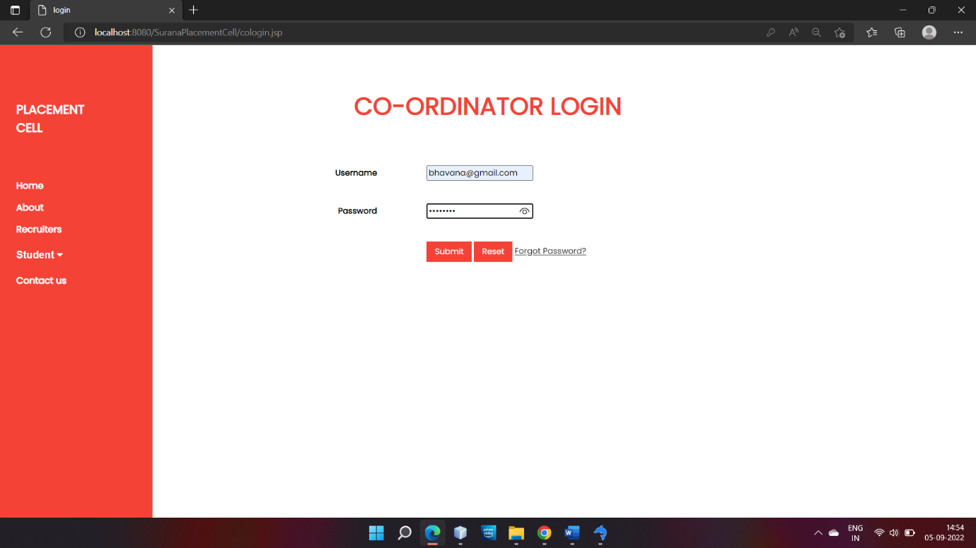

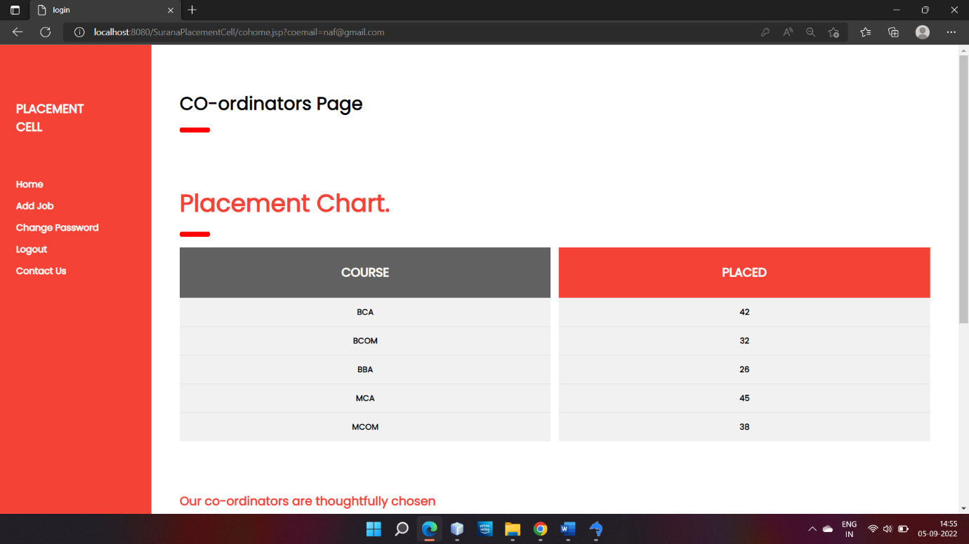

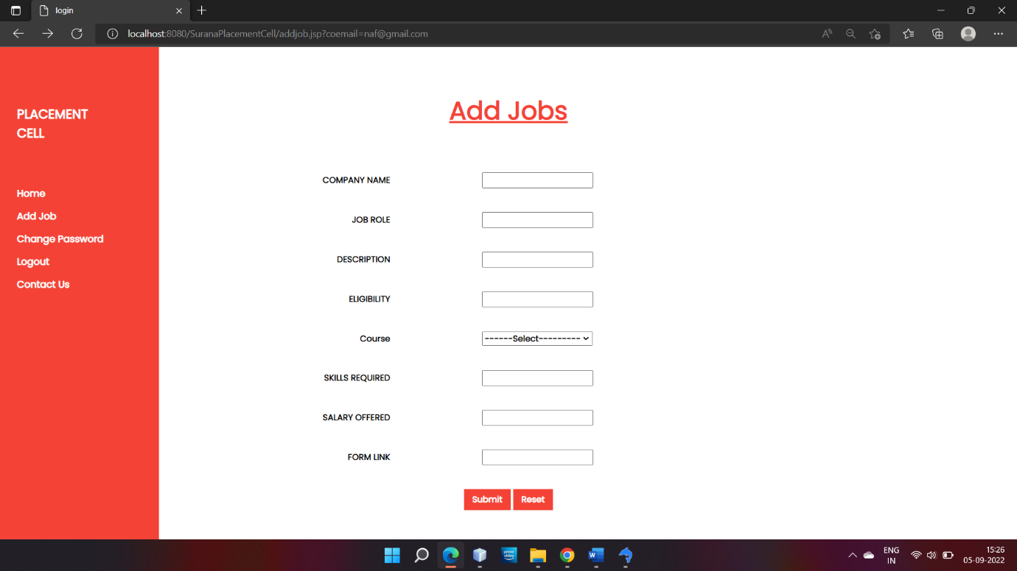

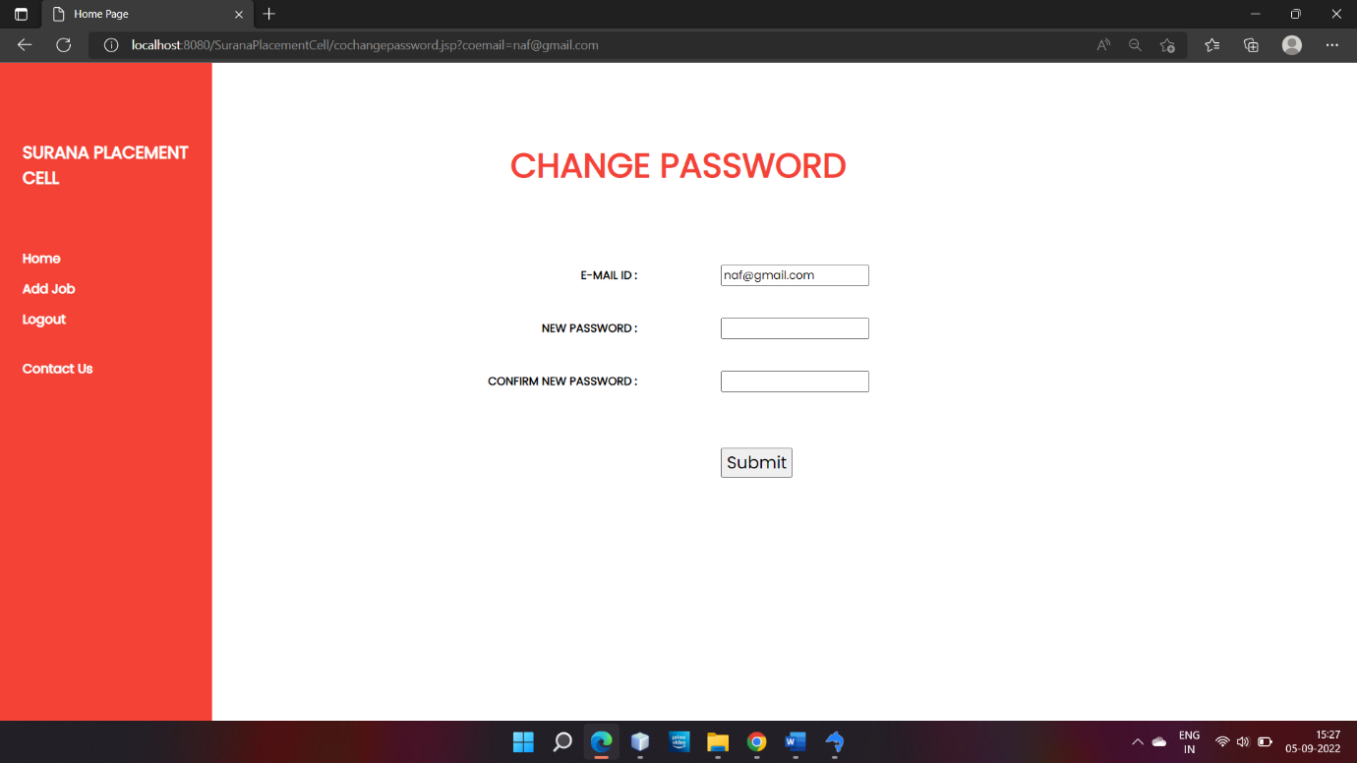

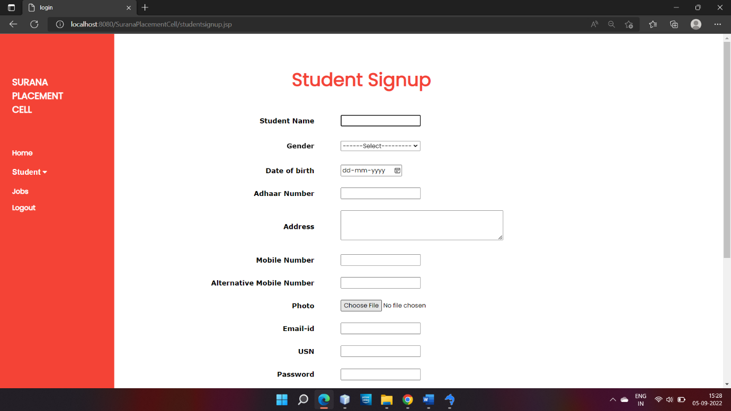

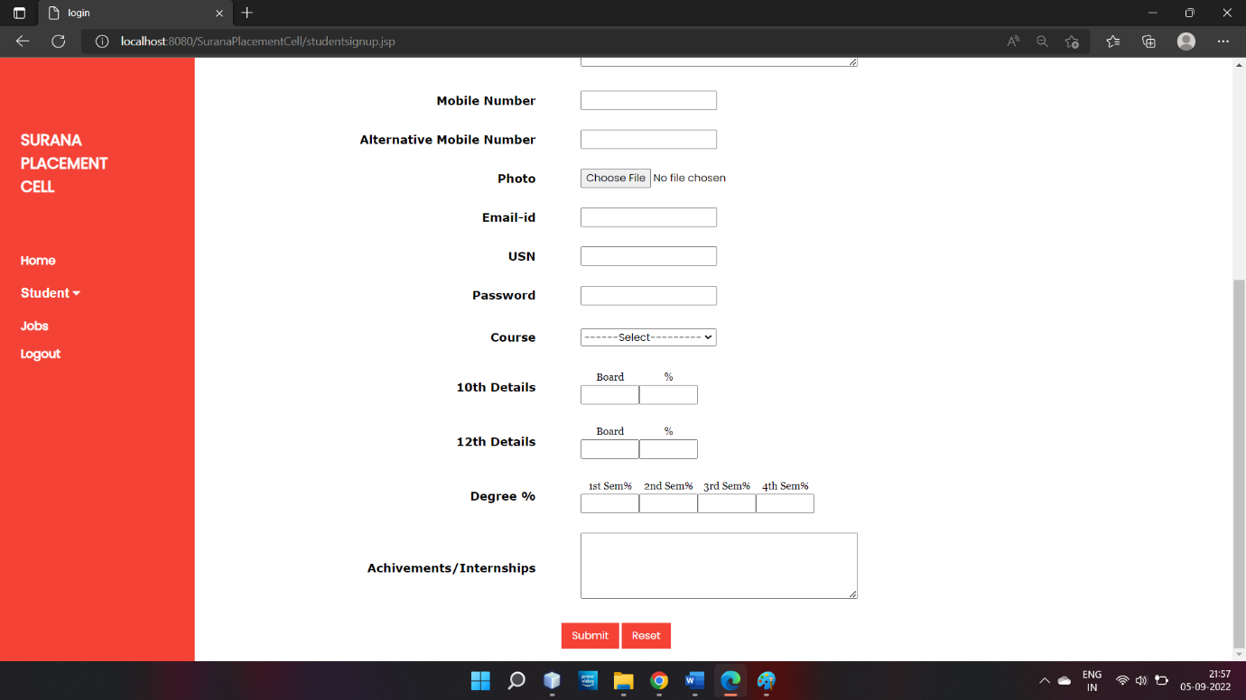

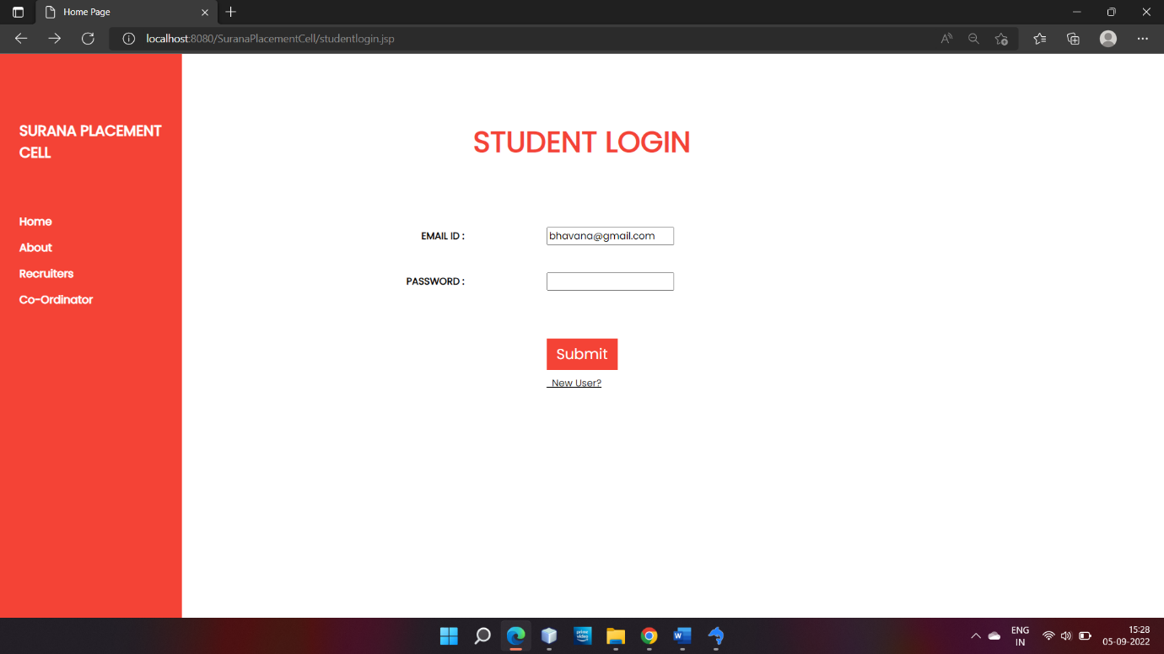

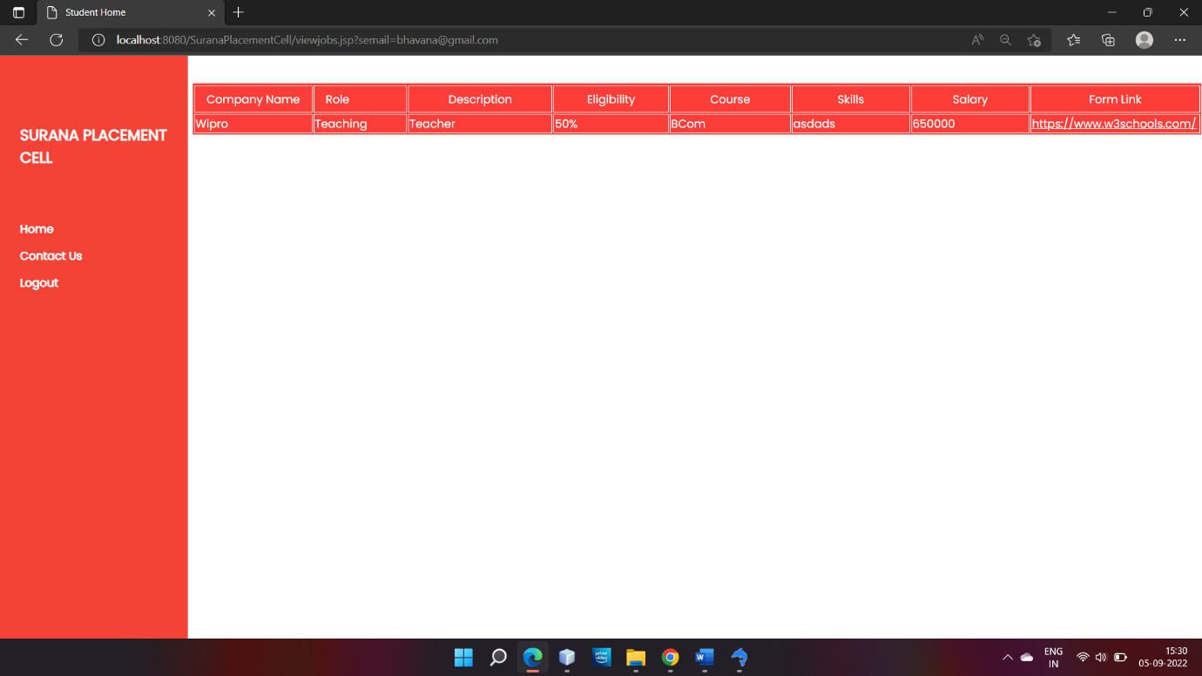

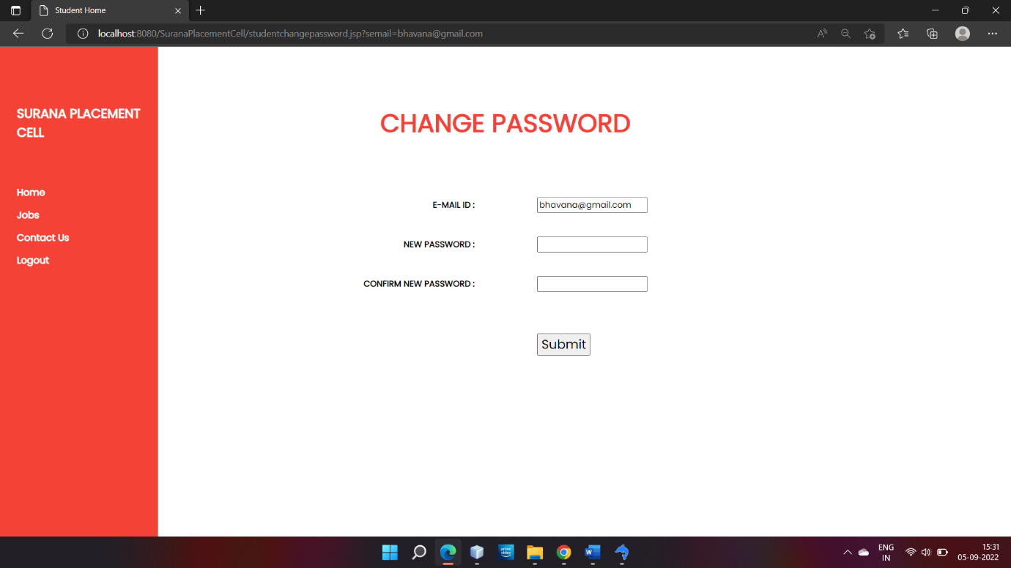

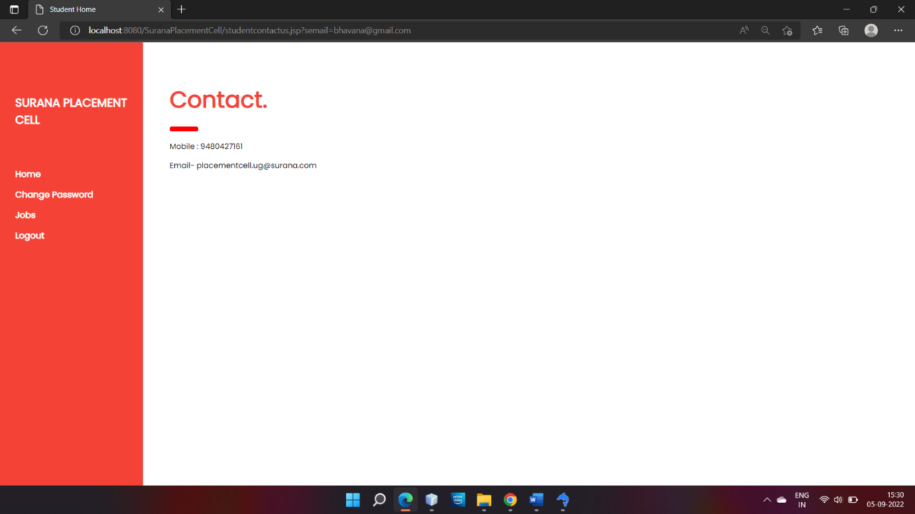

4.1. General constraints:

* In order to work on the website, the user must give the relevant user-id and password.
* Any address entered by user shall be limited with 200 characters.
* Ul is very user-friendly, which gives a easy access on the modules for user.

**4.2. Development methods:**

4.2.1. WATER FALL MODEL:

This model entails by mapping out our project into distinct, sequential phases, with each new phase beginning only when the prior phase has been completed, no phase begins until the prior phase is completed . Since the waterfall system is the most traditional method for managing a project and a sequential, linear process of project management.

It consists of several discrete phases:

* Requirements: This is the stage in which the manager analyses and gathers all the requirements and documentation for the project.
* System design: During this phase, the manager designs the workflow model for the project.
* Implementation: The system is put into practice in this phase; this is the stage where things get built.
* Testing: During this phase, each element is tested to ensure they work as expected and fulfil the necessary requirements.
* Maintenance: In this final, ongoing stage, the team performs upkeep and maintenance on the resulting product or service.

**ER diagram:**

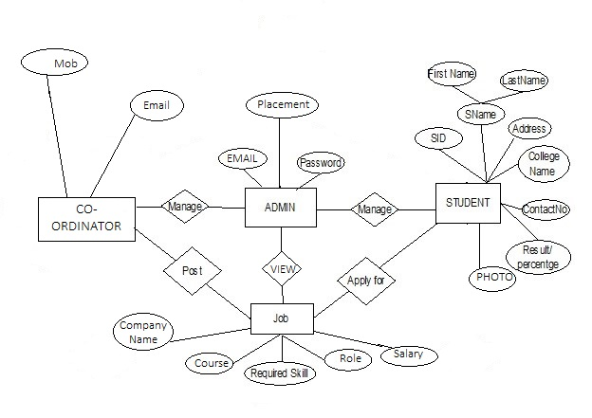

4.3. Architectural strategy:

Strategic architecture is the way that our project comes together from the ground up. This includes such pieces of information as the stakeholders, the mission and the vision of the company. Other important aspects include the plans for operation, the core strategies and the actions needed to accomplish them.

The layered (or multilayer) strategy consists of various layers, namely, presentation, service, business, and data access layers, and every layer is responsible for serving specific tasks.

4.4. Error detection and recovery:

In this phase of compilation, all possible errors made by the user are detected and reported to the user in form of error messages. This process of locating errors and reporting it to user is called Error Handling process.

Errors are of three types:

1. Lexical phase errors: These errors are detected during the lexical analysis phase.

* Exceeding length of identifier or numeric constants.
* Appearance of illegal characters
* Unmatched string

Error recovery is done using panic mode recovery in this phase.

2. Syntactic phase errors: These errors are detected during syntax analysis phase.

* Errors in structure
* Missing operator
* Misspelled keywords
* Unbalanced parenthesis

Error recovery is done using panic mode recovery, statement mode recovery, error production, global correction in this phase.

3. Semantic errors: These errors are detected during semantic analysis phase.

* Incompatible type of operands
* Undeclared variables
* Not matching of actual arguments with formal one

4.5. Data storage management:

It has the collection of processes that facilitate the designing, development, implementation and maintenance of enterprise data management systems

Below defines the database used in the project:

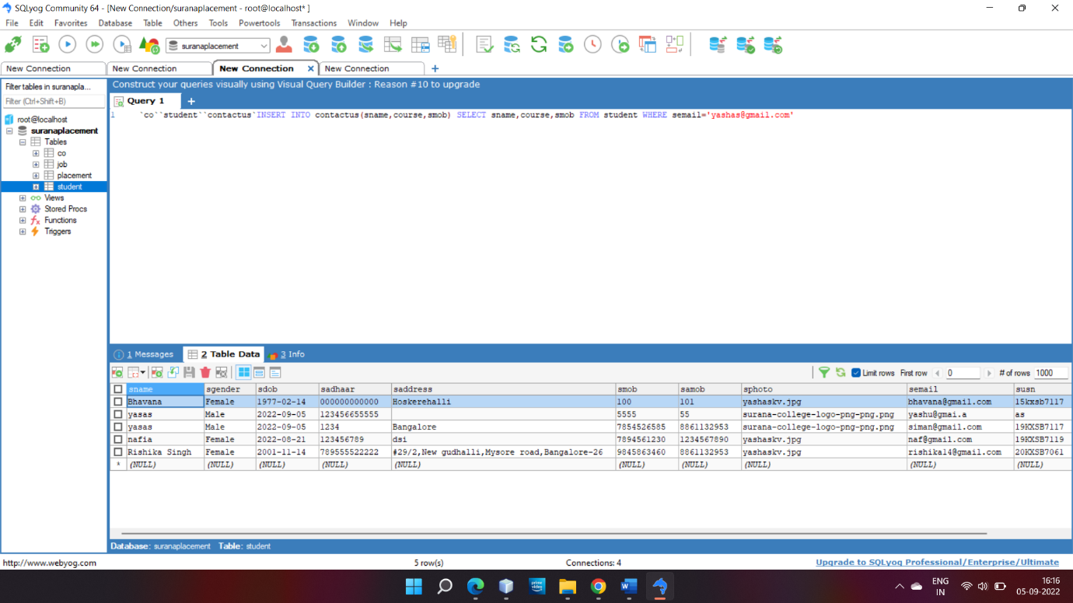

**DATA FLOW DAIGRAM**

Level 0 DFD

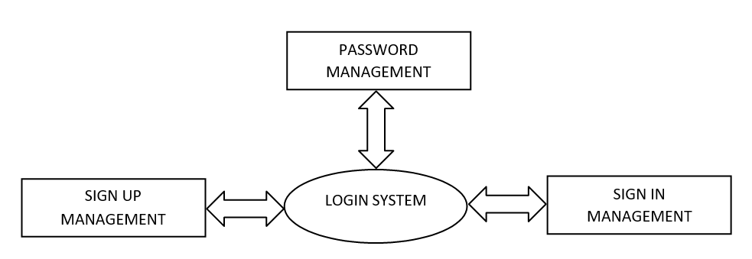

Level 1 DFD

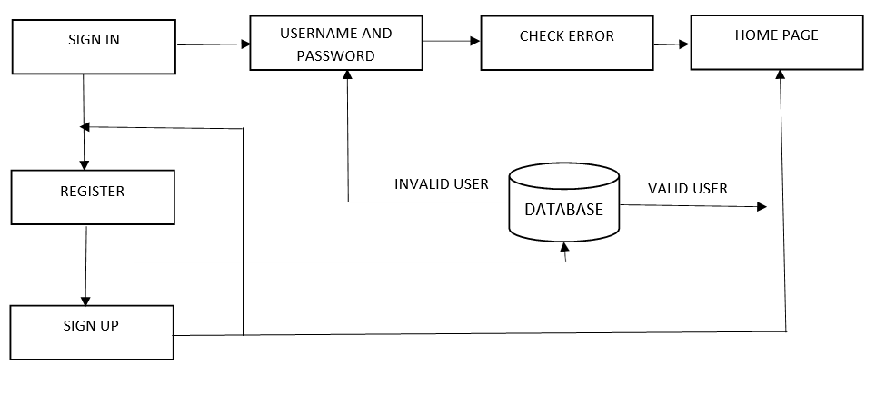

Level 2 DFD

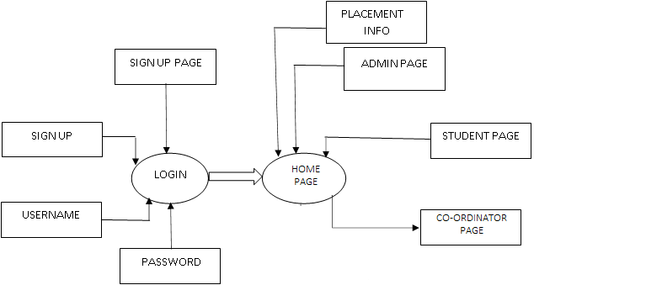

**CHAPTER 5**

Module design (tables)

**JOB DETAILS**

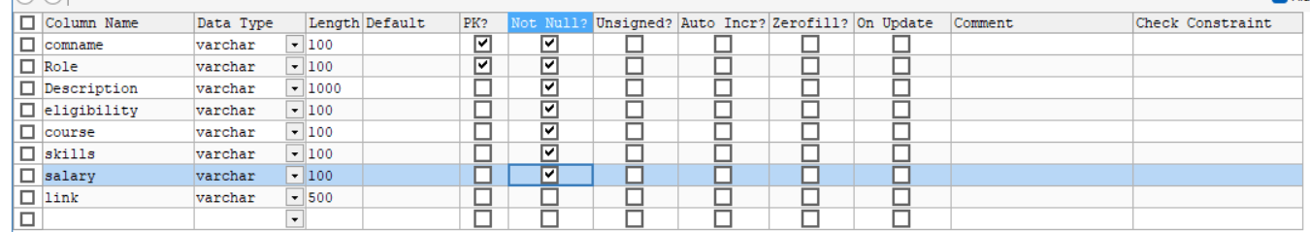

**ADMIN**

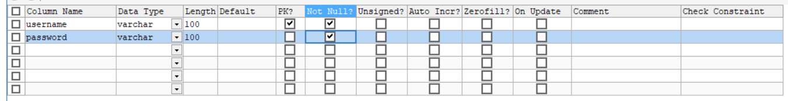

**PLACEMENT TABLE**

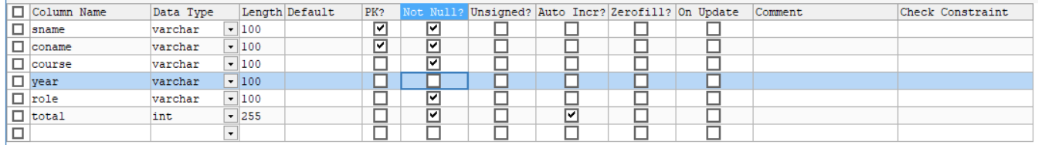

**CO-ORDINATOR TABLE**

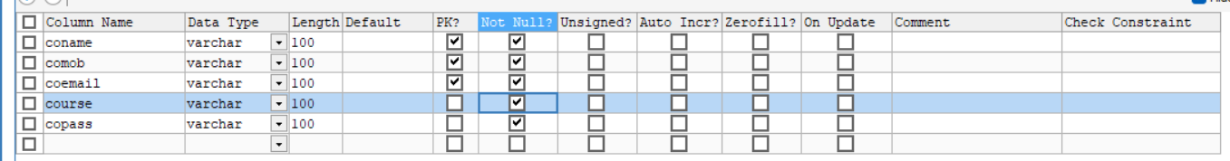

**STUDENT TABLE**

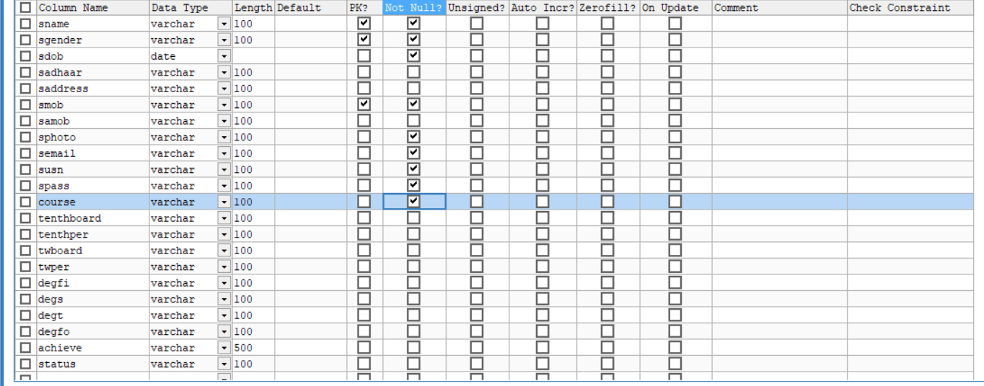

**CHAPTER 6**

(Code implementation)

6.1 Programming language and scripting language:

**What is Java Server Pages?**

Java Server Pages (JSP) is a technology for developing web pages that support dynamic content which helps developers insert java code in HTML pages by making use of special JSP tags, most of which start with <% and end with %>. A Java Server Pages component is a type of Java servlet that is designed to fulfil the role of a user interface for a Java web application. Web developers write JSPs as text files that combine HTML or XHTML code, XML elements, and embedded JSP actions and commands. Using JSP, you can collect input from users through web page forms, present records from a database or another source, and create web pages dynamically. JSP tags can be used for a variety of purposes, such as retrieving information from a database or registering user preferences, accessing JavaBeans components, passing control between pages and sharing information between requests, pages etc.

**Why use JSP?**

Java Server Pages often serve the same purpose as programs implemented using the Common Gateway Interface (CGI). But JSP offer several advantages in comparison with the CGI.

* + - Performance is significantly better because JSP allows embedding Dynamic Elements in HTML Pages itself instead of having a separate CGI
    - JSP are always compiled before it's processed by the server unlike CGI/Perl which requires the server to load an interpreter and the target script each time the page is requested.
    - Java Server Pages are built on top of the Java Servlets API, so like Servlets, JSP also has access to all the powerful Enterprise Java APIs, including JDBC, JNDI, EJB, JAXP etc.
    - JSP pages can be used in combination with servlets that handle the business logic, the model supported by Java servlet template engines.

Finally, JSP is an integral part of Java EE, a complete platform for enterprise class applications. This means that JSP can play a part in the simplest applications to the most complex and demanding.

**Advantages of JSP?**

Following is the list of other advantages of using JSP over other technologies:

* + - **vs. Active Server Pages (ASP):** The advantages of JSP are twofold. First, the dynamic part is written in Java, not Visual Basic or other MS specific language, so it is more powerful and easier to use. Second, it is portable to other operating systems and non-Microsoft Web servers.
    - **vs. Pure Servlets:** It is more convenient to write (and to modify!) regular HTML than to have plenty of println statements that generate the HTML.
    - **vs. Server-Side Includes (SSI):** SSI is really only intended for simple inclusions, not for "real" programs that use form data, make database connections, and the like.
    - **vs. JavaScript:** JavaScript can generate HTML dynamically on the client but can hardly interact with the web server to perform complex tasks like database access and image processing etc.
    - **vs. Static HTML:** Regular HTML, of course, cannot contain dynamic information.

The web server needs a JSP engine ie. container to process JSP pages. The JSP container is responsible for intercepting requests for JSP pages. This tutorial makes use of Apache which has built-in JSP container to support JSP pages development.

A JSP container works with the Web server to provide the runtime environment and other services a JSP needs. It knows how to understand the special elements that are part of JSPs.

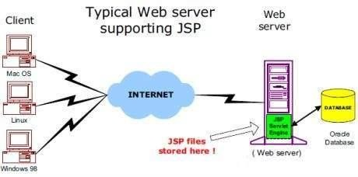Following diagram shows the position of JSP container and JSP files in a Web Application.

**JSP Processing :**

The following steps explain how the web server creates the web page using JSP:

* + - As with a normal page, your browser sends an HTTP request to the web server.
    - The web server recognizes that the HTTP request is for a JSP page and forwards it to a JSP engine. This is done by using the URL or JSP page which ends with **.jsp** instead of .html.
    - The JSP engine loads the JSP page from disk and converts it into a servlet content. This conversion is very simple in which all template text is converted to println( ) statements and all JSP elements are converted to Java code that implements the corresponding dynamic behavior of the page.
    - The JSP engine compiles the servlet into an executable class and forwards the original request to a servlet engine.
    - A part of the web server called the servlet engine loads the Servlet class and executes it. During execution, the servlet produces an output in HTML format, which the servlet engine passes to the web server inside an HTTP response.
    - The web server forwards the HTTP response to your browser in terms of static HTML content.
    - Finally, web browser handles the dynamically generated HTML page inside the HTTP response exactly as if it were a static page.

All the above-mentioned steps can be shown below in the following diagram:

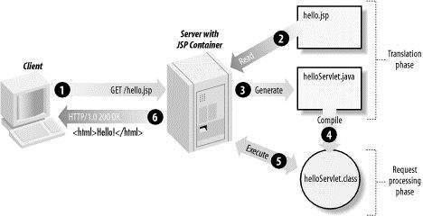

Typically, the JSP engine checks to see whether a servlet for a JSP file already exists and whether the modification date on the JSP is older than the servlet. If the JSP is older than its generated servlet, the JSP container assumes that the JSP hasn't changed and that the generated servlet still matches the JSP's contents. This makes the process more efficient than with other scripting languages (such as PHP) and therefore faster.

**CODES**

**HOME PAGE**

<%--

Document : new

Created on : 10 Aug, 2022, 1:22:58 PM

Author : k v

--%>

<%@page contentType="text/html" pageEncoding="UTF-8"%>

<!DOCTYPE html>

<html>

<head>

<meta http-equiv="Content-Type" content="text/html; charset=UTF-8">

<title>Home Page</title>

</head>

<body>

<!DOCTYPE html>

<html lang="en">

<head>

<title>HOME</title>

<meta charset="UTF-8">

<meta name="viewport" content="width=device-width, initial-scale=1">

<link rel="stylesheet" href="https://www.w3schools.com/w3css/4/w3.css">

<link rel="stylesheet" href="https://fonts.googleapis.com/css?family=Poppins">

<style>

body,h1,h2,h3,h4,h5 {font-family: "Poppins", sans-serif}

body {font-size:16px;}

.w3-half img{margin-bottom:-6px;margin-top:16px;opacity:0.8;cursor:pointer}

.w3-half img:hover{opacity:1}

</style>

</head>

<body>

<!-- Sidebar/menu -->

<nav class="w3-sidebar w3-red w3-collapse w3-top w3-large w3-padding" style="z-index:3;width:300px;font-weight:bold;" id="mySidebar"><br>

<a href="javascript:void(0)" onClick="w3_close()" class="w3-button w3-hide-large w3-display-topleft" style="width:100%;font-size:22px">Close Menu</a>

<div class="w3-container">

<h3 class="w3-padding-64"><b>PLACEMENT<br>CELL</b></h3>

</div>

<div class="w3-bar-block">

<a href="#" onClick="w3_close()" class="w3-bar-item w3-button w3-hover-white">Home</a>

<a href="#services" onClick="w3_close()" class="w3-bar-item w3-button w3-hover-white">About</a>

<a href="#designers" onClick="w3_close()" class="w3-bar-item w3-button w3-hover-white">Recruiters</a>

<a href="cologin.jsp" onClick="w3_close()" class="w3-bar-item w3-button w3-hover-white">Co-Ordinator</a>

<meta name="viewport" content="width=device-width, initial-scale=1">

<link rel="stylesheet" href="https://cdnjs.cloudflare.com/ajax/libs/font-awesome/4.7.0/css/font-awesome.min.css">

<style>

.navbar {

overflow: hidden;

background-color:crimsonred;

font-family: Arial, Helvetica, sans-serif;

}

.navbar a {

float: left;

font-size: 16px;

color: white;

text-align: center;

padding: 14px 16px;

text-decoration: none;

}

.dropdown {

float: left;

overflow: hidden;

}

.dropdown .dropbtn {

cursor: pointer;

font-size: 20px;

border: none;

outline: none;

color: white;

padding: 14px 16px;

background-color: inherit;

font-family: inherit;

margin: 0;

}

.navbar a:hover, .dropdown:hover .dropbtn, .dropbtn:focus {

background-color: red;

}

.dropdown-content {

display: none;

position: absolute;

background-color: #f9f9f9;

min-width: 160px;

box-shadow: 0px 8px 16px 0px rgba(0,0,0,0.2);

z-index: 1;

}

.dropdown-content a {

float: none;

color: red;

padding: 12px 16px;

text-decoration: none;

display: block;

text-align: left;

}

.dropdown-content a:hover {

background-color: #ddd;

}

.show {

display: block;

}

</style>

</head>

<body>

<div class="navbar">

<div class="dropdown">

<button class="dropbtn" onClick="myFunction()">Student

<i class="fa fa-caret-down"></i>

</button>

<div class="dropdown-content" id="myDropdown">

<a href="studentlogin.jsp">Login</a>

<a href="studentsignup.jsp">Create account</a>

</div>

</div>

</div>

<a href="contactus.jsp" onClick="w3_close()" class="w3-bar-item w3-button w3-hover-white">Contact Us</a>

<script>

/* When the user clicks on the button,

toggle between hiding and showing the dropdown content */

function myFunction() {

document.getElementById("myDropdown").classList.toggle("show");

}

// Close the dropdown if the user clicks outside of it

window.onclick = function(e) {

if (!e.target.matches('.dropbtn')) {

var myDropdown = document.getElementById("myDropdown");

if (myDropdown.classList.contains('show')) {

myDropdown.classList.remove('show');

}

}

}

</script>

</div>

</nav>

<!-- Top menu on small screens -->

<header class="w3-container w3-top w3-hide-large w3-red w3-xlarge w3-padding">

<a href="javascript:void(0)" class="w3-button w3-red w3-margin-right" onClick="w3_open()">☰</a>

</header>

<!-- Overlay effect when opening sidebar on small screens -->

<div class="w3-overlay w3-hide-large" onClick="w3_close()" style="cursor:pointer" title="close side menu" id="myOverlay"></div>

<!-- !PAGE CONTENT! -->

<div class="w3-main" style="margin-left:340px;margin-right:40px">

<!-- Header -->

<div class="w3-container" style="margin-top:80px" id="showcase">

<h1 class="w3-jumbo"><b>Surana Placement cell</b></h1>

<h1 class="w3-xxxlarge w3-text-red"><b>and Career Guidance.</b></h1>

<hr style="width:550px;border:5px solid red" class="w3-round">

</div>

<!-- Photo grid (modal) -->

<!-- Photo grid (modal) -->

<div class="w3-row-padding">

<div class="w3-half">

<img src="https://i.ytimg.com/vi/9TesXxHbQS4/maxresdefault.jpg" style="width:100%" height="495" onClick="onClick(this)" alt="Concrete meets bricks">

</div>

<div class="w3-half">

<img src="https://cache.careers360.mobi/media/presets/720X480/colleges/social-media/media-gallery/5437/2018/7/17/Surana-College-Centre-for-Post-Graduate-Studies-Bangalore03.JPG" style="width:100%" onClick="onClick(this)" alt="Windows for the atrium">

</div>

</div>

<div class="w3-container" id="services" style="margin-top:90px">

<h1 class="w3-xxxlarge w3-text-red"><b>ABOUT</b></h1>

<hr style="width:150px;border:5px solid red" class="w3-round">

<p> <h4> <B>

Surana Placement cell acts as an interface between the students and the corporate world.

The placement cell helps every student to utilize the resources available in the campus. Students will be facilitated with Enthusiastic Faculty, distinguished alumni, library and internet facilities for student’s assistance to get them ahead in this competitive world.

<p>

Surana College not only believes in providing quality education to its students as per University syllabus but also works relentlessly in making them employable and placement ready through pre-placement training activities spread over three years of under graduation program.

</P></h4>

<h1 class="w3-xlarge w3-text-red"><b>OBJECTIVES OF PLACEMENT CELL

</b></h1>

<h4><P>●Giving Equal importance to every individual</p>

<p>●Providing rigorous training required for the placements as per the requirements of the companies</P>

<p>●Providing campus placements/Internships in best companies</p>

<p>●Providing Career Counselling & career guidance program for students to enable them to enter the corporate world with right skills and attitude.</p>

</p>

</br>

</B>

</p> </h4>

</div>

<!-- Designers -->

<div class="w3-container" id="designers" style="margin-top:75px">

<h1 class="w3-xxxlarge w3-text-red"><b>Our Recruiters</b></h1>

<hr style="width:300px;border:5px solid red" class="w3-round">

<div class="w3-display-bottommiddle w3-container w3-text-white w3-padding-32 w3-hide-small">

</div>

</div>

<link rel="stylesheet" href="https://www.w3schools.com/w3css/4/w3.css">

<link rel="stylesheet" href="https://fonts.googleapis.com/css?family=Raleway">

<style>

body,h1,h2,h3,h4,h5 {font-family: "Raleway", sans-serif}

.w3-quarter img{margin-bottom: -6px; cursor: pointer}

.w3-quarter img:hover{opacity: 0.6; transition: 0.3s}

</style>

</head>

<body class="w3-light-grey">

<!-- Photo grid -->

<div class="w3-row w3-grayscale-min">

<div class="w3-quarter">

<img src="https://www.suranacollege.edu.in/wp-content/uploads/2019/01/40.jpg" style="width:80%" >

<img src="https://www.suranacollege.edu.in/wp-content/uploads/2019/01/2.png" style="width:80%" >

<img src="https://www.suranacollege.edu.in/wp-content/uploads/2019/01/1.png" style="width:80%">

<img src="https://www.suranacollege.edu.in/wp-content/uploads/2019/01/46.jpg" style="width:80%">

</div>

<div class="w3-quarter">

<img src="https://www.suranacollege.edu.in/wp-content/uploads/2019/01/7.png" style="width:80%">

<img src="https://www.suranacollege.edu.in/wp-content/uploads/2019/01/4.png" style="width:80%">

<img src="https://www.suranacollege.edu.in/wp-content/uploads/2019/01/15.jpg" style="width:80%" >

<img src="https://www.suranacollege.edu.in/wp-content/uploads/2019/01/1-1.jpg" style="width:80%" >

</div>

<div class="w3-quarter">

<img src="https://www.suranacollege.edu.in/wp-content/uploads/2019/01/21.jpg" style="width:80%">

<img src="https://www.suranacollege.edu.in/wp-content/uploads/2019/01/11.png" style="width:80%">

<img src="https://www.suranacollege.edu.in/wp-content/uploads/2019/01/12.jpg" style="width:80%">

<img src="https://www.suranacollege.edu.in/wp-content/uploads/2019/01/13.png" style="width:80%">

</div>

<div class="w3-quarter">

<img src="https://www.suranacollege.edu.in/wp-content/uploads/2019/01/15.png" style="width:80%" >

<img src="https://www.suranacollege.edu.in/wp-content/uploads/2019/01/25.jpg" style="width:80%" >

<img src="https://www.suranacollege.edu.in/wp-content/uploads/2019/01/6.png" style="width:80%">

<img src="https://www.suranacollege.edu.in/wp-content/uploads/2019/01/10.png" style="width:80%" height="180" >

</div>

<script>

// Script to open and close sidebar

function w3_open() {

document.getElementById("mySidebar").style.display = "block";

document.getElementById("myOverlay").style.display = "block";

}

function w3_close() {

document.getElementById("mySidebar").style.display = "none";

document.getElementById("myOverlay").style.display = "none";

}

// Modal Image Gallery

function onClick(element) {

document.getElementById("img01").src = element.src;

document.getElementById("modal01").style.display = "block";

var captionText = document.getElementById("caption");

captionText.innerHTML = element.alt;

}

</script>

</body>

</html>

**ADD CO-ORDINATOR 1:**

<%@ page contentType="text/html; charset=utf-8" language="java" import="java.sql.*" errorPage="" %>

<!DOCTYPE HTML>

<!--

Aesthetic by freehtml5.co

Twitter: http://twitter.com/fh5co

URL: http://freehtml5.co

-->

<html>

<head>

<title>login</title>

<meta charset="UTF-8">

<meta name="viewport" content="width=device-width, initial-scale=1">

<link rel="stylesheet" href="https://www.w3schools.com/w3css/4/w3.css">

<link rel="stylesheet" href="https://fonts.googleapis.com/css?family=Poppins">

<style>

body,h1,h2,h3,h4,h5 {font-family: "Poppins", sans-serif}

body {font-size:16px;}

.w3-half img{margin-bottom:-6px;margin-top:16px;opacity:0.8;cursor:pointer}

.w3-half img:hover{opacity:1}

.style2 {

font-family: Verdana, Arial, Helvetica, sans-serif;

font-size: 24px;

font-weight: bold;

}

</style>

</head>

<body>

<nav class="w3-sidebar w3-red w3-collapse w3-top w3-large w3-padding" style="z-index:3;width:300px;font-weight:bold;" id="mySidebar"><br>

<a href="javascript:void(0)" onClick="w3_close()" class="w3-button w3-hide-large w3-display-topleft" style="width:100%;font-size:22px">Close Menu</a>

<div class="w3-container">

<h3 class="w3-padding-64"><b>SURANA<br>PLACEMENT<br>CELL</b></h3>

</div>

<div class="w3-bar-block">

<a href="adminhome.jsp" onClick="w3_close()" class="w3-bar-item w3-button w3-hover-white">Home</a>

<meta name="viewport" content="width=device-width, initial-scale=1">

<link rel="stylesheet" href="https://cdnjs.cloudflare.com/ajax/libs/font-awesome/4.7.0/css/font-awesome.min.css">

<style>

.navbar {

overflow: hidden;

background-color:crimsonred;

font-family: Arial, Helvetica, sans-serif;

}

.navbar a {

float: left;

font-size: 16px;

color: white;

text-align: center;

padding: 14px 16px;

text-decoration: none;

}

.dropdown {

float: left;

overflow: hidden;

}

.dropdown .dropbtn {

cursor: pointer;

font-size: 20px;

border: none;

outline: none;

color: white;

padding: 14px 16px;

background-color: inherit;

font-family: inherit;

margin: 0;

}

.navbar a:hover, .dropdown:hover .dropbtn, .dropbtn:focus {

background-color: red;

}

.dropdown-content {

display: none;

position: absolute;

background-color: #f9f9f9;

min-width: 160px;

box-shadow: 0px 8px 16px 0px rgba(0,0,0,0.2);

z-index: 1;

}

.dropdown-content a {

float: none;

color: red;

padding: 12px 16px;

text-decoration: none;

display: block;

text-align: left;

}

.dropdown-content a:hover {

background-color: #ddd;

}

.show {

display: block;

}

</style>

</head>

<body>

<div class="navbar">

<div class="dropdown">

<button class="dropbtn" onClick="myFunction()">Student

<i class="fa fa-caret-down"></i>

</button>

<div class="dropdown-content" id="myDropdown2">

<p><a href="approvestudents.jsp">Approve Students</a>

<a href="viewstudents.jsp">View Students</a>

</div>

</div>

</div>

<a href="viewjobs.jsp" onClick="w3_close()" class="w3-bar-item w3-button w3-hover-white">Jobs</a>

<a href="home.jsp" onClick="w3_close()" class="w3-bar-item w3-button w3-hover-white">Logout</a>

<script>

/* When the user clicks on the button,

toggle between hiding and showing the dropdown content */

function myFunction() {

document.getElementById("myDropdown2").classList.toggle("show");

}

// Close the dropdown if the user clicks outside of it

window.onclick = function(e) {

if (!e.target.matches('.dropbtn')) {

var myDropdown = document.getElementById("myDropdown2");

if (myDropdown.classList.contains('show')) {

myDropdown.classList.remove('show');

}

}

}

</script>

</div>

</nav>

<div class="w3-container" id="contact" style="margin-top:75px">

<h1 class="w3-xxxlarge w3-text-red" align="center"><b>Add Co-Ordinator</b></h1>

<br/>

<form action="" method="post" name="form1" >

<table align="center" width="79%" border="0" cellpadding="10" cellspacing="10">

<tr>

<td width="27%" height="39"><div align="right" class="style2">Search by Number:</div></td>

<td width="2%"></td>

<td width="23%"><div align="left">

<input name="search" type="text" id="search" maxlength="10" pattern="^\d{10}$" title="only nos should be 10 digits" required/>

</div></td>

<td width="42%" colspan="3">

<div align="center">

<input type="submit"class="w3-btn w3-red" name="button" id="button" value="Submit" />

</div></td>

</tr>

</table>

</form>

<div align="center">

<%@page import="dbconnection.Dbconnection"%>

<%

if(request.getParameter("button")!=null)

{

try

{

Connection con=Dbconnection.getConnection();

Statement stmt=con.createStatement();

Statement stmt1=con.createStatement();

String search=request.getParameter("search");

ResultSet rs1;

Statement st=con.createStatement();

ResultSet rs=st.executeQuery("select * from student where smob='"+search+"' ");

String c_name="",c_mob="",semail="",course="",c_pass="";

while(rs.next())

{

c_name=rs.getString("sname");

c_mob=rs.getString("smob");

semail=rs.getString("semail");

course=rs.getString("course");

c_pass=rs.getString("smob");

%>

<table align="right" width="84%" border="1" bordercolor="white" bgcolor="#FD3D37">

<tr>

<td width="204" ><div align="center" class="style9"><b>Name</b></div></td>

<td width="227" ><div align="center" class="style9"><b>Mobile</b></div></td>

<td width="336" ><div align="center" class="style9"><b>Email</b></div></td>

<td width="265" ><div align="center" class="style9"><b>Course</b></div></td>

<td width="200"> <div align="center" class="style9"><b>Password</b></div></td>

</tr>

<tr>

<td height="39" align="center"><span class="style6"> <%=c_name%> </span></td>

<td align="center"><span class="style6"> <%=c_mob%> </span></td>

<td align="center"><span class="style6"> <%=semail%> </span></td>

<td align="center"><span class="style6"> <%=course%> </span></td>

<td align="center"><span class="style6"> <%=c_pass%> </span></td>

</tr>

<tr>

<br/>

<td bgcolor="white" colspan="5" bordercolor="white">

<div align="center">

<a href="addco2.jsp?c_mob=<%=c_mob%>">

<input type="button" name="add" id="add" value="Add" />

</div></td>

</tr>

<%

}}

catch(Exception e)

{

out.println("Exception occured" +e);

}

}

%>

</table>

</div>

</div>

<!-- jQuery -->

<script src="js/jquery.min.js"></script>

<!-- jQuery Easing -->

<script src="js/jquery.easing.1.3.js"></script>

<!-- Bootstrap -->

<script src="js/bootstrap.min.js"></script>

<!-- Waypoints -->

<script src="js/jquery.waypoints.min.js"></script>

<!-- Carousel -->

<script src="js/owl.carousel.min.js"></script>

<!-- Main -->

<script src="js/main.js"></script>

</body>

</html>

**ADD CO-ORDINATOR :**

<%@page import="java.sql.*" %>

<%@page import="java.io.*,java.sql.*,java.util.*,java.util.Vector;"%>

<%@page contentType="text/html" pageEncoding="UTF-8"%>

<!DOCTYPE HTML PUBLIC "-//W3C//DTD HTML 4.01 Transitional//EN"

"http://www.w3.org/TR/html4/loose.dtd">

<html>

<head>

<meta http-equiv="Content-Type" content="text/html; charset=UTF-8">

<title>JSP Page</title>

</head>

<body>

<table>

<%@page import="dbconnection.Dbconnection"%>

<% try

{

Connection con=Dbconnection.getConnection();

Statement stmt=con.createStatement();

ResultSet rs1;

String c_mob=request.getParameter("c_mob");

out.println(c_mob);

//Class.forName("sun.jdbc.odbc.JdbcOdbcDriver");

//Connection con = DriverManager.getConnection("jdbc:odbc:EXAM","EXAM","EXAM");

Statement st=con.createStatement();

st.executeUpdate("INSERT INTO co (coname,comob,coemail,course,copass) SELECT sname,smob,semail,course,smob FROM student where smob='"+c_mob+"'");

out.println( "<script>alert('Successfully Added');window.location='viewco.jsp';</script>");

}//try

catch(Exception e)

{

out.println(e);

}

%>

</table>

</body>

</html>

**ADD JOB:**

<%@ page contentType="text/html; charset=utf-8" language="java" import="java.sql.*" errorPage="" %>

<!DOCTYPE HTML>

<!--

Aesthetic by freehtml5.co

Twitter: http://twitter.com/fh5co

URL: http://freehtml5.co

-->

<html>

<head>

<title>login</title>

<meta charset="UTF-8">

<meta name="viewport" content="width=device-width, initial-scale=1">

<link rel="stylesheet" href="https://www.w3schools.com/w3css/4/w3.css">

<link rel="stylesheet" href="https://fonts.googleapis.com/css?family=Poppins">

<style>

body,h1,h2,h3,h4,h5 {font-family: "Poppins", sans-serif}

body {font-size:16px;}

.w3-half img{margin-bottom:-6px;margin-top:16px;opacity:0.8;cursor:pointer}

.w3-half img:hover{opacity:1}

</style>

</head>

<body>

<nav class="w3-sidebar w3-red w3-collapse w3-top w3-large w3-padding" style="z-index:3;width:300px;font-weight:bold;" id="mySidebar"><br>

<a href="javascript:void(0)" onClick="w3_close()" class="w3-button w3-hide-large w3-display-topleft" style="width:100%;font-size:22px">Close Menu</a>

<div class="w3-container">

<h3 class="w3-padding-64"><b>PLACEMENT<br>CELL</b></h3>

</div>

<%@page import="dbconnection.Dbconnection"%>

<%

// Class.forName("sun.jdbc.odbc.JdbcOdbcDriver");

// Connection con = DriverManager.getConnection("jdbc:odbc:EXAM","EXAM","EXAM");

try

{

Connection con=Dbconnection.getConnection();

Statement stmt=con.createStatement();

ResultSet rs1;

String coemail=request.getParameter("coemail");

Statement st=con.createStatement();

ResultSet rsl=st.executeQuery("select * from co where coemail ='" + coemail + "'");

String course="",s_name="",s_mob="";

while(rsl.next())

{

coemail=rsl.getString("coemail");

// course=rsl.getString("course");

// s_name=rsl.getString("sname");

// s_mob=rsl.getString("smob");

%>

<div class="w3-bar-block">

<a href="cohome.jsp?coemail=<%=coemail%>" onClick="w3_close()" class="w3-bar-item w3-button w3-hover-white">Home</a>

<a href="addjob.jsp?coemail=<%=coemail%>" onClick="w3_close()" class="w3-bar-item w3-button w3-hover-white">Add Job</a>

<a href="cochangepassword.jsp?coemail=<%=coemail%>" onClick="w3_close()" class="w3-bar-item w3-button w3-hover-white">Change Password</a>

<meta name="viewport" content="width=device-width, initial-scale=1">

<link rel="stylesheet" href="https://cdnjs.cloudflare.com/ajax/libs/font-awesome/4.7.0/css/font-awesome.min.css">

<style>

.navbar {

overflow: hidden;

background-color:crimsonred;

font-family: Arial, Helvetica, sans-serif;

}

.navbar a {

float: left;

font-size: 16px;

color: white;

text-align: center;

padding: 14px 16px;

text-decoration: none;

}

.dropdown {

float: left;

overflow: hidden;

}

.dropdown .dropbtn {

cursor: pointer;

font-size: 20px;

border: none;

outline: none;

color: white;

padding: 14px 16px;

background-color: inherit;

font-family: inherit;

margin: 0;

}

.navbar a:hover, .dropdown:hover .dropbtn, .dropbtn:focus {

background-color: red;

}

.dropdown-content {

display: none;

position: absolute;

background-color: #f9f9f9;

min-width: 160px;

box-shadow: 0px 8px 16px 0px rgba(0,0,0,0.2);

z-index: 1;

}

.dropdown-content a {

float: none;

color: red;

padding: 12px 16px;

text-decoration: none;

display: block;

text-align: left;

}

.dropdown-content a:hover {

background-color: #ddd;

}

.show {

display: block;

}

</style>

</head>

<body>

</div>

<a href="home.jsp" onClick="w3_close()" class="w3-bar-item w3-button w3-hover-white">Logout</a> <br/>

<a href="cocontactus.jsp?coemail=<%=coemail%>" onclick="w3_close()" class="w3-bar-item w3-button w3-hover-white">Contact Us</a>

<%

}

}

catch(Exception e)

{

out.println(e);

}

%>

<script>

/* When the user clicks on the button,

toggle between hiding and showing the dropdown content */

function myFunction2() {

document.getElementById("myDropdown2").classList.toggle("show");

}

// Close the dropdown if the user clicks outside of it

window.onclick = function(e) {

if (!e.target.matches('.dropbtn')) {

var myDropdown = document.getElementById("myDropdown2");

if (myDropdown.classList.contains('show')) {

myDropdown.classList.remove('show');

}

}

}

</script>

<script>

function myFunction() {

document.getElementById("myDropdown").classList.toggle("show");

}

// Close the dropdown if the user clicks outside of it

window.onclick = function(e) {

if (!e.target.matches('.dropbtn')) {

var myDropdown = document.getElementById("myDropdown");

if (myDropdown.classList.contains('show')) {

myDropdown.classList.remove('show');

}

}

}

</script>

</nav>

<div class="w3-container" id="contact" style="margin-top:75px">

<h1 class="w3-xxxlarge w3-text-red" align="center"><b><u>Add Jobs </u></b></h1>

<hr style="width:100px;border:5px solid red" class="w3-round">

<b>

<form action="" method="post" name="form1" font-family: Arial>

<table align="center" width="79%" border="0" cellpadding="15" cellspacing="15">

<tr>

<td height="39"><div align="right">COMPANY NAME</div></td>

<td>&nbsp;</td>

<td><input type="text" name="t1" id="t1" required></td>

</tr>

<tr>

<td height="39"><div align="right">JOB ROLE</div></td>

<td>&nbsp;</td>

<td><input type="text" name="t2" id="t2" required></td>

</tr>

<tr>

<td height="59"><div align="right">DESCRIPTION</div></td>

<td>&nbsp;</td>

<td><div align="left">

<input type="text" name="t3" id="t3" required>

</div></td>

</tr>

<tr>

<td height="51"><div align="right">ELIGIBILITY</div></td>

<td>&nbsp;</td>

<td><div align="left">

<input name="t4" type="text" id="t4" required>

</div></td>

</tr>

<tr>

<td height="59"><div align="right" class="style2">Course</div></td>

<td><div align="left">

<td ><select name="t5" id="t5">

<option value="">------Select--------- </option>

<option value ="BCA">BCA</option>

<option value ="BCom">BCom</option>

<option value ="BA">BA</option>

<option value ="BBA">BBA</option>

<option value ="Bsc">BSc</option>

<option value ="MCA">MCA</option>

<option value ="MBA">MBA</option>

<option value ="MCom">MCom</option>

</select> </td>

</tr>

<tr>

<td height="39"><div align="right">SKILLS REQUIRED</div></td>

<td>&nbsp;</td>

<td><input type="text" name="t6" id="t6" required></td>

</tr>

<tr>

<td height="39"><div align="right">SALARY OFFERED</div></td>

<td>&nbsp;</td>

<td><input type="text" name="t7" id="t7" required></td>

</tr>

<tr>

<td height="39"><div align="right">FORM LINK</div></td>

<td>&nbsp;</td>

<td><input type="text" name="t8" id="t8" required></td>

</tr>

</B>

<tr>

<td colspan="3">

<div align="center">

<input type="submit" class="w3-btn w3-red" name="button" id="button" value="Submit" />

<input name="Submit2" class="w3-btn w3-red" type="reset" value="Reset" />

</div></td>

</tr>

</table>

</form>

<%@page import="dbconnection.Dbconnection"%>

<%

if(request.getParameter("button")!=null)

{

try

{

Connection con=Dbconnection.getConnection();

Statement stmt=con.createStatement();

// ResultSet rs;

String t1=request.getParameter("t1").trim();

String t2=request.getParameter("t2").trim();

String t3=request.getParameter("t3").trim();

String t4=request.getParameter("t4").trim();

String t5=request.getParameter("t5").trim();

String t6=request.getParameter("t6").trim();

String t7=request.getParameter("t7").trim();

String t8=request.getParameter("t8").trim();

int count=0;

ResultSet rs;

rs=stmt.executeQuery("select * from job where course="+"'"+t5+"'");

while(rs.next())

{

count++;

}

out.println(count);

if(count==0)

{

PreparedStatement pstmt=con.prepareStatement("insert into job values(?,?,?,?,?,?,?,?)");

pstmt.setString(1,t1);

pstmt.setString(2,t2);

pstmt.setString(3,t3);

pstmt.setString(4,t4);

pstmt.setString(5,t5);

pstmt.setString(6,t6);

pstmt.setString(7,t7);

pstmt.setString(8,t8);

pstmt.executeUpdate();

pstmt.close();

con.close();

out.println( "<script>alert('Added Sucessfully');window.location='cohome.jsp';</script>");

// response.sendRedirect("donerregsaveack.jsp");

}

else

{

out.println( "<script>alert('Try Again');window.location='cohome.jsp';</script>");

// response.sendRedirect("donerregsaveinvalid.jsp");

}

}

catch(Exception e)

{

out.println("Exception occured" +e);

}

}

%>

</div>

</div>

<div class="gototop js-top">

<a href="#" class="js-gotop"><i class="icon-arrow-up"></i></a>

</div>

<!-- jQuery -->

<script src="js/jquery.min.js"></script>

<!-- jQuery Easing -->

<script src="js/jquery.easing.1.3.js"></script>

<!-- Bootstrap -->

<script src="js/bootstrap.min.js"></script>

<!-- Waypoints -->

<script src="js/jquery.waypoints.min.js"></script>

<!-- Carousel -->

<script src="js/owl.carousel.min.js"></script>

<!-- Main -->

<script src="js/main.js"></script>

<style>

</style>

</body>

</html>

**ADMIN HOME :**

<%@ page contentType="text/html; charset=utf-8" language="java" import="java.sql.*" errorPage="" %>

<!DOCTYPE HTML>

<!--

Aesthetic by freehtml5.co

Twitter: http://twitter.com/fh5co

URL: http://freehtml5.co

-->

<html>

<head>

<title>login</title>

<meta charset="UTF-8">

<meta name="viewport" content="width=device-width, initial-scale=1">

<link rel="stylesheet" href="https://www.w3schools.com/w3css/4/w3.css">

<link rel="stylesheet" href="https://fonts.googleapis.com/css?family=Poppins">

<style>

body,h1,h2,h3,h4,h5 {font-family: "Poppins", sans-serif}

body {font-size:16px;}

.w3-half img{margin-bottom:-6px;margin-top:16px;opacity:0.8;cursor:pointer}

.w3-half img:hover{opacity:1}

</style>

</head>

<body>

<nav class="w3-sidebar w3-red w3-collapse w3-top w3-large w3-padding" style="z-index:3;width:300px;font-weight:bold;" id="mySidebar"><br>

<a href="javascript:void(0)" onClick="w3_close()" class="w3-button w3-hide-large w3-display-topleft" style="width:100%;font-size:22px">Close Menu</a>

<div class="w3-container">

<h3 class="w3-padding-64"><b>SURANA<br>PLACEMENT<br>CELL</b></h3>

</div>

<div class="w3-bar-block">

<a href="#" onClick="w3_close()" class="w3-bar-item w3-button w3-hover-white">Home</a>

<meta name="viewport" content="width=device-width, initial-scale=1">

<link rel="stylesheet" href="https://cdnjs.cloudflare.com/ajax/libs/font-awesome/4.7.0/css/font-awesome.min.css">

<style>

.navbar {

overflow: hidden;

background-color:crimsonred;

font-family: Arial, Helvetica, sans-serif;

}

.navbar a {

float: left;

font-size: 16px;

color: white;

text-align: center;

padding: 14px 16px;

text-decoration: none;

}

.dropdown {

float: left;

overflow: hidden;

}

.dropdown .dropbtn {

cursor: pointer;

font-size: 20px;

border: none;

outline: none;

color: white;

padding: 14px 16px;

background-color: inherit;

font-family: inherit;

margin: 0;

}

.navbar a:hover, .dropdown:hover .dropbtn, .dropbtn:focus {

background-color: red;

}

.dropdown-content {

display: none;

position: absolute;

background-color: #f9f9f9;

min-width: 160px;

box-shadow: 0px 8px 16px 0px rgba(0,0,0,0.2);

z-index: 1;

}

.dropdown-content a {

float: none;

color: red;

padding: 12px 16px;

text-decoration: none;

display: block;

text-align: left;

}

.dropdown-content a:hover {

background-color: #ddd;

}

.show {

display: block;

}

</style>

</head>

<body>

<div class="navbar">

<div class="dropdown">

<button class="dropbtn" onClick="myFunction2()">Co-Ordinator

<i class="fa fa-caret-down"></i>

</button>

<div class="dropdown-content" id="my">

<p><a href="addco1.jsp">Add Co-ordinator</a>

<a href="viewco.jsp">View Co-ordinators</a>

</div>

</div>

<script>

/* When the user clicks on the button,

toggle between hiding and showing the dropdown content */

function myFunction2() {

document.getElementById("my").classList.toggle("show");

}

// Close the dropdown if the user clicks outside of it

window.onclick = function(e) {

if (!e.target.matches('.dropbtn')) {

var myDropdown = document.getElementById("my");

if (myDropdown.classList.contains('show')) {

myDropdown.classList.remove('show');

}

}

}

</script>

</div>

<div class="navbar">

<div class="dropdown">

<button class="dropbtn" onClick="myFunction()">Student

<i class="fa fa-caret-down"></i>

</button>

<div class="dropdown-content" id="my2">

<a href="viewstudents.jsp">View Students</a>

</div>

</div>

</div>

<div class="navbar">

<div class="dropdown">

<button class="dropbtn" onClick="myFunction3()">Placements

<i class="fa fa-caret-down"></i>

</button>

<div class="dropdown-content" id="my3">

<p><a href="placements.jsp">Add Placements</a>

<a href="viewplacements.jsp">View Placements</a>

</div>

</div>

</div>

<a href="adminviewjobs.jsp" onClick="w3_close()" class="w3-bar-item w3-button w3-hover-white">Jobs</a>

<a href="home.jsp" onClick="w3_close()" class="w3-bar-item w3-button w3-hover-white">Logout</a>

<script>

/* When the user clicks on the button,

toggle between hiding and showing the dropdown content */

function myFunction() {

document.getElementById("my2").classList.toggle("show");

}

// Close the dropdown if the user clicks outside of it

window.onclick = function(e) {

if (!e.target.matches('.dropbtn')) {

var myDropdown = document.getElementById("my2");

if (myDropdown.classList.contains('show')) {

myDropdown.classList.remove('show');

}

}

}

</script>

<script>

/* When the user clicks on the button,

toggle between hiding and showing the dropdown content */

function myFunction3() {

document.getElementById("my3").classList.toggle("show");

}

// Close the dropdown if the user clicks outside of it

window.onclick = function(e) {

if (!e.target.matches('.dropbtn')) {

var myDropdown = document.getElementById("my3");

if (myDropdown.classList.contains('show')) {

myDropdown.classList.remove('show');

}

}

}

</script>

</head>

</NAV>

<!-- Top menu on small screens -->

<header class="w3-container w3-top w3-hide-large w3-red w3-xlarge w3-padding">

<a href="javascript:void(0)" class="w3-button w3-red w3-margin-right" onclick="w3_open()">☰</a>

</header>

<!-- Overlay effect when opening sidebar on small screens -->

<div class="w3-overlay w3-hide-large" onclick="w3_close()" style="cursor:pointer" title="close side menu" id="myOverlay"></div>

<!-- !PAGE CONTENT! -->

<div class="w3-main" style="margin-left:340px;margin-right:40px">

<!-- Header -->

<div class="w3-container" style="margin-top:80px" id="showcase">

<h1 class="w3-xxxlarge w3-text-red"><b>ADMIN PAGE.</b></h1>

<hr style="width:50px;border:5px solid red" class="w3-round">

</div>

<!-- Photo grid (modal) -->

<!-- Photo grid (modal) -->

<div class="w3-row-padding">

<!-- Profile -->

<div class="w3-card w3-round w3-white">

<div class="w3-container">

<h4 class="w3-center">Admin Profile</h4>

<p class="w3-center"><img src="https://www.suranacollege.edu.in/wp-content/uploads/2019/01/bba-fac1-150x150.jpg" class="w3-circle" style="height:250px;width:200px" alt="Avatar"></p>

<hr>

<p><i class="fa fa-pencil fa-fw w3-margin-right w3-text-theme"></i> MURLIDHAR V</p>

<p><i class="fa fa-home fa-fw w3-margin-right w3-text-theme"></i> Placement officer</p>

<p><i class="fa fa-phone fa-fw w3-margin-right w3-text-theme"></i> 9886553161</p>

</div>

</div>

<br>

<div align="center"></div>

</div>

<div class="gototop js-top">

<a href="#" class="js-gotop"><i class="icon-arrow-up"></i></a>

</div>

<!-- jQuery -->

<script src="js/jquery.min.js"></script>

<!-- jQuery Easing -->

<script src="js/jquery.easing.1.3.js"></script>

<!-- Bootstrap -->

<script src="js/bootstrap.min.js"></script>

<!-- Waypoints -->

<script src="js/jquery.waypoints.min.js"></script>

<!-- Carousel -->

<script src="js/owl.carousel.min.js"></script>

<!-- Main -->

<script src="js/main.js"></script>

</body>

</html>

**ADMIN VIEW JOB:**

<%@ page contentType="text/html; charset=iso-8859-1" language="java" import="java.sql.*" errorPage="" %>

<!DOCTYPE HTML PUBLIC "-//W3C//DTD HTML 4.01 Transitional//EN"

"http://www.w3.org/TR/html4/loose.dtd">

<html>

<head>

<title>login</title>

<meta charset="UTF-8">

<meta name="viewport" content="width=device-width, initial-scale=1">

<link rel="stylesheet" href="https://www.w3schools.com/w3css/4/w3.css">

<link rel="stylesheet" href="https://fonts.googleapis.com/css?family=Poppins">

<style>

body,h1,h2,h3,h4,h5 {font-family: "Poppins", sans-serif}

body {font-size:16px;}

.w3-half img{margin-bottom:-6px;margin-top:16px;opacity:0.8;cursor:pointer}

.w3-half img:hover{opacity:1}

.style1 {font-size: 18px}

</style>

</head>

<title>HOME</title>

<meta charset="UTF-8">

<meta name="viewport" content="width=device-width, initial-scale=1">

<link rel="stylesheet" href="https://www.w3schools.com/w3css/4/w3.css">

<link rel="stylesheet" href="https://fonts.googleapis.com/css?family=Poppins">

<style>

body,h1,h2,h3,h4,h5 {font-family: "Poppins", sans-serif}

body {font-size:16px;}

.w3-half img{margin-bottom:-6px;margin-top:16px;opacity:0.8;cursor:pointer}

.w3-half img:hover{opacity:1}

</style>

</head>

<body>

<!-- Sidebar/menu -->

<nav class="w3-sidebar w3-red w3-collapse w3-top w3-large w3-padding" style="z-index:3;width:300px;font-weight:bold;" id="mySidebar"><br>

<a href="javascript:void(0)" onclick="w3_close()" class="w3-button w3-hide-large w3-display-topleft" style="width:100%;font-size:22px">Close Menu</a>

<div class="w3-container">

<h3 class="w3-padding-64"><b>PLACEMENT<br>CELL</b></h3>

</div>

<div class="w3-bar-block">

<a href="studenthome.jsp" onclick="w3_close()" class="w3-bar-item w3-button w3-hover-white">Home</a>

<meta name="viewport" content="width=device-width, initial-scale=1">

<link rel="stylesheet" href="https://cdnjs.cloudflare.com/ajax/libs/font-awesome/4.7.0/css/font-awesome.min.css">

<p>

<style>

.navbar {

overflow: hidden;

background-color:crimsonred;

font-family: Arial, Helvetica, sans-serif;

}

.navbar a {

float: left;

font-size: 16px;

color: white;

text-align: center;

padding: 14px 16px;

text-decoration: none;

}

.dropdown {

float: left;

overflow: hidden;

}

.dropdown .dropbtn {

cursor: pointer;

font-size: 20px;

border: none;

outline: none;

color: white;

padding: 14px 16px;

background-color: inherit;

font-family: inherit;

margin: 0;

}

.navbar a:hover, .dropdown:hover .dropbtn, .dropbtn:focus {

background-color: red;

}

.dropdown-content {

display: none;

position: absolute;

background-color: #f9f9f9;

min-width: 160px;

box-shadow: 0px 8px 16px 0px rgba(0,0,0,0.2);

z-index: 1;

}

.dropdown-content a {

float: none;

color: red;

padding: 12px 16px;

text-decoration: none;

display: block;

text-align: left;

}

.dropdown-content a:hover {

background-color: #ddd;

}

.show {

display: block;

}

</style>

</p>

<div class="navbar">

<div class="dropdown">

<button class="dropbtn" onClick="myFunction2()">Co-Ordinator

<i class="fa fa-caret-down"></i>

</button>

<div class="dropdown-content" id="my">

<p><a href="addco1.jsp">Add Co-ordinator</a>

<a href="viewco.jsp">View Co-ordinators</a>

</div>

</div>

<script>

/* When the user clicks on the button,

toggle between hiding and showing the dropdown content */

function myFunction2() {

document.getElementById("my").classList.toggle("show");

}

// Close the dropdown if the user clicks outside of it

window.onclick = function(e) {

if (!e.target.matches('.dropbtn')) {

var myDropdown = document.getElementById("my");

if (myDropdown.classList.contains('show')) {

myDropdown.classList.remove('show');

}

}

}

</script>

</div>

<div class="navbar">

<div class="dropdown">

<button class="dropbtn" onClick="myFunction()">Student

<i class="fa fa-caret-down"></i>

</button>

<div class="dropdown-content" id="my2">

<a href="viewstudents.jsp">View Students</a>

</div>

</div>

</div>

<div class="navbar">

<div class="dropdown">

<button class="dropbtn" onClick="myFunction3()">Placements

<i class="fa fa-caret-down"></i>

</button>

<div class="dropdown-content" id="my3">

<p><a href="placements.jsp">Add Placements</a>

<a href="viewplacements.jsp">View Placements</a>

</div>

</div>

</div>

</div>

</div>

<a href="home.jsp" onclick="w3_close()" class="w3-bar-item w3-button w3-hover-white">Logout</a>

<script>

/* When the user clicks on the button,

toggle between hiding and showing the dropdown content */

function myFunction() {

document.getElementById("myDropdown").classList.toggle("show");

}

// Close the dropdown if the user clicks outside of it

window.onclick = function(e) {

if (!e.target.matches('.dropbtn')) {

var myDropdown = document.getElementById("myDropdown");

if (myDropdown.classList.contains('show')) {

myDropdown.classList.remove('show');

}

}

}

</script>

<script>

/* When the user clicks on the button,

toggle between hiding and showing the dropdown content */

function myFunction() {

document.getElementById("my2").classList.toggle("show");

}

// Close the dropdown if the user clicks outside of it

window.onclick = function(e) {

if (!e.target.matches('.dropbtn')) {

var myDropdown = document.getElementById("my2");

if (myDropdown.classList.contains('show')) {

myDropdown.classList.remove('show');

}

}

}

</script>

<script>

/* When the user clicks on the button,

toggle between hiding and showing the dropdown content */

function myFunction3() {

document.getElementById("my3").classList.toggle("show");

}

// Close the dropdown if the user clicks outside of it

window.onclick = function(e) {

if (!e.target.matches('.dropbtn')) {

var myDropdown = document.getElementById("my3");

if (myDropdown.classList.contains('show')) {

myDropdown.classList.remove('show');

}

}

}

</script>

</nav>

<p>

<body style="margin:0px" bgcolor="#FFFFFF">

</td>

</tr>

</table>

</p>

<div>

<div>

<font color="white" size="4">

<table align="right" width="84%" border="1" bordercolor="white" bgcolor="#FD3D37">

<tr>

<tr>

<td width="186" bordercolor="#516415" ><div align="center" class="style9">Company Name</div></td>

<td width="147" height="43" bordercolor="#000000" ><div align="center" class="w3-half style1">Role </div></td>

<td width="227" bordercolor="#516415" ><div align="center" class="style9">Description</div></td>

<td width="181" bordercolor="#516415" ><div align="center" class="style9">Eligibility</div></td>

<td width="190" bordercolor="#516415" ><div align="center" class="style9">Course</div></td>

<td width="186" bordercolor="#516415" ><div align="center" class="style9">Skills</div></td>

<td width="186" bordercolor="#516415" ><div align="center" class="style9">Salary</div></td>

<td width="186" bordercolor="#516415" ><div align="center" class="style9">Form Link</div></td>

</tr>

<div/>

<%@page import="dbconnection.Dbconnection"%>

<%

Connection con=Dbconnection.getConnection();

Statement stmt=con.createStatement();

ResultSet rs1;

// Class.forName("sun.jdbc.odbc.JdbcOdbcDriver");

// Connection con = DriverManager.getConnection("jdbc:odbc:EXAM","EXAM","EXAM");

try

{

Statement st = con.createStatement();

ResultSet rs=st.executeQuery("select * from job");

String jrole="",jdes="",jelig="",jskills="",jsal="",jform="",jcom="",jcourse="";

while(rs.next())

{

jcom=rs.getString("comname");

jrole=rs.getString("Role");

jdes=rs.getString("Description");

jelig=rs.getString("eligibility");

jskills=rs.getString("skills");

jsal=rs.getString("salary");

jcourse=rs.getString("course");

jform=rs.getString("link");

%>

<tr>

<td height="28" bordercolor="#516415" ><span class="style6"> <%=jcom%> </span></td>

<td height="28" bordercolor="#516415" ><span class="style6"> <%=jrole%> </span></td>

<td bordercolor="#516415" ><span class="style6"> <%=jdes%> </span></td>

<td bordercolor="#516415" ><span class="style6"> <%=jelig%> </span></td>

<td bordercolor="#516415" ><span class="style6"> <%=jcourse%> </span></td>

<td bordercolor="#516415" ><span class="style6"> <%=jskills%> </span></td>

<td height="28" bordercolor="#516415" ><span class="style6"> <%=jsal%> </span></td>

<td height="28" bordercolor="#516415" ><span class="style6"> <a href=<%=jform%>><%=jform%></a> </span></td>

</tr>

<%

}

}

catch(Exception e)

{

out.println(e);

}

%>

</table>

</body>

</html>

**APPROVE :**

<%@ page contentType="text/html; charset=iso-8859-1" language="java" import="java.sql.*" errorPage="" %>

<%@page import ="dbconnection.Dbconnection"%>

<%

try

{

String s=request.getParameter("semail").trim();

//Class.forName("com.mysql.jdbc.Driver");

Connection con=Dbconnection.getConnection();

Statement stmt=con.createStatement();

//ResultSet rs;

String s1="update student set status='Approved' where semail="+"'"+s+"'";

//out.println("done");

stmt.executeUpdate(s1);

// rs.close();

stmt.close();

con.close();

/*out.println("<script> alert('deleted successfully'); </script>");

out.println("<br><br><br><h1><a href=Showmycart.jsp>Return to Cart</a></h1>");

*/

out.println( "<script>alert('Student Approved');window.location='viewstudents.jsp';</script>");

}

catch(Exception e)

{

out.println(e);

}

%>

**CO-ORDINATOR CHANGE PASSWORD:**

<%@ page contentType="text/html; charset=utf-8" language="java" import="java.sql.*" errorPage="" %>

<!DOCTYPE HTML>

<html lang="en">

<head>

<meta http-equiv="Content-Type" content="text/html; charset=UTF-8">

<title>Home Page</title>

</head>

<body>

<!DOCTYPE html>

<html lang="en">

<head>

<title>HOME</title>

<meta charset="UTF-8">

<meta name="viewport" content="width=device-width, initial-scale=1">

<link rel="stylesheet" href="https://www.w3schools.com/w3css/4/w3.css">

<link rel="stylesheet" href="https://fonts.googleapis.com/css?family=Poppins">

<style>

body,h1,h2,h3,h4,h5 {font-family: "Poppins", sans-serif}

body {font-size:16px;}

.w3-half img{margin-bottom:-6px;margin-top:16px;opacity:0.8;cursor:pointer}

.w3-half img:hover{opacity:1}

</style>

</head>

<body>

<!-- Sidebar/menu -->

<nav class="w3-sidebar w3-red w3-collapse w3-top w3-large w3-padding" style="z-index:3;width:300px;font-weight:bold;" id="mySidebar"><br>

<a href="javascript:void(0)" onclick="w3_close()" class="w3-button w3-hide-large w3-display-topleft" style="width:100%;font-size:22px">Close Menu</a>

<div class="w3-container">

<h3 class="w3-padding-64"><b> SURANA PLACEMENT<br>CELL</b></h3>

</div>

<%@page import="dbconnection.Dbconnection"%>

<%

// Class.forName("sun.jdbc.odbc.JdbcOdbcDriver");

// Connection con = DriverManager.getConnection("jdbc:odbc:EXAM","EXAM","EXAM");

try

{

Connection con=Dbconnection.getConnection();

Statement stmt=con.createStatement();

ResultSet rs1;

String coemail=request.getParameter("coemail");

Statement st=con.createStatement();

ResultSet rsl=st.executeQuery("select * from co where coemail ='" + coemail + "'");

String course="",s_name="",s_mob="";

while(rsl.next())

{

coemail=rsl.getString("coemail");

// course=rsl.getString("course");

// s_name=rsl.getString("sname");

// s_mob=rsl.getString("smob");

%>

<div class="w3-bar-block">

<a href="cohome.jsp?coemail=<%=coemail%>" onClick="w3_close()" class="w3-bar-item w3-button w3-hover-white">Home</a>

<a href="addjob.jsp?coemail=<%=coemail%>" onClick="w3_close()" class="w3-bar-item w3-button w3-hover-white">Add Job</a>

<a href="home.jsp" onClick="w3_close()" class="w3-bar-item w3-button w3-hover-white">Logout</a> <br/>

<a href="cocontactus.jsp?coemail=<%=coemail%>" onclick="w3_close()" class="w3-bar-item w3-button w3-hover-white">Contact Us</a>

<link rel="stylesheet" href="https://cdnjs.cloudflare.com/ajax/libs/font-awesome/4.7.0/css/font-awesome.min.css">

<style>

.navbar {

overflow: hidden;

background-color:crimsonred;

font-family: Arial, Helvetica, sans-serif;

}

.navbar a {

float: left;

font-size: 16px;

color: white;

text-align: center;

padding: 14px 16px;

text-decoration: none;

}

.dropdown {

float: left;

overflow: hidden;

}

.dropdown .dropbtn {

cursor: pointer;

font-size: 20px;

border: none;

outline: none;

color: white;

padding: 14px 16px;

background-color: inherit;

font-family: inherit;

margin: 0;

}

.navbar a:hover, .dropdown:hover .dropbtn, .dropbtn:focus {

background-color: red;

}

.dropdown-content {

display: none;

position: absolute;

background-color: #f9f9f9;

min-width: 160px;

box-shadow: 0px 8px 16px 0px rgba(0,0,0,0.2);

z-index: 1;

}

.dropdown-content a {

float: none;

color: red;

padding: 12px 16px;

text-decoration: none;

display: block;

text-align: left;

}

.dropdown-content a:hover {

background-color: #ddd;

}

.show {

display: block;

}

</style>

</head>

<body>

</div>

<script language="javascript">

function check()

{

var a= document.form1.newpass2.value;

var b= document.form1.newpass.value;

if(document.form1.newpass2.value =="")

{

alert("Enter the new password");

document.form1.newpass2.focus();

return false;

}

else if(a.length<8)

{

alert("password should be minimum 8 characters");

document.form1.newpass2.focus();

return false;

}

if(document.form1.newpass.value=="")

{

alert("ReEnter the password");

document.form1.newpass.focus();

return false;

}

else if(a!=b)

{

alert("Wrong password match");

document.form1.newpass.focus();

return false;

}

return true;

}

</script>

</head>

<body>

</nav>

<div class="w3-container" id="contact" style="margin-top:100px">

<h1 class="w3-xxxlarge w3-text-red" align="center"><b>CHANGE PASSWORD</b></h1>

<hr style="width:100px;border:5px solid red" class="w3-round">

<form name="form1" action="" method="post" onsubmit="return check()">

<table align="CENTER" width="50%" border="0" cellpadding="15" cellspacing="15">

<tr>

<div class="w3-section">

<td><div align="right"><strong>E-MAIL ID :</strong></div></td>

<td>&nbsp;</td>

<td><div align="left">

<input type="text" name="coemail" id="coemail" value="<%=coemail%>" readonly>

</div>

<%

}

}

catch(Exception e)

{

out.println(e);

}

%>

</tr>

<tr>

<div class="w3-section">

<td><div align="right"><strong>NEW PASSWORD :</strong></div></td>

<td>&nbsp;</td>

<td><div align="left">

<input type="text" name="newpass2" id="newpass2" >

</div>

</tr>

<tr>

<td><div align="right"><strong>CONFIRM NEW PASSWORD :</strong></div></td>

<td>&nbsp;</td>

<td><div align="left">

<input type="text" name="newpass" id="newpass">

</div></td>

</tr><br/>

<tr>

<td>&nbsp;</td>

<td>&nbsp;</td>

<td>

<br/>

<div align="left">

<h3>

<input name="Submit" type="submit" value="Submit" />

</h3>

</tr>

</table>

<span class="col-md-5 col-md-offset-2 gtco-heading text-center">

</p>

</span>

</form>

<%@page import="dbconnection.Dbconnection"%>

<%

if(request.getParameter("Submit")!= null)

{

try

{

Connection con=Dbconnection.getConnection();

Statement stmt=con.createStatement();

ResultSet rsl;

String c1 =request.getParameter("coemail").trim();

String c2 = request.getParameter("newpass2").trim();

// session.getAttribute("c1", c1);

// Class.forName("sun.jdbc.odbc.JdbcOdbcDriver");

// Connection con = DriverManager.getConnection("jdbc:odbc:EXAM","EXAM","EXAM");

Statement st = con.createStatement();

ResultSet rs = st.executeQuery("select * from co where coemail='" + c1 + "'");

int found=0;

while(rs.next())

{

stmt.executeUpdate("Update co set copass='"+request.getParameter("newpass2")+"' where coemail='"+c1+"'");

//id=rs.getString(1);

rs.getString("coemail");

//a=rs.getString(6);

//m=rs.getString(4);

//e=rs.getString(3);

found++;

}

if(found==1)

{

///Cookie cook1 = new Cookie("Admin",u);

///cook1.setMaxAge(1200);

/// response.addCookie(cook1);

// session.setAttribute("username",id);

// //out.println(e);

// session.setAttribute("fname",f);

// //session.setAttribute("id",id);

// session.setAttribute("mobile",m);

// //session.setAttribute("pwd",p);

out.println( "<script>alert('Chnaged Succesfully');window.location='cohome.jsp?coemail="+c1+"';</script>");

}

else

out.println( "<script>alert('Wrong Email.Please Check it and try again');window.location='cochangepassword.jsp';</script>");

}

catch(Exception e)

{

out.println("Exception occured" +e);

}

}

%>

</div>

<div class="gototop js-top">

<a href="#" class="js-gotop"><i class="icon-arrow-up"></i></a>

</div>

<!-- jQuery -->

<script src="js/jquery.min.js"></script>

<!-- jQuery Easing -->

<script src="js/jquery.easing.1.3.js"></script>

<!-- Bootstrap -->

<script src="js/bootstrap.min.js"></script>

<!-- Waypoints -->

<script src="js/jquery.waypoints.min.js"></script>

<!-- Carousel -->

<script src="js/owl.carousel.min.js"></script>

<!-- Main -->

<script src="js/main.js"></script>

</body>

</html>

**CO-ORDINATOR HOME:**

<%@ page contentType="text/html; charset=utf-8" language="java" import="java.sql.*" errorPage="" %>

<!DOCTYPE HTML>

<!--

Aesthetic by freehtml5.co

Twitter: http://twitter.com/fh5co

URL: http://freehtml5.co

-->

<html>

<head>

<title>login</title>

<meta charset="UTF-8">

<meta name="viewport" content="width=device-width, initial-scale=1">

<link rel="stylesheet" href="https://www.w3schools.com/w3css/4/w3.css">

<link rel="stylesheet" href="https://fonts.googleapis.com/css?family=Poppins">

<style>

body,h1,h2,h3,h4,h5 {font-family: "Poppins", sans-serif}

body {font-size:16px;}

.w3-half img{margin-bottom:-6px;margin-top:16px;opacity:0.8;cursor:pointer}

.w3-half img:hover{opacity:1}

</style>

</head>

<body>

<nav class="w3-sidebar w3-red w3-collapse w3-top w3-large w3-padding" style="z-index:3;width:300px;font-weight:bold;" id="mySidebar"><br>

<a href="javascript:void(0)" onClick="w3_close()" class="w3-button w3-hide-large w3-display-topleft" style="width:100%;font-size:22px">Close Menu</a>

<div class="w3-container">

<h3 class="w3-padding-64"><b>PLACEMENT<br>CELL</b></h3>

</div>

<%@page import="dbconnection.Dbconnection"%>

<%

// Class.forName("sun.jdbc.odbc.JdbcOdbcDriver");

// Connection con = DriverManager.getConnection("jdbc:odbc:EXAM","EXAM","EXAM");

try

{

Connection con=Dbconnection.getConnection();

Statement stmt=con.createStatement();

ResultSet rs1;

String coemail=request.getParameter("coemail");

Statement st=con.createStatement();

ResultSet rsl=st.executeQuery("select * from co where coemail ='" + coemail + "'");

String course="",s_name="",s_mob="";

while(rsl.next())

{

coemail=rsl.getString("coemail");

// course=rsl.getString("course");

// s_name=rsl.getString("sname");

// s_mob=rsl.getString("smob");

%>

<div class="w3-bar-block">

<a href="cohome.jsp?coemail=<%=coemail%>" onClick="w3_close()" class="w3-bar-item w3-button w3-hover-white">Home</a>

<a href="addjob.jsp?coemail=<%=coemail%>" onClick="w3_close()" class="w3-bar-item w3-button w3-hover-white">Add Job</a>

<a href="cochangepassword.jsp?coemail=<%=coemail%>" onClick="w3_close()" class="w3-bar-item w3-button w3-hover-white">Change Password</a>

<meta name="viewport" content="width=device-width, initial-scale=1">

<link rel="stylesheet" href="https://cdnjs.cloudflare.com/ajax/libs/font-awesome/4.7.0/css/font-awesome.min.css">

<style>

.navbar {

overflow: hidden;

background-color:crimsonred;

font-family: Arial, Helvetica, sans-serif;

}

.navbar a {

float: left;

font-size: 16px;

color: white;

text-align: center;

padding: 14px 16px;

text-decoration: none;

}

.dropdown {

float: left;

overflow: hidden;

}

.dropdown .dropbtn {

cursor: pointer;

font-size: 20px;

border: none;

outline: none;

color: white;

padding: 14px 16px;

background-color: inherit;

font-family: inherit;

margin: 0;

}

.navbar a:hover, .dropdown:hover .dropbtn, .dropbtn:focus {

background-color: red;

}

.dropdown-content {

display: none;

position: absolute;

background-color: #f9f9f9;

min-width: 160px;

box-shadow: 0px 8px 16px 0px rgba(0,0,0,0.2);

z-index: 1;

}

.dropdown-content a {

float: none;

color: red;

padding: 12px 16px;

text-decoration: none;

display: block;

text-align: left;

}

.dropdown-content a:hover {

background-color: #ddd;

}

.show {

display: block;

}

</style>

</head>

<body>

</div>

<a href="home.jsp" onClick="w3_close()" class="w3-bar-item w3-button w3-hover-white">Logout</a> <br/>

<a href="cocontactus.jsp?coemail=<%=coemail%>" onclick="w3_close()" class="w3-bar-item w3-button w3-hover-white">Contact Us</a>

<%

}

}

catch(Exception e)

{

out.println(e);

}

%>

<script>

/* When the user clicks on the button,

toggle between hiding and showing the dropdown content */

function myFunction2() {

document.getElementById("myDropdown2").classList.toggle("show");

}

// Close the dropdown if the user clicks outside of it

window.onclick = function(e) {

if (!e.target.matches('.dropbtn')) {

var myDropdown = document.getElementById("myDropdown2");

if (myDropdown.classList.contains('show')) {

myDropdown.classList.remove('show');

}

}

}

</script>

<script>

function myFunction() {

document.getElementById("myDropdown").classList.toggle("show");

}

// Close the dropdown if the user clicks outside of it

window.onclick = function(e) {

if (!e.target.matches('.dropbtn')) {

var myDropdown = document.getElementById("myDropdown");

if (myDropdown.classList.contains('show')) {

myDropdown.classList.remove('show');

}

}

}

</script>

</nav>

<!-- !PAGE CONTENT! -->

<div class="w3-main" style="margin-left:340px;margin-right:40px">

<!-- Header -->

<div class="w3-container" style="margin-top:80px" id="showcase">

<h1 class="w3-xxlarge"><b>CO-ordinators Page</h1>

<hr style="width:50px;border:5px solid red" class="w3-round">

</div>

<!-- Packages / Pricing Tables -->

<div class="w3-container" id="packages" style="margin-top:75px">

<h1 class="w3-xxxlarge w3-text-red"><b>Placement Chart.</b></h1>

<hr style="width:50px;border:5px solid red" class="w3-round">

</div>

<div class="w3-row-padding">

<div class="w3-half w3-margin-bottom">

<ul class="w3-ul w3-light-grey w3-center">

<li class="w3-dark-grey w3-xlarge w3-padding-32">COURSE</li>

<li class="w3-padding-16">BCA</li>

<li class="w3-padding-16">BCOM</li>

<li class="w3-padding-16">BBA</li>

<li class="w3-padding-16">MCA</li>

<li class="w3-padding-16">MCOM</li>

</ul>

</div>

<div class="w3-half">

<ul class="w3-ul w3-light-grey w3-center">

<li class="w3-red w3-xlarge w3-padding-32">PLACED</li>

<li class="w3-padding-16">42</li>

<li class="w3-padding-16">32</li>

<li class="w3-padding-16">26</li>

<li class="w3-padding-16">45</li>

<li class="w3-padding-16">38</li>

</ul>

</div>

</div>

<!-- Designers -->

<div class="w3-container" id="designers" style="margin-top:75px">

<h1 class="w3-xlarge w3-text-red"><b>Our co-ordinators are thoughtfully chosen</b></h1>

<hr style="width:50px;border:5px solid red" class="w3-round">

<!-- The Team -->

<div class="w3-row-padding w3-grayscale">

<div class="w3-col m4 w3-margin-bottom">

<div class="w3-light-grey">

<img src="https://th.bing.com/th/id/OIP.YdeIfhObIzXUduFV-kWdlwHaGS?pid=ImgDet&rs=1" alt=" style="width:100%">

<div class="w3-container">

<h3>yuvaraj</h3>

<p class="w3-opacity">C0-ordinator</p>

<p>Phasellus eget enim eu lectus faucibus vestibulum. Suspendisse sodales pellentesque elementum.</p>

</div>

</div>

</div>

<div class="w3-col m4 w3-margin-bottom">

<div class="w3-light-grey">

<img src="https://th.bing.com/th/id/OIP.YdeIfhObIzXUduFV-kWdlwHaGS?pid=ImgDet&rs=1" alt="Jane" style="width:100%">

<div class="w3-container">

<h3>Jane Doe</h3>

<p class="w3-opacity">Designer</p>

<p>Phasellus eget enim eu lectus faucibus vestibulum. Suspendisse sodales pellentesque elementum.</p>

</div>

</div>

</div>

</div>

<!-- End page content -->

</div>

<script>

// Script to open and close sidebar

function w3_open() {

document.getElementById("mySidebar").style.display = "block";

document.getElementById("myOverlay").style.display = "block";

}

function w3_close() {

document.getElementById("mySidebar").style.display = "none";

document.getElementById("myOverlay").style.display = "none";

}

// Modal Image Gallery

function onClick(element) {

document.getElementById("img01").src = element.src;

document.getElementById("modal01").style.display = "block";

var captionText = document.getElementById("caption");

captionText.innerHTML = element.alt;

}

</script>

</body>

</html>

**CO-ORDINATOR LOGIN:**

<%@ page contentType="text/html; charset=utf-8" language="java" import="java.sql.*" errorPage="" %>

<!DOCTYPE HTML>

<html lang="en">

<head>

<title>login</title>

<meta charset="UTF-8">

<meta name="viewport" content="width=device-width, initial-scale=1">

<link rel="stylesheet" href="https://www.w3schools.com/w3css/4/w3.css">

<link rel="stylesheet" href="https://fonts.googleapis.com/css?family=Poppins">

<style>

body,h1,h2,h3,h4,h5 {font-family: "Poppins", sans-serif}

body {font-size:16px;}

.w3-half img{margin-bottom:-6px;margin-top:16px;opacity:0.8;cursor:pointer}

.w3-half img:hover{opacity:1}

</style>

</head>

<body>

<nav class="w3-sidebar w3-red w3-collapse w3-top w3-large w3-padding" style="z-index:3;width:300px;font-weight:bold;" id="mySidebar"><br>

<a href="javascript:void(0)" onclick="w3_close()" class="w3-button w3-hide-large w3-display-topleft" style="width:100%;font-size:22px">Close Menu</a>

<div class="w3-container">

<h3 class="w3-padding-64"><b>PLACEMENT<br>CELL</b></h3>

</div>

<div class="w3-bar-block">

<a href="home.jsp" onclick="w3_close()" class="w3-bar-item w3-button w3-hover-white">Home</a>

<a href="home.jsp#showcase" onclick="w3_close()" class="w3-bar-item w3-button w3-hover-white">About</a>

<a href="#designers" onclick="w3_close()" class="w3-bar-item w3-button w3-hover-white">Recruiters</a>

<div class="navbar">

<div class="dropdown">

<button class="dropbtn" onclick="myFunction()">Student

<i class="fa fa-caret-down"></i>

</button>

<div class="dropdown-content" id="myDropdown">

<a href="studentlogin.jsp">Login</a>

<a href="studentsignup.jsp">Create account</a>

</div>

</div>

</div>

<script>

/* When the user clicks on the button,

toggle between hiding and showing the dropdown content */

function myFunction() {

document.getElementById("myDropdown").classList.toggle("show");

}

// Close the dropdown if the user clicks outside of it

window.onclick = function(e) {

if (!e.target.matches('.dropbtn')) {

var myDropdown = document.getElementById("myDropdown");

if (myDropdown.classList.contains('show')) {

myDropdown.classList.remove('show');

}

}

}

</script>

<a href="home.jsp#designers" onclick="w3_close()" class="w3-bar-item w3-button w3-hover-white">Contact us</a>

<meta name="viewport" content="width=device-width, initial-scale=1">

<link rel="stylesheet" href="https://cdnjs.cloudflare.com/ajax/libs/font-awesome/4.7.0/css/font-awesome.min.css">

<style>

.navbar {

overflow: hidden;

background-color:crimsonred;

font-family: Arial, Helvetica, sans-serif;

}

.navbar a {

float: left;

font-size: 16px;

color: white;

text-align: center;

padding: 14px 16px;

text-decoration: none;

}

.dropdown {

float: left;

overflow: hidden;

}

.dropdown .dropbtn {

cursor: pointer;

font-size: 20px;

border: none;

outline: none;

color: white;

padding: 14px 16px;

background-color: inherit;

font-family: inherit;

margin: 0;

}

.navbar a:hover, .dropdown:hover .dropbtn, .dropbtn:focus {

background-color: red;

}

.dropdown-content {

display: none;

position: absolute;

background-color: #f9f9f9;

min-width: 160px;

box-shadow: 0px 8px 16px 0px rgba(0,0,0,0.2);

z-index: 1;

}

.dropdown-content a {

float: none;

color: red;

padding: 12px 16px;

text-decoration: none;

display: block;

text-align: left;

}

.dropdown-content a:hover {

background-color: #ddd;

}

.show {

display: block;

}

</style>

</head>

<body>

<script>

/* When the user clicks on the button,

toggle between hiding and showing the dropdown content */

function myFunction() {

document.getElementById("myDropdown").classList.toggle("show");

}

// Close the dropdown if the user clicks outside of it

window.onclick = function(e) {

if (!e.target.matches('.dropbtn')) {

var myDropdown = document.getElementById("myDropdown");

if (myDropdown.classList.contains('show')) {

myDropdown.classList.remove('show');

}

}

}

</script>

</div>

<a href="studentlogin.jsp"></a>

</nav>

<!-- Contact -->

<div class="w3-container" id="contact" style="margin-top:75px">

<h1 class="w3-xxxlarge w3-text-red" align="center"><b>CO-ORDINATOR LOGIN</b></h1>

<hr style="width:100px;border:5px solid red" class="w3-round">

<body>

<div class="gtco-loader"></div>

<div id="page">

<form action="" method="post">

<table align="CENTER" width="50%" border="0" cellpadding="15" cellspacing="15">

<tr>

<td width="21%"><div align="right"><strong>Username</strong></div></td>

<td width="1%">&nbsp;</td>

<td width="49%"><div align="left">

<input type="text" name="textfield" id="textfield">

</div></td>

</tr>

<tr>

<td><div align="right"><strong>Password</strong></div></td>

<td>&nbsp;</td>

<td><div align="left">

<input type="password" name="textfield2" id="textfield2">

</div></td>

</tr>

<tr>

<td>&nbsp;</td>

<td>&nbsp;</td>

<td>

<div align="left">

<input name="Submit" class="w3-btn w3-red" type="submit" value="Submit" />

<input name="Submit2" class="w3-btn w3-red" type="reset" value="Reset" />

<a href="cochangepassword.jsp" class="style1">Forgot Password?</a></div></td>

</tr>

</table>

<span class="col-md-8 col-md-offset-2 gtco-heading text-center">

</p>

</span>

</form>

<%@page import="dbconnection.Dbconnection"%>

<%

if(request.getParameter("Submit")!= null)

{

try

{

Connection con=Dbconnection.getConnection();

Statement stmt=con.createStatement();

ResultSet rs,rs1;

// String type=request.getParameter("select").trim();

//String pid=request.getParameter("textfield2").trim();

String u=request.getParameter("textfield").trim();

String p=request.getParameter("textfield2").trim();

out.println(u);

rs=stmt.executeQuery("select * from co where coemail="+"'"+u+"'"+" and copass="+"'"+p+"'");

/// rs=stmt.executeQuery("select * from adminlogin");

String f="",a="",m="",e="",id="",coemail="";

int found=0;

while(rs.next())

{

coemail=rs.getString("coemail");

found++;

}

if(found==1)

{

///Cookie cook1 = new Cookie("Admin",u);

///cook1.setMaxAge(1200);

/// response.addCookie(cook1);

// session.setAttribute("username",id);

// //out.println(e);

// session.setAttribute("fname",f);

// //session.setAttribute("id",id);

// session.setAttribute("mobile",m);

// //session.setAttribute("pwd",p);

response.sendRedirect("cohome.jsp?coemail="+coemail+"");

}

else

{

out.println( "<script>alert('Login Unsuccess');window.location='home.jsp';</script>");

}

rs.close();

stmt.close();

con.close();

}

catch(Exception e)

{

out.println("Exception occured" +e);

}

}

%>

</div>

<div class="gototop js-top">

<a href="#" class="js-gotop"><i class="icon-arrow-up"></i></a>

</div>

<!-- jQuery -->

<script src="js/jquery.min.js"></script>

<!-- jQuery Easing -->

<script src="js/jquery.easing.1.3.js"></script>

<!-- Bootstrap -->

<script src="js/bootstrap.min.js"></script>

<!-- Waypoints -->

<script src="js/jquery.waypoints.min.js"></script>

<!-- Carousel -->

<script src="js/owl.carousel.min.js"></script>

<!-- Main -->

<script src="js/main.js"></script>

</body>

</html>

<%@ page contentType="text/html; charset=utf-8" language="java" import="java.sql.*" errorPage="" %>

<!DOCTYPE HTML>

<html lang="en">

<head>

<title>login</title>

<meta charset="UTF-8">

<meta name="viewport" content="width=device-width, initial-scale=1">

<link rel="stylesheet" href="https://www.w3schools.com/w3css/4/w3.css">

<link rel="stylesheet" href="https://fonts.googleapis.com/css?family=Poppins">

<style>

body,h1,h2,h3,h4,h5 {font-family: "Poppins", sans-serif}

body {font-size:16px;}

.w3-half img{margin-bottom:-6px;margin-top:16px;opacity:0.8;cursor:pointer}

.w3-half img:hover{opacity:1}

</style>

</head>

<body>

<nav class="w3-sidebar w3-red w3-collapse w3-top w3-large w3-padding" style="z-index:3;width:300px;font-weight:bold;" id="mySidebar"><br>

<a href="javascript:void(0)" onclick="w3_close()" class="w3-button w3-hide-large w3-display-topleft" style="width:100%;font-size:22px">Close Menu</a>

<div class="w3-container">

<h3 class="w3-padding-64"><b>PLACEMENT<br>CELL</b></h3>

</div>

<div class="w3-bar-block">

<a href="home.jsp" onclick="w3_close()" class="w3-bar-item w3-button w3-hover-white">Home</a>

<a href="home.jsp#showcase" onclick="w3_close()" class="w3-bar-item w3-button w3-hover-white">About</a>

<a href="#designers" onclick="w3_close()" class="w3-bar-item w3-button w3-hover-white">Recruiters</a>

<div class="navbar">

<div class="dropdown">

<button class="dropbtn" onclick="myFunction()">Student

<i class="fa fa-caret-down"></i>

</button>

<div class="dropdown-content" id="myDropdown">

<a href="studentlogin.jsp">Login</a>

<a href="studentsignup.jsp">Create account</a>

</div>

</div>

</div>

<script>

/* When the user clicks on the button,

toggle between hiding and showing the dropdown content */

function myFunction() {

document.getElementById("myDropdown").classList.toggle("show");

}

// Close the dropdown if the user clicks outside of it

window.onclick = function(e) {

if (!e.target.matches('.dropbtn')) {

var myDropdown = document.getElementById("myDropdown");

if (myDropdown.classList.contains('show')) {

myDropdown.classList.remove('show');

}

}

}

</script>

<a href="home.jsp#designers" onclick="w3_close()" class="w3-bar-item w3-button w3-hover-white">Contact us</a>

<meta name="viewport" content="width=device-width, initial-scale=1">

<link rel="stylesheet" href="https://cdnjs.cloudflare.com/ajax/libs/font-awesome/4.7.0/css/font-awesome.min.css">

<style>

.navbar {

overflow: hidden;

background-color:crimsonred;

font-family: Arial, Helvetica, sans-serif;

}

.navbar a {

float: left;

font-size: 16px;

color: white;

text-align: center;

padding: 14px 16px;

text-decoration: none;

}

.dropdown {

float: left;

overflow: hidden;

}

.dropdown .dropbtn {

cursor: pointer;

font-size: 20px;

border: none;

outline: none;

color: white;

padding: 14px 16px;

background-color: inherit;

font-family: inherit;

margin: 0;

}

.navbar a:hover, .dropdown:hover .dropbtn, .dropbtn:focus {

background-color: red;

}

.dropdown-content {

display: none;

position: absolute;

background-color: #f9f9f9;

min-width: 160px;

box-shadow: 0px 8px 16px 0px rgba(0,0,0,0.2);

z-index: 1;

}

.dropdown-content a {

float: none;

color: red;

padding: 12px 16px;

text-decoration: none;

display: block;

text-align: left;

}

.dropdown-content a:hover {

background-color: #ddd;

}

.show {

display: block;

}

</style>

</head>

<body>

<script>

/* When the user clicks on the button,

toggle between hiding and showing the dropdown content */

function myFunction() {

document.getElementById("myDropdown").classList.toggle("show");

}

// Close the dropdown if the user clicks outside of it

window.onclick = function(e) {

if (!e.target.matches('.dropbtn')) {

var myDropdown = document.getElementById("myDropdown");

if (myDropdown.classList.contains('show')) {

myDropdown.classList.remove('show');

}

}

}

</script>

</div>

<a href="studentlogin.jsp"></a>

</nav>

<!-- Contact -->

<div class="w3-container" id="contact" style="margin-top:75px">

<h1 class="w3-xxxlarge w3-text-red" align="center"><b>CO-ORDINATOR LOGIN</b></h1>

<hr style="width:100px;border:5px solid red" class="w3-round">

<body>

<div class="gtco-loader"></div>

<div id="page">

<form action="" method="post">

<table align="CENTER" width="50%" border="0" cellpadding="15" cellspacing="15">

<tr>

<td width="21%"><div align="right"><strong>Username</strong></div></td>

<td width="1%">&nbsp;</td>

<td width="49%"><div align="left">

<input type="text" name="textfield" id="textfield">

</div></td>

</tr>

<tr>

<td><div align="right"><strong>Password</strong></div></td>

<td>&nbsp;</td>

<td><div align="left">

<input type="password" name="textfield2" id="textfield2">

</div></td>

</tr>

<tr>

<td>&nbsp;</td>

<td>&nbsp;</td>

<td>

<div align="left">

<input name="Submit" class="w3-btn w3-red" type="submit" value="Submit" />

<input name="Submit2" class="w3-btn w3-red" type="reset" value="Reset" />

<a href="cochangepassword.jsp" class="style1">Forgot Password?</a></div></td>

</tr>

</table>

<span class="col-md-8 col-md-offset-2 gtco-heading text-center">

</p>

</span>

</form>

<%@page import="dbconnection.Dbconnection"%>

<%

if(request.getParameter("Submit")!= null)

{

try

{

Connection con=Dbconnection.getConnection();

Statement stmt=con.createStatement();

ResultSet rs,rs1;

// String type=request.getParameter("select").trim();

//String pid=request.getParameter("textfield2").trim();

String u=request.getParameter("textfield").trim();

String p=request.getParameter("textfield2").trim();

out.println(u);

rs=stmt.executeQuery("select * from co where coemail="+"'"+u+"'"+" and copass="+"'"+p+"'");

/// rs=stmt.executeQuery("select * from adminlogin");

String f="",a="",m="",e="",id="",coemail="";

int found=0;

while(rs.next())

{

coemail=rs.getString("coemail");

found++;

}

if(found==1)

{

///Cookie cook1 = new Cookie("Admin",u);

///cook1.setMaxAge(1200);

/// response.addCookie(cook1);

// session.setAttribute("username",id);

// //out.println(e);

// session.setAttribute("fname",f);

// //session.setAttribute("id",id);

// session.setAttribute("mobile",m);

// //session.setAttribute("pwd",p);

response.sendRedirect("cohome.jsp?coemail="+coemail+"");

}

else

{

out.println( "<script>alert('Login Unsuccess');window.location='home.jsp';</script>");

}

rs.close();

stmt.close();

con.close();

}

catch(Exception e)

{

out.println("Exception occured" +e);

}

}

%>

</div>

<div class="gototop js-top">

<a href="#" class="js-gotop"><i class="icon-arrow-up"></i></a>

</div>

<!-- jQuery -->

<script src="js/jquery.min.js"></script>

<!-- jQuery Easing -->

<script src="js/jquery.easing.1.3.js"></script>

<!-- Bootstrap -->

<script src="js/bootstrap.min.js"></script>

<!-- Waypoints -->

<script src="js/jquery.waypoints.min.js"></script>

<!-- Carousel -->

<script src="js/owl.carousel.min.js"></script>

<!-- Main -->

<script src="js/main.js"></script>

</body>

</html>

**CONTACT US:**

<%--

Document : new

Created on : 10 Aug, 2022, 1:22:58 PM

Author : k v

--%>

<%@ page contentType="text/html; charset=utf-8" language="java" import="java.sql.*" errorPage="" %>

<!DOCTYPE html>

<html>

<head>

<meta http-equiv="Content-Type" content="text/html; charset=UTF-8">

<title>Home Page</title>

</head>

<body>

<!DOCTYPE html>

<html lang="en">

<head>

<title>HOME</title>

<meta charset="UTF-8">

<meta name="viewport" content="width=device-width, initial-scale=1">

<link rel="stylesheet" href="https://www.w3schools.com/w3css/4/w3.css">

<link rel="stylesheet" href="https://fonts.googleapis.com/css?family=Poppins">

<style>

body,h1,h2,h3,h4,h5 {font-family: "Poppins", sans-serif}

body {font-size:16px;}

.w3-half img{margin-bottom:-6px;margin-top:16px;opacity:0.8;cursor:pointer}

.w3-half img:hover{opacity:1}

</style>

</head>

<body>

<!-- Sidebar/menu -->

<nav class="w3-sidebar w3-red w3-collapse w3-top w3-large w3-padding" style="z-index:3;width:300px;font-weight:bold;" id="mySidebar"><br>

<a href="javascript:void(0)" onclick="w3_close()" class="w3-button w3-hide-large w3-display-topleft" style="width:100%;font-size:22px">Close Menu</a>

<div class="w3-container">

<h3 class="w3-padding-64"><b> SURANA PLACEMENT<br>CELL</b></h3>

</div>

<div class="w3-bar-block">

<a href="#" onclick="w3_close()" class="w3-bar-item w3-button w3-hover-white">Home</a>

<a href="#services" onclick="w3_close()" class="w3-bar-item w3-button w3-hover-white">About</a>

<a href="#designers" onclick="w3_close()" class="w3-bar-item w3-button w3-hover-white">Recruiters</a>

<a href="cologin.jsp" onclick="w3_close()" class="w3-bar-item w3-button w3-hover-white">Co-Ordinator</a>

<meta name="viewport" content="width=device-width, initial-scale=1">

<link rel="stylesheet" href="https://cdnjs.cloudflare.com/ajax/libs/font-awesome/4.7.0/css/font-awesome.min.css">

<style>

.navbar {

overflow: hidden;

background-color:crimsonred;

font-family: Arial, Helvetica, sans-serif;

}

.navbar a {

float: left;

font-size: 16px;

color: white;

text-align: center;

padding: 14px 16px;

text-decoration: none;

}

.dropdown {

float: left;

overflow: hidden;

}

.dropdown .dropbtn {

cursor: pointer;

font-size: 20px;

border: none;

outline: none;

color: white;

padding: 14px 16px;

background-color: inherit;

font-family: inherit;

margin: 0;

}

.navbar a:hover, .dropdown:hover .dropbtn, .dropbtn:focus {

background-color: red;

}

.dropdown-content {

display: none;

position: absolute;

background-color: #f9f9f9;

min-width: 160px;

box-shadow: 0px 8px 16px 0px rgba(0,0,0,0.2);

z-index: 1;

}

.dropdown-content a {

float: none;

color: red;

padding: 12px 16px;

text-decoration: none;

display: block;

text-align: left;

}

.dropdown-content a:hover {

background-color: #ddd;

}

.show {

display: block;

}

</style>

</head>

<body>

<div class="navbar">

<div class="dropdown">

<button class="dropbtn" onclick="myFunction()">Student

<i class="fa fa-caret-down"></i>

</button>

<div class="dropdown-content" id="myDropdown">

<a href="studentlogin.jsp">Login</a>

<a href="studentsignup.jsp">Create account</a>

</div>

</div>

</div>

<a href="contactus.jsp" onclick="w3_close()" class="w3-bar-item w3-button w3-hover-white">Contact Us</a>

<script>

/* When the user clicks on the button,

toggle between hiding and showing the dropdown content */

function myFunction() {

document.getElementById("myDropdown").classList.toggle("show");

}

// Close the dropdown if the user clicks outside of it

window.onclick = function(e) {

if (!e.target.matches('.dropbtn')) {

var myDropdown = document.getElementById("myDropdown");

if (myDropdown.classList.contains('show')) {

myDropdown.classList.remove('show');

}

}

}

</script>

</div>

</nav>

<!-- Top menu on small screens -->

<header class="w3-container w3-top w3-hide-large w3-red w3-xlarge w3-padding">

<a href="javascript:void(0)" class="w3-button w3-red w3-margin-right" onclick="w3_open()">☰</a>

</header>

<!-- Overlay effect when opening sidebar on small screens -->

<div class="w3-overlay w3-hide-large" onclick="w3_close()" style="cursor:pointer" title="close side menu" id="myOverlay"></div>

<!-- !PAGE CONTENT! -->

<div class="w3-main" style="margin-left:340px;margin-right:40px">

<!-- Contact -->

<div class="w3-container" id="contact" style="margin-top:75px">

<h1 class="w3-xxxlarge w3-text-red"><b>Contact.</b></h1>

<hr style="width:50px;border:5px solid red" class="w3-round">

<form >

<div class="w3-section">

<label>Mobile : 9480427161</label>

</div>

<div class="w3-section">

<label>Email- placementcell.ug@surana.com

</div>

<!-- W3.CSS Container -->

<script>

// Script to open and close sidebar

function w3_open() {

document.getElementById("mySidebar").style.display = "block";

document.getElementById("myOverlay").style.display = "block";

}

function w3_close() {

document.getElementById("mySidebar").style.display = "none";

document.getElementById("myOverlay").style.display = "none";

}

// Modal Image Gallery

function onClick(element) {

document.getElementById("img01").src = element.src;

document.getElementById("modal01").style.display = "block";

var captionText = document.getElementById("caption");

captionText.innerHTML = element.alt;

}

</script>

</body>

</html>

**DELETE CO-ORDINATOR:**

<%@page import="java.sql.*" %>

<%@page import="java.io.*,java.sql.*,java.util.*,java.util.Vector;"%>

<%@page contentType="text/html" pageEncoding="UTF-8"%>

<!DOCTYPE HTML PUBLIC "-//W3C//DTD HTML 4.01 Transitional//EN"

"http://www.w3.org/TR/html4/loose.dtd">

<html>

<head>

<meta http-equiv="Content-Type" content="text/html; charset=UTF-8">

<title>JSP Page</title>

</head>

<body>

<table>

<%@page import="dbconnection.Dbconnection"%>

<% try

{

Connection con=Dbconnection.getConnection();

Statement stmt=con.createStatement();

ResultSet rs1;

String c_email=request.getParameter("c_email");

out.println(c_email);

//Class.forName("sun.jdbc.odbc.JdbcOdbcDriver");

//Connection con = DriverManager.getConnection("jdbc:odbc:EXAM","EXAM","EXAM");

Statement st=con.createStatement();

st.executeUpdate("Delete from co where coemail='"+c_email+"'");

response.sendRedirect("viewco.jsp");

}//try

catch(Exception e)

{

out.println(e);

}

%>

</table>

</body>

</html>

**DELETE STUDENT:**

<%@page import="java.sql.*" %>

<%@page import="java.io.*,java.sql.*,java.util.*,java.util.Vector;"%>

<%@page contentType="text/html" pageEncoding="UTF-8"%>

<!DOCTYPE HTML PUBLIC "-//W3C//DTD HTML 4.01 Transitional//EN"

"http://www.w3.org/TR/html4/loose.dtd">

<html>

<head>

<meta http-equiv="Content-Type" content="text/html; charset=UTF-8">

<title>JSP Page</title>

</head>

<body>

<table>

<%@page import="dbconnection.Dbconnection"%>

<% try

{

Connection con=Dbconnection.getConnection();

Statement stmt=con.createStatement();

ResultSet rs1;

String semail=request.getParameter("semail");

out.println(semail);

//Class.forName("sun.jdbc.odbc.JdbcOdbcDriver");

//Connection con = DriverManager.getConnection("jdbc:odbc:EXAM","EXAM","EXAM");

Statement st=con.createStatement();

st.executeUpdate("Delete from student where semail='"+semail+"'");

response.sendRedirect("viewstudents.jsp");

}//try

catch(Exception e)

{

out.println(e);

}

%>

</table>

</body>

</html>

**PLACEMENTS:**

<%@ page contentType="text/html; charset=utf-8" language="java" import="java.sql.*" errorPage="" %>

<!DOCTYPE HTML>

<html>

<head>

<title>login</title>

<meta charset="UTF-8">

<meta name="viewport" content="width=device-width, initial-scale=1">

<link rel="stylesheet" href="https://www.w3schools.com/w3css/4/w3.css">

<link rel="stylesheet" href="https://fonts.googleapis.com/css?family=Poppins">

<style>

body,h1,h2,h3,h4,h5 {font-family: "Poppins", sans-serif}

body {font-size:16px;}

.w3-half img{margin-bottom:-6px;margin-top:16px;opacity:0.8;cursor:pointer}

.w3-half img:hover{opacity:1}

.style2 {

font-family: Verdana, Arial, Helvetica, sans-serif;

font-size: 18px;

font-weight: bold;

}

</style>

</head>

<body>

<nav class="w3-sidebar w3-red w3-collapse w3-top w3-large w3-padding" style="z-index:3;width:300px;font-weight:bold;" id="mySidebar"><br>

<a href="javascript:void(0)" onClick="w3_close()" class="w3-button w3-hide-large w3-display-topleft" style="width:100%;font-size:22px">Close Menu</a>

<div class="w3-container">

<h3 class="w3-padding-64"><b>SURANA<br>PLACEMENT<br>CELL</b></h3>

</div>

<div class="w3-bar-block">

<a href="#" onClick="w3_close()" class="w3-bar-item w3-button w3-hover-white">Home</a>

<meta name="viewport" content="width=device-width, initial-scale=1">

<link rel="stylesheet" href="https://cdnjs.cloudflare.com/ajax/libs/font-awesome/4.7.0/css/font-awesome.min.css">

<style>

.navbar {

overflow: hidden;

background-color:crimsonred;

font-family: Arial, Helvetica, sans-serif;

}

.navbar a {

float: left;

font-size: 16px;

color: white;

text-align: center;

padding: 14px 16px;

text-decoration: none;

}

.dropdown {

float: left;

overflow: hidden;

}

.dropdown .dropbtn {

cursor: pointer;

font-size: 20px;

border: none;

outline: none;

color: white;

padding: 14px 16px;

background-color: inherit;

font-family: inherit;

margin: 0;

}

.navbar a:hover, .dropdown:hover .dropbtn, .dropbtn:focus {

background-color: red;

}

.dropdown-content {

display: none;

position: absolute;

background-color: #f9f9f9;

min-width: 160px;

box-shadow: 0px 8px 16px 0px rgba(0,0,0,0.2);

z-index: 1;

}

.dropdown-content a {

float: none;

color: red;

padding: 12px 16px;

text-decoration: none;

display: block;

text-align: left;

}

.dropdown-content a:hover {

background-color: #ddd;

}

.show {

display: block;

}

</style>

</head>

<body>

<div class="navbar">

<div class="dropdown">

<button class="dropbtn" onClick="myFunction()">Student

<i class="fa fa-caret-down"></i>

</button>

<div class="dropdown-content" id="myDropdown2">

<p><a href="approvestudents.jsp">Approve Students</a>

<a href="viewstudents.jsp">View Students</a>

</div>

</div>

</div>

<a href="viewjobs.jsp" onClick="w3_close()" class="w3-bar-item w3-button w3-hover-white">Jobs</a>

<a href="home.jsp" onClick="w3_close()" class="w3-bar-item w3-button w3-hover-white">Logout</a>

<script>

/* When the user clicks on the button,

toggle between hiding and showing the dropdown content */

function myFunction() {

document.getElementById("myDropdown2").classList.toggle("show");

}

// Close the dropdown if the user clicks outside of it

window.onclick = function(e) {

if (!e.target.matches('.dropbtn')) {

var myDropdown = document.getElementById("myDropdown2");

if (myDropdown.classList.contains('show')) {

myDropdown.classList.remove('show');

}

}

}

</script>

</div>

</nav>

<div class="w3-container" id="contact" style="margin-top:75px">

<h1 class="w3-xxxlarge w3-text-red" align="center"><b>Placments</b></h1>

<br/>

<form action="" method="post" name="form1" >

<table align="center" width="79%" border="0" cellpadding="10" cellspacing="10">

<tr>

<td width="31%" height="54"><div align="right" class="style2">Student Name</div></td>

<td width="1%">&nbsp;</td>

<td width="40%"><div align="left">

<input type="text" name="t1" id="t1" pattern="[A-Za-z]+" title="letters only" required />

</div></td>

</tr>

<tr>

<td height="39"><div align="right" class="style2">Company Name</div></td>

<td>&nbsp;</td>

<td><div align="left">

<input name="t2" type="text" id="t2" required/>

</div></td>

</tr>

<tr>

<td height="59"><div align="right" class="style2">Course</div></td>

<td><div align="left">

<td ><select name="t3" id="t3">

<option value="">------Select--------- </option>

<option value ="BCA">BCA</option>

<option value ="BCom">BCom</option>

<option value ="BA">BA</option>

<option value ="BBA">BBA</option>

<option value ="Bsc">BSc</option>

<option value ="MCA">MCA</option>

<option value ="MBA">MBA</option>

<option value ="MCom">MCom</option>

</select> </td>

</tr>

<tr>

<td height="39"><div align="right" class="style2">Year</div></td>

<td>&nbsp;</td>

<td><input type="text" name="t4" id="t4" required></td>

</tr>

<tr>

<td height="51"><div align="right" class="style2">Role</div></td>

<td>&nbsp;</td>

<td><div align="left">

<input name="t5" type="text" id="t5" required>

</div></td>

</tr>

<tr>

<td colspan="3">

<div align="center">

<input type="submit" name="button" id="button" value="Submit" />

</div></td>

</table>

</form>

<div align="center">

<%@page import="dbconnection.Dbconnection"%>

<%

if(request.getParameter("button")!=null)

{

try

{

Connection con=Dbconnection.getConnection();

Statement stmt=con.createStatement();

// ResultSet rs;

String t1=request.getParameter("t1").trim();

String t2=request.getParameter("t2").trim();

String t3=request.getParameter("t3").trim();

String t4=request.getParameter("t4").trim();

String t5=request.getParameter("t5").trim();

/* String t6=request.getParameter("t6").trim();

String t7=request.getParameter("t7").trim();*/

int count=0;

ResultSet rs;

rs=stmt.executeQuery("select * from placement where course="+"'"+t3+"'");

while(rs.next())

{

count++;

}

out.println(count);

if(count==0)

{

PreparedStatement pstmt=con.prepareStatement("insert into placement(sname,coname,course,year,role) values(?,?,?,?,?)");

pstmt.setString(1,t1);

pstmt.setString(2,t2);

pstmt.setString(3,t3);

pstmt.setString(4,t4);

pstmt.setString(5,t5);

/*pstmt.setString(6,t6);

pstmt.setString(7,t7);

*/

pstmt.executeUpdate();

pstmt.close();

con.close();

out.println( "<script>alert('Sucessfully added');window.location='viewplacements.jsp';</script>");

// response.sendRedirect("donerregsaveack.jsp");

}

else

{

out.println( "<script>alert('Sorry...Try Again');window.location='adminhome.jsp';</script>");

// response.sendRedirect("donerregsaveinvalid.jsp");

}

}

catch(Exception e)

{

out.println("Exception occured" +e);

}

}

%>

</div>

</div>

<!-- jQuery -->

<script src="js/jquery.min.js"></script>

<!-- jQuery Easing -->

<script src="js/jquery.easing.1.3.js"></script>

<!-- Bootstrap -->

<script src="js/bootstrap.min.js"></script>

<!-- Waypoints -->

<script src="js/jquery.waypoints.min.js"></script>

<!-- Carousel -->

<script src="js/owl.carousel.min.js"></script>

<!-- Main -->

<script src="js/main.js"></script>

</body>

</html>

**RESUME:**

<%@ page contentType="text/html; charset=iso-8859-1" language="java" import="java.sql.*" errorPage="" %>

<!DOCTYPE html PUBLIC "-//W3C//DTD XHTML 1.0 Transitional//EN" "http://www.w3.org/TR/xhtml1/DTD/xhtml1-transitional.dtd">

<html xmlns="http://www.w3.org/1999/xhtml">

<head>

<meta http-equiv="Content-Type" content="text/html; charset=utf-8">

<title>resume</title>

<meta name="viewport" content="width=device-width, initial-scale=1">

<link rel="stylesheet" href="https://www.w3schools.com/w3css/4/w3.css">

<link rel="stylesheet" href="https://fonts.googleapis.com/css?family=Poppins">

<style>

body,h1,h2,h3,h4,h5 {font-family: "Poppins", sans-serif}

body {font-size:16px;}

.w3-half img{margin-bottom:-6px;margin-top:16px;opacity:0.8;cursor:pointer}

.w3-half img:hover{opacity:1}

</style>

</head>

<body>

<nav class="w3-sidebar w3-red w3-collapse w3-top w3-large w3-padding" style="z-index:3;width:300px;font-weight:bold;" id="mySidebar"><br>

<a href="javascript:void(0)" onclick="w3_close()" class="w3-button w3-hide-large w3-display-topleft" style="width:100%;font-size:22px">Close Menu</a>

<div class="w3-container">

<h3 class="w3-padding-64"><b>PLACEMENT<br>CELL</b></h3>

</div>

<div class="w3-bar-block">

<a href="adminhome.jsp" onclick="w3_close()" class="w3-bar-item w3-button w3-hover-white">Home</a>

<a href="viewstudents.jsp" onclick="w3_close()" class="w3-bar-item w3-button w3-hover-white">View Students</a>

</nav>

<style type="text/css">

<!--

.style1 {

font-family: Arial, Helvetica, sans-serif;

font-weight: bold;

font-size: xx-large;

color: black;

}

.style2 {

font-family: Geneva, Arial, Helvetica, sans-serif;

font-weight: bold;

font-size: xx-large;

}

body {

background-color: white;

}

.style4 {color: black; }

.style10 {color: black; font-weight: bold;font-size: xx-large; }

-->

</style>

</head>

<body>

<%@page import="dbconnection.Dbconnection"%>

<%

//Class.forName("sun.jdbc.odbc.JdbcOdbcDriver");

//Connection con = DriverManager.getConnection("jdbc:odbc:EXAM","EXAM","EXAM");

Connection con=Dbconnection.getConnection();

Statement stmt=con.createStatement();

ResultSet rs1;

try {

String semail = request.getParameter("semail");

Statement st = con.createStatement();

ResultSet rs = st.executeQuery("select sname,sgender,sdob,sadhaar,saddress,smob,samob,semail,susn,course,tenthboard,tenthper,twboard,twper,degfi,degs,degt,degfo,achieve,sphoto from student where semail='" + semail + "'");

String s1 = "", s2 = "", s3 = "", s4 = "", s5 = "", s6 = "", s7 = "", s8 = "", s9 = "", s10 = "", s11 = "", s12 = "", s13 = "", s14 = "",s15="",s16="",s17="",s18="",s19="",s20="";

while (rs.next()) {

s1 = rs.getString("sname");

s2 = rs.getString("sgender");

s3 = rs.getString("sdob");

s4 = rs.getString("sadhaar");

s5 = rs.getString("saddress");

s6 = rs.getString("semail");

s7 = rs.getString("susn");

s8 = rs.getString("course");

s9 = rs.getString("tenthboard");

s10 = rs.getString("tenthper");

s11 = rs.getString("twboard");

s12 = rs.getString("twper");

s13 = rs.getString("degfi");

s15 = rs.getString("degs");

s16 = rs.getString("degt");

s17 = rs.getString("degfo");

s18 = rs.getString("achieve");

s19 = rs.getString("smob");

s14 = rs.getString("samob");

s20=rs.getString("sphoto");

%>

<table width="885" align="center" border="1" border-style="solid" bordercolor="#FF3300">

<tr>

<td width="662" height="206"><div align="center" class="style1">Resume</div></td>

<td width="207"><label> <span class="style10"> </span> </label> <img src=<%=s20%> align="right" height="200" width="200"

><span class="style10"> </span></td>

</tr>

</table>

<table width="890" align="center" height="735" border="1" bordercolor="#FF3300">

<tr>

<td width="269" height="82"><div align="left" class="style4">

<p class="style2">Name :

&nbsp;&nbsp;&nbsp;&nbsp; &nbsp;</p>

</div></td>

<td width="173"><div align="center" class="style4">

<p class="style2"><%=s1%> &nbsp;&nbsp;&nbsp;&nbsp; &nbsp;</p>

</div></td>

<td width="257"><div align="left" class="style4">

<p class="style2">USN

&nbsp;&nbsp;&nbsp;&nbsp; &nbsp;&nbsp;&nbsp;&nbsp; : </p>

</div></td>

<td width="163"><span class="style10"> </span>

<div align="center" class="style10"><%=s7%></div>

<span class="style10"> </span></td>

</tr>

<tr>

<td height="79"><div align="left" class="style4">

<p class="style2">Gender :</p>

</div></td>

<td><label> <span class="style10"> </span> </label>

<div align="center" class="style10"><%=s2%></div>

<span class="style10"> </span></td>

<td><div align="left" class="style4">

<p class="style2">Course

&nbsp;&nbsp;&nbsp;&nbsp; : </p>

</div></td>

<td><span class="style10"> </span>

<div align="center" class="style10"><%=s8%></div>

<span class="style10"> </span> </td>

</tr>

<tr>

<td height="84"><div align="left" class="style4">

<p class="style2">Date of Birth </p>

</div></td>

<td><label> <span class="style10"> </span> </label>

<div align="center" class="style10"><%=s3%></div>

<span class="style10"> </span></td>

<td><div align="left" class="style4">

<p><span class="style2">Tenth Board </span><span class="style2">:</span></p>

<p><br />

</p>

</div></td>

<td><span class="style10"> </span>

<div align="center" class="style10"><%=s9%></div>

<span class="style10"> </span> </td>

</tr>

<tr>

<td height="82"><div align="left" class="style4">

<p class="style2">Adhaar

&nbsp;&nbsp;&nbsp;&nbsp;: </p>

</div></td>

<td><label> <span class="style10"> </span> </label>

<div align="center" class="style10"><%=s4%></div>

<span class="style10"> </span></td>

<td><div align="left" class="style4"><span class="style2">Tenth %:</span></div></td>

<td><span class="style10"> </span>

<div align="center" class="style10"><%=s10%></div>

<span class="style10"> </span></td>

</tr>

<tr>

<td height="65"><div align="left" class="style4">

<p class="style2">Address

&nbsp;&nbsp;: </p>

</div></td>

<td><label> <span class="style10"> </span> </label>

<div align="center" class="style10"><%=s5%></div>

<span class="style10"> </span></td>

<td><div align="left" class="style4">

<p class="style2">12th Board

:</p>

</div></td>

<td><span class="style10"> </span>

<div align="center" class="style10"><%=s11%></div>

<span class="style10"> </span></td>

</tr>

<tr>

<td height="87"><div align="left" class="style4">

<p class="style2">Mobile

&nbsp;&nbsp;&nbsp;&nbsp; : </p>

</div></td>

<td><label> <span class="style10"> </span> </label>

<div align="center" class="style10"><%=s19%></div>

<span class="style10"> </span></td>

<td><div align="left" class="style4">

<p class="style2">12th %

:</p>

</div></td>

<td><p>&nbsp;</p>

<div align="center" class="style10"><%=s11%></div>

<span class="style10"> </span></td>

</tr>

<tr>

<td height="87"><div align="left" class="style4"><span class="style2">Alternative mobile

&nbsp;&nbsp;&nbsp;&nbsp;&nbsp;:</span></div></td>

<td><label> <span class="style10"> </span> </label>

<div align="center" class="style10"><%=s14%></div>

<span class="style10"> </span></td>

<td><div align="left" class="style4">

<p class="style2">Degree 1st sem% </p>

</div></td>

<td><label> <span class="style10"> </span> </label>

<div align="center" class="style10"><%=s13%></div></td>

</tr>

<tr>

<td height="97"><div align="left" class="style4">

<p class="style2">Degree 2nd sem% </p>

</div></td>

<td><label> <span class="style10"> </span> </label>

<div align="center" class="style10"><%=s15%></div>

<span class="style10"> </span></td>

<td><div align="left" class="style4">

<p class="style2">Degree 3rd sem% </p>

</div></td>

<td><label> <span class="style10"> </span> </label>

<div align="center" class="style10"><%=s16%></div></td>

</tr>

<tr>

<td height="41"><div align="left" class="style4">

<p class="style2">Degree 4th sem% </p>

</div></td>

<td><label> <span class="style10"> </span> </label>

<div align="center" class="style10"><%=s17%></div>

<span class="style10"> </span></td>

<td><div align="left" class="style4">

<p class="style2">&nbsp;Acheivements:</p>

</div></td>

<td><label> <span class="style10"> </span> </label>

<div align="center" class="style10"><%=s18%></div></td>

</tr>

<%

}//while

}//try

catch (Exception e) {

out.println(e);

}

%>

</table>

</body>

</html>

**STUDENT CHANGE PASSWORD:**

<%@ page contentType="text/html; charset=utf-8" language="java" import="java.sql.*" errorPage="" %>

<!DOCTYPE HTML>

<html>

<head>

<title>Student Home</title>

<meta charset="UTF-8">

<meta name="viewport" content="width=device-width, initial-scale=1">

<link rel="stylesheet" href="https://www.w3schools.com/w3css/4/w3.css">

<link rel="stylesheet" href="https://fonts.googleapis.com/css?family=Poppins">

<style>

body,h1,h2,h3,h4,h5 {font-family: "Poppins", sans-serif}

body {font-size:16px;}

.w3-half img{margin-bottom:-6px;margin-top:16px;opacity:0.8;cursor:pointer}

.w3-half img:hover{opacity:1}

</style>

</head>

<body>

<nav class="w3-sidebar w3-red w3-collapse w3-top w3-large w3-padding" style="z-index:3;width:300px;font-weight:bold;" id="mySidebar"><br>

<a href="javascript:void(0)" onclick="w3_close()" class="w3-button w3-hide-large w3-display-topleft" style="width:100%;font-size:22px">Close Menu</a>

<div class="w3-container">

<h3 class="w3-padding-64"><b>SURANA PLACEMENT<br>CELL</b></h3>

</div>

<div class="w3-bar-block">

<%@page import="dbconnection.Dbconnection"%>

<%

// Class.forName("sun.jdbc.odbc.JdbcOdbcDriver");

// Connection con = DriverManager.getConnection("jdbc:odbc:EXAM","EXAM","EXAM");

try

{

Connection con=Dbconnection.getConnection();

Statement stmt=con.createStatement();

ResultSet rs1;

String semail=request.getParameter("semail");

Statement st=con.createStatement();

ResultSet rsl=st.executeQuery("select * from student where semail ='" + semail + "'");

String course="",s_name="",s_mob="";

while(rsl.next())

{

semail=rsl.getString("semail");

course=rsl.getString("course");

s_name=rsl.getString("sname");

s_mob=rsl.getString("smob");

%>

<tr>

<a href="studenthome.jsp?semail=<%=semail%>" onclick="w3_close()" class="w3-bar-item w3-button w3-hover-white">Home</a>

<a href="viewjobs.jsp?semail=<%=semail%>" onclick="w3_close()" class="w3-bar-item w3-button w3-hover-white">Jobs</a>

<a href="studentcontactus.jsp?semail=<%=semail%>" onclick="w3_close()" class="w3-bar-item w3-button w3-hover-white">Contact Us</a>

<a href="home.jsp" onclick="w3_close()" class="w3-bar-item w3-button w3-hover-white">Logout</a>

</tr>

<meta name="viewport" content="width=device-width, initial-scale=1">

<link rel="stylesheet" href="https://cdnjs.cloudflare.com/ajax/libs/font-awesome/4.7.0/css/font-awesome.min.css">

<style>

.navbar {

overflow: hidden;

background-color:crimsonred;

font-family: Arial, Helvetica, sans-serif;

}

.navbar a {

float: left;

font-size: 16px;

color: white;

text-align: center;

padding: 14px 16px;

text-decoration: none;

}

.dropdown {

float: left;

overflow: hidden;

}

.dropdown .dropbtn {

cursor: pointer;

font-size: 20px;

border: none;

outline: none;

color: white;

padding: 14px 16px;

background-color: inherit;

font-family: inherit;

margin: 0;

}

.navbar a:hover, .dropdown:hover .dropbtn, .dropbtn:focus {

background-color: red;

}

.dropdown-content {

display: none;

position: absolute;

background-color: #f9f9f9;

min-width: 160px;

box-shadow: 0px 8px 16px 0px rgba(0,0,0,0.2);

z-index: 1;

}

.dropdown-content a {

float: none;

color: red;

padding: 12px 16px;

text-decoration: none;

display: block;

text-align: left;

}

.dropdown-content a:hover {

background-color: #ddd;

}

.show {

display: block;

}

</style>

</head>

<body>

<div class="navbar">

<!-- <div class="dropdown">

<button class="dropbtn" onclick="myFunction()">Resume

<i class="fa fa-caret-down"></i>

</button>

<div class="dropdown-content" id="myDropdown">

<a href="studentlogin.jsp">Add</a>

<a href="companylogin.jsp">Edit</a>

</div>

</div>

</div> -->

</NAV>

<script language="javascript">

function check()

{

var a= document.form1.newpass2.value;

var b= document.form1.newpass.value;

if(document.form1.newpass2.value =="")

{

alert("Enter the new password");

document.form1.newpass2.focus();

return false;

}

else if(a.length<8)

{

alert("password should be minimum 8 characters");

document.form1.newpass2.focus();

return false;

}

if(document.form1.newpass.value=="")

{

alert("ReEnter the password");

document.form1.newpass.focus();

return false;

}

else if(a!=b)

{

alert("Wrong password match");

document.form1.newpass.focus();

return false;

}

return true;

}

</script>

</head>

<body>

</nav>

<div class="w3-container" id="contact" style="margin-top:100px">

<h1 class="w3-xxxlarge w3-text-red" align="center"><b>CHANGE PASSWORD</b></h1>

<hr style="width:100px;border:5px solid red" class="w3-round">

<form name="form1" action="" method="post" onsubmit="return check()">

<table align="CENTER" width="50%" border="0" cellpadding="15" cellspacing="15">

<tr>

<div class="w3-section">

<td><div align="right"><strong>E-MAIL ID :</strong></div></td>

<td>&nbsp;</td>

<td><div align="left">

<input type="text" name="coemail" id="coemail" value="<%=semail%>" readonly>

</div>

</tr>

<%

}

}

catch(Exception e)

{

out.println(e);

}

%>

<tr>

<div class="w3-section">

<td><div align="right"><strong>NEW PASSWORD :</strong></div></td>

<td>&nbsp;</td>

<td><div align="left">

<input type="text" name="newpass2" id="newpass2" >

</div>

</tr>

<tr>

<td><div align="right"><strong>CONFIRM NEW PASSWORD :</strong></div></td>

<td>&nbsp;</td>

<td><div align="left">

<input type="text" name="newpass" id="newpass">

</div></td>

</tr><br/>

<tr>

<td>&nbsp;</td>

<td>&nbsp;</td>

<td>

<br/>

<div align="left">

<h3>

<input name="Submit" type="submit" value="Submit" />

</h3>

</tr>

</table>

<span class="col-md-5 col-md-offset-2 gtco-heading text-center">

</p>

</span>

</form>

<%@page import="dbconnection.Dbconnection"%>

<%

if(request.getParameter("Submit")!= null)

{

try

{

Connection con=Dbconnection.getConnection();

Statement stmt=con.createStatement();

ResultSet rsl;

String semail=request.getParameter("semail");

String c1 =request.getParameter("coemail").trim();

String c2 = request.getParameter("newpass2").trim();

// session.getAttribute("c1", c1);

// Class.forName("sun.jdbc.odbc.JdbcOdbcDriver");

// Connection con = DriverManager.getConnection("jdbc:odbc:EXAM","EXAM","EXAM");

Statement st = con.createStatement();

ResultSet rs = st.executeQuery("select * from student where semail='" + c1 + "'");

int found=0;

while(rs.next())

{

stmt.executeUpdate("Update student set spass='"+request.getParameter("newpass2")+"' where semail='"+c1+"'");

//id=rs.getString(1);

rs.getString("semail");

//a=rs.getString(6);

//m=rs.getString(4);

//e=rs.getString(3);

found++;

}

if(found==1)

{

///Cookie cook1 = new Cookie("Admin",u);

///cook1.setMaxAge(1200);

/// response.addCookie(cook1);

// session.setAttribute("username",id);

// //out.println(e);

// session.setAttribute("fname",f);

// //session.setAttribute("id",id);

// session.setAttribute("mobile",m);

// //session.setAttribute("pwd",p);

out.println( "<script>alert('Chnaged Succesfully');window.location='studenthome.jsp?semail="+semail+"';</script>");

}

else

out.println( "<script>alert('Wrong Email.Please Check it and try again');window.location='studentchangepassword.jsp';</script>");

}

catch(Exception e)

{

out.println("Exception occured" +e);

}

}

%>

</div>

<div class="gototop js-top">

<a href="#" class="js-gotop"><i class="icon-arrow-up"></i></a>

</div>

<!-- jQuery -->

<script src="js/jquery.min.js"></script>

<!-- jQuery Easing -->

<script src="js/jquery.easing.1.3.js"></script>

<!-- Bootstrap -->

<script src="js/bootstrap.min.js"></script>

<!-- Waypoints -->

<script src="js/jquery.waypoints.min.js"></script>

<!-- Carousel -->

<script src="js/owl.carousel.min.js"></script>

<!-- Main -->

<script src="js/main.js"></script>

</body>

</html>

**STUDENT HOME:**

<%@ page contentType="text/html; charset=utf-8" language="java" import="java.sql.*" errorPage="" %>

<!DOCTYPE HTML>

<!--

Aesthetic by freehtml5.co

Twitter: http://twitter.com/fh5co

URL: http://freehtml5.co

-->

<html>

<head>

<title>Student Home</title>

<meta charset="UTF-8">

<meta name="viewport" content="width=device-width, initial-scale=1">

<link rel="stylesheet" href="https://www.w3schools.com/w3css/4/w3.css">

<link rel="stylesheet" href="https://fonts.googleapis.com/css?family=Poppins">

<style>

body,h1,h2,h3,h4,h5 {font-family: "Poppins", sans-serif}

body {font-size:16px;}

.w3-half img{margin-bottom:-6px;margin-top:16px;opacity:0.8;cursor:pointer}

.w3-half img:hover{opacity:1}

</style>

</head>

<body>

<nav class="w3-sidebar w3-red w3-collapse w3-top w3-large w3-padding" style="z-index:3;width:300px;font-weight:bold;" id="mySidebar"><br>

<a href="javascript:void(0)" onclick="w3_close()" class="w3-button w3-hide-large w3-display-topleft" style="width:100%;font-size:22px">Close Menu</a>

<div class="w3-container">

<h3 class="w3-padding-64"><b>SURANA PLACEMENT<br>CELL</b></h3>

</div>

<div class="w3-bar-block">

<%@page import="dbconnection.Dbconnection"%>

<%

// Class.forName("sun.jdbc.odbc.JdbcOdbcDriver");

// Connection con = DriverManager.getConnection("jdbc:odbc:EXAM","EXAM","EXAM");

try

{

Connection con=Dbconnection.getConnection();

Statement stmt=con.createStatement();

ResultSet rs1;

String semail=request.getParameter("semail");

Statement st=con.createStatement();

ResultSet rsl=st.executeQuery("select * from student where semail ='" + semail + "'");

String course="",s_name="",s_mob="";

while(rsl.next())

{

semail=rsl.getString("semail");

course=rsl.getString("course");

s_name=rsl.getString("sname");

s_mob=rsl.getString("smob");

%>

<tr>

<a href="studenthome.jsp?semail=<%=semail%>" onclick="w3_close()" class="w3-bar-item w3-button w3-hover-white">Home</a>

<a href="studentchangepassword.jsp?semail=<%=semail%>" onclick="w3_close()" class="w3-bar-item w3-button w3-hover-white">Change Password</a>

<a href="viewjobs.jsp?semail=<%=semail%>" onclick="w3_close()" class="w3-bar-item w3-button w3-hover-white">Jobs</a>

<a href="studentcontactus.jsp?semail=<%=semail%>" onclick="w3_close()" class="w3-bar-item w3-button w3-hover-white">Contact Us</a>

<a href="home.jsp" onclick="w3_close()" class="w3-bar-item w3-button w3-hover-white">Logout</a>

</tr>

<%

}

}

catch(Exception e)

{

out.println(e);

}

%>

<meta name="viewport" content="width=device-width, initial-scale=1">

<link rel="stylesheet" href="https://cdnjs.cloudflare.com/ajax/libs/font-awesome/4.7.0/css/font-awesome.min.css">

<style>

.navbar {

overflow: hidden;

background-color:crimsonred;

font-family: Arial, Helvetica, sans-serif;

}

.navbar a {

float: left;

font-size: 16px;

color: white;

text-align: center;

padding: 14px 16px;

text-decoration: none;

}

.dropdown {

float: left;

overflow: hidden;

}

.dropdown .dropbtn {

cursor: pointer;

font-size: 20px;

border: none;

outline: none;

color: white;

padding: 14px 16px;

background-color: inherit;

font-family: inherit;

margin: 0;

}

.navbar a:hover, .dropdown:hover .dropbtn, .dropbtn:focus {

background-color: red;

}

.dropdown-content {

display: none;

position: absolute;

background-color: #f9f9f9;

min-width: 160px;

box-shadow: 0px 8px 16px 0px rgba(0,0,0,0.2);

z-index: 1;

}

.dropdown-content a {

float: none;

color: red;

padding: 12px 16px;

text-decoration: none;

display: block;

text-align: left;

}

.dropdown-content a:hover {

background-color: #ddd;

}

.show {

display: block;

}

</style>

</head>

<body>

<div class="navbar">

<!-- <div class="dropdown">

<button class="dropbtn" onclick="myFunction()">Resume

<i class="fa fa-caret-down"></i>

</button>

<div class="dropdown-content" id="myDropdown">

<a href="studentlogin.jsp">Add</a>

<a href="companylogin.jsp">Edit</a>

</div>

</div>

</div> -->

</NAV>

<!-- Top menu on small screens -->

<header class="w3-container w3-top w3-hide-large w3-red w3-xlarge w3-padding">

<a href="javascript:void(0)" class="w3-button w3-red w3-margin-right" onclick="w3_open()">☰</a>

</header>

<!-- Overlay effect when opening sidebar on small screens -->

<div class="w3-overlay w3-hide-large" onclick="w3_close()" style="cursor:pointer" title="close side menu" id="myOverlay"></div>

<!-- !PAGE CONTENT! -->

<div class="w3-main" style="margin-left:340px;margin-right:40px">

<!-- Header -->

<div class="w3-container" style="margin-top:80px" id="showcase">

<h1 class="w3-xxxlarge w3-text-red"><b>STUDENT PAGE.</b></h1>

<hr style="width:320px;border:5px solid red" class="w3-round">

</div>

<!-- Photo grid (modal) -->

<!-- Photo grid (modal) -->

<div class="w3-row-padding">

<div class="w3-half">

<img src="https://www.jamesgmartin.center/wp-content/uploads/2019/04/Fotolia_199951929_Subscription_Monthly_M-1024x682.jpg" style="width:100%" onclick="onClick(this)">

</div>

<div class="w3-half">

<img src="https://www.suranacollege.edu.in/wp-content/uploads/2019/01/BCA-students-at-ESOTERIC-Inauguration-2018-19.jpg" style="width:120%" height="490" onclick="onClick(this)">

</div>

</div>

<div class="w3-container" id="services" style="margin-top:90px">

<h1 class="w3-xxxlarge w3-text-red"><b>STUDENT'S TESTIMONIALS</b></h1>

<hr style="width:550px;border:5px solid red" class="w3-round">

<p> <h4>

"My mentors helped us enhance my academic and interpersonal skills. I am thankful to Training & Placement cell for providing a platform to enhance my skills and an opportunity to showcase them. In the last I am saying that The World is here ."

<p>Richard andero(bcom_2015 batch)

</P></h4>

<p> <h4>

"A memory to cherish for lifetime. My experience was full of learning and grooming. Being a global university It gave me an opportunity to meet different kind of people from around the world and learnt many things from them. I am thankful to all the faculties, mentors and entire SET department for providing us with quality education. I am also grateful to TNP Cell for organising placements in this pandemic and helping me to get placed in 3 companies on Campus including Tcs Digital. Overall it was a great experience and lifetime memory . If you want to make a career in CSE I would highly recommend you to join.”"<p>Tara singh(bcA_2019 batch)

</P></h4>

</div>

<div align="center"></div>

</div>

<div class="gototop js-top">

<a href="#" class="js-gotop"><i class="icon-arrow-up"></i></a>

</div>

<!-- jQuery -->

<script src="js/jquery.min.js"></script>

<!-- jQuery Easing -->

<script src="js/jquery.easing.1.3.js"></script>

<!-- Bootstrap -->

<script src="js/bootstrap.min.js"></script>

<!-- Waypoints -->

<script src="js/jquery.waypoints.min.js"></script>

<!-- Carousel -->

<script src="js/owl.carousel.min.js"></script>

<!-- Main -->

<script src="js/main.js"></script>

</body>

</html>

**STUDENT LOGIN:**

<%@ page contentType="text/html; charset=utf-8" language="java" import="java.sql.*" errorPage="" %>

<!DOCTYPE HTML>

<html lang="en">

<head>

<meta http-equiv="Content-Type" content="text/html; charset=UTF-8">

<title>Home Page</title>

</head>

<body>

<!DOCTYPE html>

<html lang="en">

<head>

<title>HOME</title>

<meta charset="UTF-8">

<meta name="viewport" content="width=device-width, initial-scale=1">

<link rel="stylesheet" href="https://www.w3schools.com/w3css/4/w3.css">

<link rel="stylesheet" href="https://fonts.googleapis.com/css?family=Poppins">

<style>

body,h1,h2,h3,h4,h5 {font-family: "Poppins", sans-serif}

body {font-size:16px;}

.w3-half img{margin-bottom:-6px;margin-top:16px;opacity:0.8;cursor:pointer}

.w3-half img:hover{opacity:1}

</style>

</head>

<body>

<!-- Sidebar/menu -->

<nav class="w3-sidebar w3-red w3-collapse w3-top w3-large w3-padding" style="z-index:3;width:300px;font-weight:bold;" id="mySidebar"><br>

<a href="javascript:void(0)" onclick="w3_close()" class="w3-button w3-hide-large w3-display-topleft" style="width:100%;font-size:22px">Close Menu</a>

<div class="w3-container">

<h3 class="w3-padding-64"><b> SURANA PLACEMENT<br>CELL</b></h3>

</div>

<div class="w3-bar-block">

<a href="home.jsp" onclick="w3_close()" class="w3-bar-item w3-button w3-hover-white">Home</a>

<a href="home.jsp#serv" onclick="w3_close()" class="w3-bar-item w3-button w3-hover-white">About</a>

<a href="home.jsp#designers" onclick="w3_close()" class="w3-bar-item w3-button w3-hover-white">Recruiters</a>

<a href="cologin.jsp" onclick="w3_close()" class="w3-bar-item w3-button w3-hover-white">Co-Ordinator</a>

<meta name="viewport" content="width=device-width, initial-scale=1">

<link rel="stylesheet" href="https://cdnjs.cloudflare.com/ajax/libs/font-awesome/4.7.0/css/font-awesome.min.css">

<style>

.navbar {

overflow: hidden;

background-color:crimsonred;

font-family: Arial, Helvetica, sans-serif;

}

.navbar a {

float: left;

font-size: 16px;

color: white;

text-align: center;

padding: 14px 16px;

text-decoration: none;

}

.dropdown {

float: left;

overflow: hidden;

}

.dropdown .dropbtn {

cursor: pointer;

font-size: 20px;

border: none;

outline: none;

color: white;

padding: 14px 16px;

background-color: inherit;

font-family: inherit;

margin: 0;

}

.navbar a:hover, .dropdown:hover .dropbtn, .dropbtn:focus {

background-color: red;

}

.dropdown-content {

display: none;

position: absolute;

background-color: #f9f9f9;

min-width: 160px;

box-shadow: 0px 8px 16px 0px rgba(0,0,0,0.2);

z-index: 1;

}

.dropdown-content a {

float: none;

color: red;

padding: 12px 16px;

text-decoration: none;

display: block;

text-align: left;

}

.dropdown-content a:hover {

background-color: #ddd;

}

.show {

display: block;

}

</style>

</head>

<body>

</nav>

<div class="w3-container" id="contact" style="margin-top:100px">

<h1 class="w3-xxxlarge w3-text-red" align="center"><b>STUDENT LOGIN</b></h1>

<hr style="width:100px;border:5px solid red" class="w3-round">

<form action="" method="post">

<table align="CENTER" width="50%" border="0" cellpadding="15" cellspacing="15">

<tr>

<div class="w3-section">

<td><div align="right"><strong>EMAIL ID :</strong></div></td>

<td>&nbsp;</td>

<td><div align="left">

<input type="text" name="textfield" id="textfield">

</div>

</tr>

<tr>

<td><div align="right"><strong>PASSWORD :</strong></div></td>

<td>&nbsp;</td>

<td><div align="left">

<input type="password" name="textfield2" id="textfield2">

</div></td>

</tr><br/>

<tr>

<td>&nbsp;</td>

<td>&nbsp;</td>

<td>

<br/>

<div align="left">

<h3>

<input name="Submit" class="w3-btn w3-red" type="submit" value="Submit" />

</h3>

<a href="studentsignup.jsp" class="style1">&nbsp New User?</a></div></td>

</tr>

</table>

<span class="col-md-5 col-md-offset-2 gtco-heading text-center">

</p>

</span>

</form>

<%@page import="dbconnection.Dbconnection"%>

<%

if(request.getParameter("Submit")!= null)

{

try

{

Connection con=Dbconnection.getConnection();

Statement stmt=con.createStatement();

ResultSet rs,rs1;

// String type=request.getParameter("select").trim();

//String pid=request.getParameter("textfield2").trim();

String u=request.getParameter("textfield").trim();

String p=request.getParameter("textfield2").trim();

out.println(u);

rs=stmt.executeQuery("select * from student where semail="+"'"+u+"'"+" and spass="+"'"+p+"' and status='Approved' ");

/// rs=stmt.executeQuery("select * from adminlogin");

String semail="",a="",m="",e="",id="";

int found=0;

while(rs.next())

{

//id=rs.getString(1);

semail=rs.getString("semail");

//a=rs.getString(6);

//m=rs.getString(4);

//e=rs.getString(3);

found++;

}

if(found==1)

{

///Cookie cook1 = new Cookie("Admin",u);

///cook1.setMaxAge(1200);

/// response.addCookie(cook1);

// session.setAttribute("username",id);

// //out.println(e);

// session.setAttribute("fname",f);

// //session.setAttribute("id",id);

// session.setAttribute("mobile",m);

// //session.setAttribute("pwd",p);

response.sendRedirect("studenthome.jsp?semail="+semail+"");

}

else

{

out.println( "<script>alert('Login Unsuccess');window.location='home.jsp';</script>");

}

rs.close();

stmt.close();

con.close();

}

catch(Exception e)

{

out.println("Exception occured" +e);

}

}

%>

</div>

<div class="gototop js-top">

<a href="#" class="js-gotop"><i class="icon-arrow-up"></i></a>

</div>

<!-- jQuery -->

<script src="js/jquery.min.js"></script>

<!-- jQuery Easing -->

<script src="js/jquery.easing.1.3.js"></script>

<!-- Bootstrap -->

<script src="js/bootstrap.min.js"></script>

<!-- Waypoints -->

<script src="js/jquery.waypoints.min.js"></script>

<!-- Carousel -->

<script src="js/owl.carousel.min.js"></script>

<!-- Main -->

<script src="js/main.js"></script>

</body>

</html>

**STUDENT SIGN-UP:**

<%@ page contentType="text/html; charset=utf-8" language="java" import="java.sql.*" errorPage="" %>

<!DOCTYPE HTML>

<!--

Aesthetic by freehtml5.co

Twitter: http://twitter.com/fh5co

URL: http://freehtml5.co

-->

<html>

<head>

<title>login</title>

<meta charset="UTF-8">

<meta name="viewport" content="width=device-width, initial-scale=1">

<link rel="stylesheet" href="https://www.w3schools.com/w3css/4/w3.css">

<link rel="stylesheet" href="https://fonts.googleapis.com/css?family=Poppins">

<style>

body,h1,h2,h3,h4,h5 {font-family: "Poppins", sans-serif}

body {font-size:16px;}

.w3-half img{margin-bottom:-6px;margin-top:16px;opacity:0.8;cursor:pointer}

.w3-half img:hover{opacity:1}

.style2 {

font-family: Verdana, Arial, Helvetica, sans-serif;

font-size: 18px;

font-weight: bold;

}

.style3 {font-size: 16px}

.style4 {font-family: Georgia, "Times New Roman", Times, serif}

.style5 {font-size: 16px; font-family: Georgia, "Times New Roman", Times, serif; }

</style>

</head>

<body>

<nav class="w3-sidebar w3-red w3-collapse w3-top w3-large w3-padding" style="z-index:3;width:300px;font-weight:bold;" id="mySidebar"><br>

<a href="javascript:void(0)" onClick="w3_close()" class="w3-button w3-hide-large w3-display-topleft" style="width:100%;font-size:22px">Close Menu</a>

<div class="w3-container">

<h3 class="w3-padding-64"><b>SURANA<br>PLACEMENT<br>CELL</b></h3>

</div>

<div class="w3-bar-block">

<a href="home.jsp" onClick="w3_close()" class="w3-bar-item w3-button w3-hover-white">Home</a>

<meta name="viewport" content="width=device-width, initial-scale=1">

<link rel="stylesheet" href="https://cdnjs.cloudflare.com/ajax/libs/font-awesome/4.7.0/css/font-awesome.min.css">

<style>

.navbar {

overflow: hidden;

background-color:crimsonred;

font-family: Arial, Helvetica, sans-serif;

}

.navbar a {

float: left;

font-size: 16px;

color: white;

text-align: center;

padding: 14px 16px;

text-decoration: none;

}

.dropdown {

float: left;

overflow: hidden;

}

.dropdown .dropbtn {

cursor: pointer;

font-size: 20px;

border: none;

outline: none;

color: white;

padding: 14px 16px;

background-color: inherit;

font-family: inherit;

margin: 0;

}

.navbar a:hover, .dropdown:hover .dropbtn, .dropbtn:focus {

background-color: red;

}

.dropdown-content {

display: none;

position: absolute;

background-color: #f9f9f9;

min-width: 160px;

box-shadow: 0px 8px 16px 0px rgba(0,0,0,0.2);

z-index: 1;

}

.dropdown-content a {

float: none;

color: red;

padding: 12px 16px;

text-decoration: none;

display: block;

text-align: left;

}

.dropdown-content a:hover {

background-color: #ddd;

}

.show {

display: block;

}

</style>

</head>

<body>

<div class="navbar">

<div class="dropdown">

<button class="dropbtn" onClick="myFunction()">Student

<i class="fa fa-caret-down"></i>

</button>

<div class="dropdown-content" id="myDropdown2">

<a href="viewstudents.jsp">View Students</a>

</div>

</div>

</div>

<a href="viewjobs.jsp" onClick="w3_close()" class="w3-bar-item w3-button w3-hover-white">Jobs</a>

<a href="home.jsp" onClick="w3_close()" class="w3-bar-item w3-button w3-hover-white">Logout</a>

<script>

/* When the user clicks on the button,

toggle between hiding and showing the dropdown content */

function myFunction() {

document.getElementById("myDropdown2").classList.toggle("show");

}

// Close the dropdown if the user clicks outside of it

window.onclick = function(e) {

if (!e.target.matches('.dropbtn')) {

var myDropdown = document.getElementById("myDropdown2");

if (myDropdown.classList.contains('show')) {

myDropdown.classList.remove('show');

}

}

}

</script>

</div>

</nav>

<div class="w3-container" id="contact" style="margin-top:75px">

<h1 align="center" class="w3-text-red w3-xxxlarge"><strong>Student Signup </strong></h1>

<br/>

<form action="" method="post" name="form1" onsubmit="check()" >

<table align="center" width="79%" border="0" cellpadding="10" cellspacing="10">

<b>

<tr>

<td width="31%" height="54"><div align="right" class="style2">Student Name</div></td>

<td width="1%">&nbsp;</td>

<td width="40%"><div align="left">

<input type="text" name="t1" id="t1" pattern="[A-Za-z- -.]+" title="letters only" required />

</div></td>

</tr>

<tr>

<td height="59"><div align="right" class="style2">Gender</div></td>

<td><div align="left">

<td ><select name="t2" id="t2" required="required">

<option value="">------Select--------- </option>

<option value ="Male">Male</option>

<option value ="Female">Female</option>

</select></td>

</tr>

<tr>

<td height="39"><div align="right" class="style2">Date of birth</div></td>

<td>&nbsp;</td>

<td><input type="date" name="t3" id="t3" required></td>

</tr>

<tr>

<td height="39"><div align="right" class="style2">Adhaar Number</div></td>

<td>&nbsp;</td>

<td><input type="text" name="t4" id="t4" pattern="[0-9]+" minlength="12" maxlength="12" required></td>

</tr>

<tr>

<td height="39"><div align="right" class="style2">Address</div></td>

<td>&nbsp;</td>

<td><textarea id="t5" name="t5" rows="3" cols="50" required> </textarea></td>

</tr>

<tr>

<td height="39"><div align="right" class="style2">Mobile Number</div></td>

<td>&nbsp;</td>

<td><input type="text" name="t6" id="t6" pattern="[0-9]+" minlength="10" maxlength="10" required></td>

</tr>

<tr>

<td height="39"><div align="right" class="style2">Alternative Mobile Number</div></td>

<td>&nbsp;</td>

<td><input type="text" name="t7" id="t7" pattern="[0-9]+" minlength="10" maxlength="10" required></td>

</tr>

<tr>

<td height="39"><div align="right" class="style2">Photo</div></td>

<td>&nbsp;</td>

<td><input type="file" name="t8" id="t8" required></td>

</tr>

<tr>

<td height="39"><div align="right" class="style2">Email-id</div></td>

<td>&nbsp;</td>

<td><input type="email" name="t9" id="t9" required></td>

</tr>

<tr>

<td height="39"><div align="right" class="style2">USN</div></td>

<td>&nbsp;</td>

<td><input type="text" name="t10" id="t10" minlength="10" maxlength="10" required></td>

</tr>

<tr>

<td height="51"><div align="right" class="style2">Password</div></td>

<td>&nbsp;</td>

<td><div align="left">

<input name="t11" type="password" id="t11" minlength="8" required>

</div></td>

</tr>

<tr>

<td height="59"><div align="right" class="style2">Course</div></td>

<td><div align="left">

<td ><select name="t12" id="t12" required="required">

<option value="">------Select--------- </option>

<option value ="BCA">BCA</option>

<option value ="BCom">BCom</option>

<option value ="BA">BA</option>

<option value ="BBA">BBA</option>

<option value ="Bsc">BSc</option>

<option value ="MCA">MCA</option>

<option value ="MBA">MBA</option>

<option value ="MCom">MCom</option>

</select> </td>

</tr>

<tr>

<td ><span class="style2"><div align="right"> 10th Details </div></span></td>

<td>&nbsp;</td>

<td><table width="163" border="0" cellpadding="0" cellspacing="0">

<tr>

<td width="123"><div align="center" class="style5"><font color="black">Board</font></div></td>

<td width="40"><div align="center" class="style3"><font color="black" face="arial">%</font></div></td>

</tr>

<tr>

<td><div align="center">

<input type="text" name="t13" id="t13" size="5" required= />

</div></td>

<td><div align="right">

<input type="text" name="t14" id="t14" size="5" pattern="[0-9]+" required />

</div></td>

</tr>

</table></td>

</tr>

<tr>

<td ><span class="style2"><div align="right"> 12th Details </div></span></td>

<td>&nbsp;</td>

<td><table width="163" border="0" cellpadding="0" cellspacing="0">

<tr>

<td width="123"><div align="center" class="style3 style4"><font color="black">Board</font></div></td>

<td width="40"><div align="center" class="style3"><font color="black" face="arial">%</font></div></td>

</tr>

<tr>

<td><div align="center">

<input type="text" name="t15" size="5" id="t15" required />

</div></td>

<td><div align="right">

<input type="text" name="t16" size="5" id="t16" pattern="[0-9]+" required />

</div></td>

</tr>

</table></td>

</tr>

<tr>

<td ><span class="style2"><div align="right">Degree %</div></span></td>

<td>&nbsp;</td>

<td><table width="163" border="0" cellpadding="0" cellspacing="0">

<tr>

<td width="123"><div align="center" class="style5"><font color="black">1st Sem%</font></div></td>

<td width="40"><div align="center" class="style5"><font color="black">2nd Sem%</font></div></td>

<td width="123"><div align="center" class="style5"><font color="black">3rd Sem%</font></div></td>

<td width="123"><div align="center" class="style5"><font color="black">4th Sem%</font></div></td>

</tr>

<tr>

<td><div align="center"><input type="text" name="t17" size="5" id="t17"pattern="[0-9]+" required /></div></td>

<td><div align="right">

<input type="text" name="t18" size="5" id="t18" pattern="[0-9]+" required />

</div></td>

<td><div align="center">

<input type="text" name="t19" size="5" id="t19" pattern="[0-9]+" required />

</div></td>

<td><div align="center">

<input type="text" name="t20" size="5" id="t20" pattern="[0-9]+" required />

</div></td>

</tr>

</table></td>

</tr>

<tr>

<td height="39"><div align="right" class="style2">Achivements/Internships</div></td>

<td>&nbsp;</td>

<td><textarea required id="t21" name="t21" rows="4" cols="50" > </textarea>

<tr>

<td colspan="3">

<div align="center">

<input type="submit" class="w3-btn w3-red" name="button" id="button" value="Submit" />

<input name="Submit2" class="w3-btn w3-red" type="reset" value="Reset" />

</div></td>

</tr>

</table>

</form>

<div align="center">

<%@page import="dbconnection.Dbconnection"%>

<%

if(request.getParameter("button")!=null)

{

try

{

Connection con=Dbconnection.getConnection();

Statement stmt=con.createStatement();

// ResultSet rs;

String t1=request.getParameter("t1").trim();

String t2=request.getParameter("t2").trim();

String t3=request.getParameter("t3").trim();

String t4=request.getParameter("t4").trim();

String t5=request.getParameter("t5").trim();

String t6=request.getParameter("t6").trim();

String t7=request.getParameter("t7").trim();

String t8=request.getParameter("t8").trim();

String t9=request.getParameter("t9").trim();

String t10=request.getParameter("t10").trim();

String t11=request.getParameter("t11").trim();

String t12=request.getParameter("t12").trim();

String t13=request.getParameter("t13").trim();

String t14=request.getParameter("t14").trim();

String t15=request.getParameter("t15").trim();

String t16=request.getParameter("t16").trim();

String t17=request.getParameter("t17").trim();

String t18=request.getParameter("t18").trim();

String t19=request.getParameter("t19").trim();

String t20=request.getParameter("t20").trim();

String t21=request.getParameter("t21").trim();

// String t22=request.getParameter("t22").trim();

int count=0;

ResultSet rs;

rs=stmt.executeQuery("select * from student where semail="+"'"+t9+"'");

while(rs.next())

{

count++;

}

out.println(count);

if(count==0)

{

PreparedStatement pstmt=con.prepareStatement("insert into student values(?,?,?,?,?,?,?,?,?,?,?,?,?,?,?,?,?,?,?,?,?,'Approve')");

pstmt.setString(1,t1);

pstmt.setString(2,t2);

pstmt.setString(3,t3);

pstmt.setString(4,t4);

pstmt.setString(5,t5);

pstmt.setString(6,t6);

pstmt.setString(7,t7);

pstmt.setString(8,t8);

pstmt.setString(9,t9);

pstmt.setString(10,t10);

pstmt.setString(11,t11);

pstmt.setString(12,t12);

pstmt.setString(13,t13);

pstmt.setString(14,t14);

pstmt.setString(15,t15);

pstmt.setString(16,t16);

pstmt.setString(17,t17);

pstmt.setString(18,t18);

pstmt.setString(19,t19);

pstmt.setString(20,t20);

pstmt.setString(21,t21);

// pstmt.setString(22,t22);

pstmt.executeUpdate();

pstmt.close();

con.close();

out.println( "<script>alert('Successfully Created.Please wait you will be approved soon.');window.location='home.jsp';</script>");

// response.sendRedirect("donerregsaveack.jsp");

}

else

{

out.println( "<script>alert('Sorry...Try Again');window.location='home.jsp';</script>");

// response.sendRedirect("donerregsaveinvalid.jsp");

}

}

catch(Exception e)

{

out.println("Exception occured" +e);

}

}

%>

</div>

</div>

<!-- jQuery -->

<script src="js/jquery.min.js"></script>

<!-- jQuery Easing -->

<script src="js/jquery.easing.1.3.js"></script>

<!-- Bootstrap -->

<script src="js/bootstrap.min.js"></script>

<!-- Waypoints -->

<script src="js/jquery.waypoints.min.js"></script>

<!-- Carousel -->

<script src="js/owl.carousel.min.js"></script>

<!-- Main -->

<script src="js/main.js"></script>

</body>

</html>

**VIEW CO-ORDINATORS:**

<%@ page contentType="text/html; charset=iso-8859-1" language="java" import="java.sql.*" errorPage="" %>

<!DOCTYPE HTML PUBLIC "-//W3C//DTD HTML 4.01 Transitional//EN"

"http://www.w3.org/TR/html4/loose.dtd">

<html>

<title>login</title>

<meta charset="UTF-8">

<meta name="viewport" content="width=device-width, initial-scale=1">

<link rel="stylesheet" href="https://www.w3schools.com/w3css/4/w3.css">

<link rel="stylesheet" href="https://fonts.googleapis.com/css?family=Poppins">

<style>

body,h1,h2,h3,h4,h5 {font-family: "Poppins", sans-serif}

body {font-size:16px;}

.w3-half img{margin-bottom:-6px;margin-top:16px;opacity:0.8;cursor:pointer}

.w3-half img:hover{opacity:1}

.style2 {

font-family: Verdana, Arial, Helvetica, sans-serif;

font-size: 18px;

font-weight: bold;

}

</style>

</head>

<body>

<nav class="w3-sidebar w3-red w3-collapse w3-top w3-large w3-padding" style="z-index:3;width:300px;font-weight:bold;" id="mySidebar"><br>

<a href="javascript:void(0)" onClick="w3_close()" class="w3-button w3-hide-large w3-display-topleft" style="width:100%;font-size:22px">Close Menu</a>

<div class="w3-container">

<h3 class="w3-padding-64"><b>SURANA<br>PLACEMENT<br>CELL</b></h3>

</div>

<div class="w3-bar-block">

<a href="adminhome.jsp" onClick="w3_close()" class="w3-bar-item w3-button w3-hover-white">Home</a>

<meta name="viewport" content="width=device-width, initial-scale=1">

<link rel="stylesheet" href="https://cdnjs.cloudflare.com/ajax/libs/font-awesome/4.7.0/css/font-awesome.min.css">

<style>

.navbar {

overflow: hidden;

background-color:crimsonred;

font-family: Arial, Helvetica, sans-serif;

}

.navbar a {

float: left;

font-size: 16px;

color: white;

text-align: center;

padding: 14px 16px;

text-decoration: none;

}

.dropdown {

float: left;

overflow: hidden;

}

.dropdown .dropbtn {

cursor: pointer;

font-size: 20px;

border: none;

outline: none;

color: white;

padding: 14px 16px;

background-color: inherit;

font-family: inherit;

margin: 0;

}

.navbar a:hover, .dropdown:hover .dropbtn, .dropbtn:focus {

background-color: red;

}

.dropdown-content {

display: none;

position: absolute;

background-color: #f9f9f9;

min-width: 160px;

box-shadow: 0px 8px 16px 0px rgba(0,0,0,0.2);

z-index: 1;

}

.dropdown-content a {

float: none;

color: red;

padding: 12px 16px;

text-decoration: none;

display: block;

text-align: left;

}

.dropdown-content a:hover {

background-color: #ddd;

}

.show {

display: block;

}

</style>

</head>

<body>

<div class="navbar">

<div class="dropdown">

<button class="dropbtn" onClick="myFunction()">Student

<i class="fa fa-caret-down"></i>

</button>

<div class="dropdown-content" id="myDropdown2">

<a href="viewstudents.jsp">View Students</a>

</div>

</div>

</div>

<a href="viewjobs.jsp" onClick="w3_close()" class="w3-bar-item w3-button w3-hover-white">Jobs</a>

<a href="home.jsp" onClick="w3_close()" class="w3-bar-item w3-button w3-hover-white">Logout</a>

<script>

/* When the user clicks on the button,

toggle between hiding and showing the dropdown content */

function myFunction() {

document.getElementById("myDropdown2").classList.toggle("show");

}

// Close the dropdown if the user clicks outside of it

window.onclick = function(e) {

if (!e.target.matches('.dropbtn')) {

var myDropdown = document.getElementById("myDropdown2");

if (myDropdown.classList.contains('show')) {

myDropdown.classList.remove('show');

}

}

}

</script>

</div>

</nav>

<p>

<body style="margin:0px" bgcolor="#FFFFFF">

</td>

</tr>

</table>

</p>

<div>

<font color="white" size="4">

<table align="right" width="84%" border="1" bordercolor="white" bgcolor="#FD3D37">

<tr>

<td width="204" ><div align="left" class="style9"><b>Name</b></div></td>

<td width="227" ><div align="left" class="style9"><b>Mobile</b></div></td>

<td width="336" ><div align="left" class="style9"><b>Email</b></div></td>

<td width="265" ><div align="left" class="style9"><b>Course</b></div></td>

<td width="200"> <div align="left" class="style9"><b>Password</b></div></td>

<td width="200"> <div align="left" class="style9"><b>Delete</b></div></td>

</tr>

<div/>

<%@page import="dbconnection.Dbconnection"%>

<%

// Class.forName("sun.jdbc.odbc.JdbcOdbcDriver");

// Connection con = DriverManager.getConnection("jdbc:odbc:EXAM","EXAM","EXAM");

try

{

Connection con=Dbconnection.getConnection();

Statement stmt=con.createStatement();

ResultSet rs1;

Statement st=con.createStatement();

ResultSet rs=st.executeQuery("select * from co");

String c_name="",c_mob="",c_email="",course="",c_pass="";

while(rs.next())

{

c_name=rs.getString("coname");

c_mob=rs.getString("comob");

c_email=rs.getString("coemail");

course=rs.getString("course");

c_pass=rs.getString("copass");

%>

<tr>

<td height="39" align="left"><span class="style6"> <%=c_name%> </span></td>

<td align="left"><span class="style6"> <%=c_mob%> </span></td>

<td align="left"><span class="style6"> <%=c_email%> </span></td>

<td align="left"><span class="style6"> <%=course%> </span></td>

<td align="left"><span class="style6"> <%=c_pass%> </span></td>

<td align ="left"><span class="style6"><a href="deleteco.jsp?c_email=<%=c_email%>">Delete</a></span></td>

</tr>

<%

}

}

catch(Exception e)

{

out.println(e);

}

%>

</table>

</body>

</html>

**VIEW JOBS:**

<%@ page contentType="text/html; charset=iso-8859-1" language="java" import="java.sql.*" errorPage="" %>

<!DOCTYPE HTML PUBLIC "-//W3C//DTD HTML 4.01 Transitional//EN"

"http://www.w3.org/TR/html4/loose.dtd">

<html>

<head>

<title>Student Home</title>

<meta charset="UTF-8">

<meta name="viewport" content="width=device-width, initial-scale=1">

<link rel="stylesheet" href="https://www.w3schools.com/w3css/4/w3.css">

<link rel="stylesheet" href="https://fonts.googleapis.com/css?family=Poppins">

<style>

body,h1,h2,h3,h4,h5 {font-family: "Poppins", sans-serif}

body {font-size:16px;}

.w3-half img{margin-bottom:-6px;margin-top:16px;opacity:0.8;cursor:pointer}

.w3-half img:hover{opacity:1}

</style>

</head>

<body>

<nav class="w3-sidebar w3-red w3-collapse w3-top w3-large w3-padding" style="z-index:3;width:300px;font-weight:bold;" id="mySidebar"><br>

<a href="javascript:void(0)" onclick="w3_close()" class="w3-button w3-hide-large w3-display-topleft" style="width:100%;font-size:22px">Close Menu</a>

<div class="w3-container">

<h3 class="w3-padding-64"><b>SURANA PLACEMENT<br>CELL</b></h3>

</div>

<div class="w3-bar-block">

<%@page import="dbconnection.Dbconnection"%>

<%

// Class.forName("sun.jdbc.odbc.JdbcOdbcDriver");

// Connection con = DriverManager.getConnection("jdbc:odbc:EXAM","EXAM","EXAM");

try

{

Connection con=Dbconnection.getConnection();

Statement stmt=con.createStatement();

ResultSet rs1;

String semail=request.getParameter("semail");

Statement st=con.createStatement();

ResultSet rsl=st.executeQuery("select * from student where semail ='" + semail + "'");

String course="",s_name="",s_mob="";

while(rsl.next())

{

semail=rsl.getString("semail");

course=rsl.getString("course");

s_name=rsl.getString("sname");

s_mob=rsl.getString("smob");

%>

<tr>

<a href="studenthome.jsp?semail=<%=semail%>" onclick="w3_close()" class="w3-bar-item w3-button w3-hover-white">Home</a>

<a href="studentcontactus.jsp?semail=<%=semail%>" onclick="w3_close()" class="w3-bar-item w3-button w3-hover-white">Contact Us</a>

<a href="home.jsp" onclick="w3_close()" class="w3-bar-item w3-button w3-hover-white">Logout</a>

</tr>

<%

}

}

catch(Exception e)

{

out.println(e);

}

%>

<meta name="viewport" content="width=device-width, initial-scale=1">

<link rel="stylesheet" href="https://cdnjs.cloudflare.com/ajax/libs/font-awesome/4.7.0/css/font-awesome.min.css">

<style>

.navbar {

overflow: hidden;

background-color:crimsonred;

font-family: Arial, Helvetica, sans-serif;

}

.navbar a {

float: left;

font-size: 16px;

color: white;

text-align: center;

padding: 14px 16px;

text-decoration: none;

}

.dropdown {

float: left;

overflow: hidden;

}

.dropdown .dropbtn {

cursor: pointer;

font-size: 20px;

border: none;

outline: none;

color: white;

padding: 14px 16px;

background-color: inherit;

font-family: inherit;

margin: 0;

}

.navbar a:hover, .dropdown:hover .dropbtn, .dropbtn:focus {

background-color: red;

}

.dropdown-content {

display: none;

position: absolute;

background-color: #f9f9f9;

min-width: 160px;

box-shadow: 0px 8px 16px 0px rgba(0,0,0,0.2);

z-index: 1;

}

.dropdown-content a {

float: none;

color: red;

padding: 12px 16px;

text-decoration: none;

display: block;

text-align: left;

}

.dropdown-content a:hover {

background-color: #ddd;

}

.show {

display: block;

}

</style>

</head>

<body>

<div class="navbar">

</NAV>

<p>

<body style="margin:0px" bgcolor="#FFFFFF">

</td>

</tr>

</table>

</p>

<div>

<div>

<font color="white" size="4">

<table align="right" width="84%" border="1" bordercolor="white" bgcolor="#FD3D37">

<tr>

<tr>

<td width="186" bordercolor="#516415" ><div align="center" class="style9">Company Name</div></td>

<td width="147" height="43" bordercolor="#000000" ><div align="center" class="w3-half style1">Role </div></td>

<td width="227" bordercolor="#516415" ><div align="center" class="style9">Description</div></td>

<td width="181" bordercolor="#516415" ><div align="center" class="style9">Eligibility</div></td>

<td width="190" bordercolor="#516415" ><div align="center" class="style9">Course</div></td>

<td width="186" bordercolor="#516415" ><div align="center" class="style9">Skills</div></td>

<td width="186" bordercolor="#516415" ><div align="center" class="style9">Salary</div></td>

<td width="186" bordercolor="#516415" ><div align="center" class="style9">Form Link</div></td>

<!-- <td width="186" bordercolor="#516415" ><div align="center" class="style9">Applied</div></td> -->

</tr>

<div/>

<%@page import="dbconnection.Dbconnection"%>

<%

Connection con=Dbconnection.getConnection();

Statement stmt=con.createStatement();

ResultSet rs1;

// Class.forName("sun.jdbc.odbc.JdbcOdbcDriver");

// Connection con = DriverManager.getConnection("jdbc:odbc:EXAM","EXAM","EXAM");

try

{

String semail=request.getParameter("semail");

String ccourse="";

out.println(semail);

Statement st = con.createStatement();

ResultSet rrs=st.executeQuery("select course from student where semail='" + semail + "'");

while(rrs.next())

{ ccourse=rrs.getString("course");}

ResultSet rs=st.executeQuery("select * from job where course='" +ccourse+ "' ");

String jrole="",jdes="",jelig="",jskills="",jsal="",jform="",jcom="",jcourse="";

while(rs.next())

{

jcom=rs.getString("comname");

jrole=rs.getString("Role");

jdes=rs.getString("Description");

jelig=rs.getString("eligibility");

jskills=rs.getString("skills");

jsal=rs.getString("salary");

jcourse=rs.getString("course");

jform=rs.getString("link");

%>

<tr>

<td height="28" bordercolor="#516415" ><span class="style6"> <%=jcom%> </span></td>

<td height="28" bordercolor="#516415" ><span class="style6"> <%=jrole%> </span></td>

<td bordercolor="#516415" ><span class="style6"> <%=jdes%> </span></td>

<td bordercolor="#516415" ><span class="style6"> <%=jelig%> </span></td>

<td bordercolor="#516415" ><span class="style6"> <%=jcourse%> </span></td>

<td bordercolor="#516415" ><span class="style6"> <%=jskills%> </span></td>

<td height="28" bordercolor="#516415" ><span class="style6"> <%=jsal%> </span></td>

<td height="28" bordercolor="#516415" ><span class="style6"> <a href=<%=jform%> target="_blank"><%=jform%></a> </span></td>

<!-- <td height="28" bordercolor="#516415" ><span class="style6"><a href="applyjobs.jsp"> Apply</a> </span></td> -->

</tr>

<%

}

}

catch(Exception e)

{

out.println(e);

}

%>

</table>

</body>

</html>

**VIEW CO-ORDINATORS:**

<%@ page contentType="text/html; charset=iso-8859-1" language="java" import="java.sql.*" errorPage="" %>

<!DOCTYPE HTML PUBLIC "-//W3C//DTD HTML 4.01 Transitional//EN"

"http://www.w3.org/TR/html4/loose.dtd">

<html>

<title>login</title>

<meta charset="UTF-8">

<meta name="viewport" content="width=device-width, initial-scale=1">

<link rel="stylesheet" href="https://www.w3schools.com/w3css/4/w3.css">

<link rel="stylesheet" href="https://fonts.googleapis.com/css?family=Poppins">

<style>

body,h1,h2,h3,h4,h5 {font-family: "Poppins", sans-serif}

body {font-size:16px;}

.w3-half img{margin-bottom:-6px;margin-top:16px;opacity:0.8;cursor:pointer}

.w3-half img:hover{opacity:1}

.style3 {font-size: 24px}

</style>

</head>

<body>

<nav class="w3-sidebar w3-red w3-collapse w3-top w3-large w3-padding" style="z-index:3;width:300px;font-weight:bold;" id="mySidebar"><br>

<a href="javascript:void(0)" onClick="w3_close()" class="w3-button w3-hide-large w3-display-topleft" style="width:100%;font-size:22px">Close Menu</a>

<div class="w3-container">

<h3 class="w3-padding-64"><b>SURANA<br>PLACEMENT<br>CELL</b></h3>

</div>

<div class="w3-bar-block">

<a href="adminhome.jsp" onClick="w3_close()" class="w3-bar-item w3-button w3-hover-white">Home</a>

<meta name="viewport" content="width=device-width, initial-scale=1">

<link rel="stylesheet" href="https://cdnjs.cloudflare.com/ajax/libs/font-awesome/4.7.0/css/font-awesome.min.css">

<style>

.navbar {

overflow: hidden;

background-color:crimsonred;

font-family: Arial, Helvetica, sans-serif;

}

.navbar a {

float: left;

font-size: 16px;

color: white;

text-align: center;

padding: 14px 16px;

text-decoration: none;

}

.dropdown {

float: left;

overflow: hidden;

}

.dropdown .dropbtn {

cursor: pointer;

font-size: 20px;

border: none;

outline: none;

color: white;

padding: 14px 16px;

background-color: inherit;

font-family: inherit;

margin: 0;

}

.navbar a:hover, .dropdown:hover .dropbtn, .dropbtn:focus {

background-color: red;

}

.dropdown-content {

display: none;

position: absolute;

background-color: #f9f9f9;

min-width: 160px;

box-shadow: 0px 8px 16px 0px rgba(0,0,0,0.2);

z-index: 1;

}

.dropdown-content a {

float: none;

color: red;

padding: 12px 16px;

text-decoration: none;

display: block;

text-align: left;

}

.dropdown-content a:hover {

background-color: #ddd;

}

.show {

display: block;

}

</style>

</head>

<body>

<div class="navbar">

<div class="dropdown">

<button class="dropbtn" onClick="myFunction()">Student

<i class="fa fa-caret-down"></i>

</button>

<div class="dropdown-content" id="myDropdown2">

<p><a href="approvestudents.jsp">Approve Students</a>

<a href="viewstudents.jsp">View Students</a>

</div>

</div>

</div>

<a href="viewjobs.jsp" onClick="w3_close()" class="w3-bar-item w3-button w3-hover-white">Year</a>

<a href="home.jsp" onClick="w3_close()" class="w3-bar-item w3-button w3-hover-white">Logout</a>

<script>

/* When the user clicks on the button,

toggle between hiding and showing the dropdown content */

function myFunction() {

document.getElementById("myDropdown2").classList.toggle("show");

}

// Close the dropdown if the user clicks outside of it

window.onclick = function(e) {

if (!e.target.matches('.dropbtn')) {

var myDropdown = document.getElementById("myDropdown2");

if (myDropdown.classList.contains('show')) {

myDropdown.classList.remove('show');

}

}

}

</script>

</div>

</nav>

<div/>

<%@page import="dbconnection.Dbconnection"%>

<%

// Class.forName("sun.jdbc.odbc.JdbcOdbcDriver");

// Connection con = DriverManager.getConnection("jdbc:odbc:EXAM","EXAM","EXAM");

try

{

Connection con=Dbconnection.getConnection();

Statement stmt=con.createStatement();

ResultSet rs1;

Statement st=con.createStatement();

ResultSet rs=st.executeQuery("SELECT * FROM placement ORDER BY total DESC LIMIT 1");

String c_name="",c_mob="",c_email="",course="",c_pass="",tot="";

while(rs.next())

{

//c_name=rs.getString("sname");

//c_mob=rs.getString("coname");

//c_email=rs.getString("course");

//course=rs.getString("year");

//c_pass=rs.getString("role");

tot=rs.getString("total");

%>

<p>

<body style="margin:0px" bgcolor="#FFFFFF">

</td>

</tr>

</table>

</p>

<div class="center" id="contact" style="margin-top:75px">

<h1 class="w3-xxxlarge w3-text-red" align="center"><b>Total Placed = <%=tot%> </b></h1>

<p class="w3-xxxlarge w3-text-red" align="center"><span class="center" style="margin-top:75px"><span class="center" style="margin-top:75px"><span class="center" style="margin-top:75px">

</span></p>

</div>

<br/>

<br/>

<%

}}

catch(Exception e)

{

out.println(e);

}

%>

<div>

<font color="white" size="4">

<table align="right" width="84%" border="1" bordercolor="white" bgcolor="#FD3D37">

<tr>

<td width="204" ><div align="center" class="style9"><b>Student Name</b></div></td>

<td width="227" ><div align="center" class="style9"><b>Company Name</b></div></td>

<td width="336" ><div align="center" class="style9"><b>Course</b></div></td>

<td width="265" ><div align="center" class="style9"><b>Year</b></div></td>

<td width="200"> <div align="center" class="style9"><b>Role</b></div></td>

</tr>

<div/>

<%@page import="dbconnection.Dbconnection"%>

<%

// Class.forName("sun.jdbc.odbc.JdbcOdbcDriver");

// Connection con = DriverManager.getConnection("jdbc:odbc:EXAM","EXAM","EXAM");

try

{

Connection con=Dbconnection.getConnection();

Statement stmt=con.createStatement();

ResultSet rs1;

Statement st=con.createStatement();

ResultSet rs=st.executeQuery("select * from placement");

String c_name="",c_mob="",c_email="",course="",c_pass="",tot="";

while(rs.next())

{

c_name=rs.getString("sname");

c_mob=rs.getString("coname");

c_email=rs.getString("course");

course=rs.getString("year");

c_pass=rs.getString("role");

tot=rs.getString("total");

%>

<div>

<div/>

<tr>

<td height="39" align="center"><span class="style6"> <%=c_name%> </span></td>

<td align="left"><span class="style6"> <%=c_mob%> </span></td>

<td align="left"><span class="style6"> <%=c_email%> </span></td>

<td align="left"><span class="style6"> <%=course%> </span></td>

<td align="left"><span class="style6"> <%=c_pass%> </span></td>

</tr>

<%

}}

catch(Exception e)

{

out.println(e);

}

%>

</table>

</body>

</html>

**VIEW PLACEMENTS:**

<%@ page contentType="text/html; charset=iso-8859-1" language="java" import="java.sql.*" errorPage="" %>

<!DOCTYPE HTML PUBLIC "-//W3C//DTD HTML 4.01 Transitional//EN"

"http://www.w3.org/TR/html4/loose.dtd">

<html>

<title>login</title>

<meta charset="UTF-8">

<meta name="viewport" content="width=device-width, initial-scale=1">

<link rel="stylesheet" href="https://www.w3schools.com/w3css/4/w3.css">

<link rel="stylesheet" href="https://fonts.googleapis.com/css?family=Poppins">

<style>

body,h1,h2,h3,h4,h5 {font-family: "Poppins", sans-serif}

body {font-size:16px;}

.w3-half img{margin-bottom:-6px;margin-top:16px;opacity:0.8;cursor:pointer}

.w3-half img:hover{opacity:1}

.style3 {font-size: 24px}

</style>

</head>

<body>

<nav class="w3-sidebar w3-red w3-collapse w3-top w3-large w3-padding" style="z-index:3;width:300px;font-weight:bold;" id="mySidebar"><br>

<a href="javascript:void(0)" onClick="w3_close()" class="w3-button w3-hide-large w3-display-topleft" style="width:100%;font-size:22px">Close Menu</a>

<div class="w3-container">

<h3 class="w3-padding-64"><b>SURANA<br>PLACEMENT<br>CELL</b></h3>

</div>

<div class="w3-bar-block">

<a href="adminhome.jsp" onClick="w3_close()" class="w3-bar-item w3-button w3-hover-white">Home</a>

<meta name="viewport" content="width=device-width, initial-scale=1">

<link rel="stylesheet" href="https://cdnjs.cloudflare.com/ajax/libs/font-awesome/4.7.0/css/font-awesome.min.css">

<style>

.navbar {

overflow: hidden;

background-color:crimsonred;

font-family: Arial, Helvetica, sans-serif;

}

.navbar a {

float: left;

font-size: 16px;

color: white;

text-align: center;

padding: 14px 16px;

text-decoration: none;

}

.dropdown {

float: left;

overflow: hidden;

}

.dropdown .dropbtn {

cursor: pointer;

font-size: 20px;

border: none;

outline: none;

color: white;

padding: 14px 16px;

background-color: inherit;

font-family: inherit;

margin: 0;

}

.navbar a:hover, .dropdown:hover .dropbtn, .dropbtn:focus {

background-color: red;

}

.dropdown-content {

display: none;

position: absolute;

background-color: #f9f9f9;

min-width: 160px;

box-shadow: 0px 8px 16px 0px rgba(0,0,0,0.2);

z-index: 1;

}

.dropdown-content a {

float: none;

color: red;

padding: 12px 16px;

text-decoration: none;

display: block;

text-align: left;

}

.dropdown-content a:hover {

background-color: #ddd;

}

.show {

display: block;

}

</style>

</head>

<body>

<div class="navbar">

<div class="dropdown">

<button class="dropbtn" onClick="myFunction()">Student

<i class="fa fa-caret-down"></i>

</button>

<div class="dropdown-content" id="myDropdown2">

<p><a href="approvestudents.jsp">Approve Students</a>

<a href="viewstudents.jsp">View Students</a>

</div>

</div>

</div>

<a href="viewjobs.jsp" onClick="w3_close()" class="w3-bar-item w3-button w3-hover-white">Year</a>

<a href="home.jsp" onClick="w3_close()" class="w3-bar-item w3-button w3-hover-white">Logout</a>

<script>

/* When the user clicks on the button,

toggle between hiding and showing the dropdown content */

function myFunction() {

document.getElementById("myDropdown2").classList.toggle("show");

}

// Close the dropdown if the user clicks outside of it

window.onclick = function(e) {

if (!e.target.matches('.dropbtn')) {

var myDropdown = document.getElementById("myDropdown2");

if (myDropdown.classList.contains('show')) {

myDropdown.classList.remove('show');

}

}

}

</script>

</div>

</nav>

<div/>

<%@page import="dbconnection.Dbconnection"%>

<%

// Class.forName("sun.jdbc.odbc.JdbcOdbcDriver");

// Connection con = DriverManager.getConnection("jdbc:odbc:EXAM","EXAM","EXAM");

try

{

Connection con=Dbconnection.getConnection();

Statement stmt=con.createStatement();

ResultSet rs1;

Statement st=con.createStatement();

ResultSet rs=st.executeQuery("SELECT * FROM placement ORDER BY total DESC LIMIT 1");

String c_name="",c_mob="",c_email="",course="",c_pass="",tot="";

while(rs.next())

{

//c_name=rs.getString("sname");

//c_mob=rs.getString("coname");

//c_email=rs.getString("course");

//course=rs.getString("year");

//c_pass=rs.getString("role");

tot=rs.getString("total");

%>

<p>

<body style="margin:0px" bgcolor="#FFFFFF">

</td>

</tr>

</table>

</p>

<div class="center" id="contact" style="margin-top:75px">

<h1 class="w3-xxxlarge w3-text-red" align="center"><b>Total Placed = <%=tot%> </b></h1>

<p class="w3-xxxlarge w3-text-red" align="center"><span class="center" style="margin-top:75px"><span class="center" style="margin-top:75px"><span class="center" style="margin-top:75px">

</span></p>

</div>

<br/>

<br/>

<%

}}

catch(Exception e)

{

out.println(e);

}

%>

<div>

<font color="white" size="4">

<table align="right" width="84%" border="1" bordercolor="white" bgcolor="#FD3D37">

<tr>

<td width="204" ><div align="center" class="style9"><b>Student Name</b></div></td>

<td width="227" ><div align="center" class="style9"><b>Company Name</b></div></td>

<td width="336" ><div align="center" class="style9"><b>Course</b></div></td>

<td width="265" ><div align="center" class="style9"><b>Year</b></div></td>

<td width="200"> <div align="center" class="style9"><b>Role</b></div></td>

</tr>

<div/>

<%@page import="dbconnection.Dbconnection"%>

<%

// Class.forName("sun.jdbc.odbc.JdbcOdbcDriver");

// Connection con = DriverManager.getConnection("jdbc:odbc:EXAM","EXAM","EXAM");

try

{

Connection con=Dbconnection.getConnection();

Statement stmt=con.createStatement();

ResultSet rs1;

Statement st=con.createStatement();

ResultSet rs=st.executeQuery("select * from placement");

String c_name="",c_mob="",c_email="",course="",c_pass="",tot="";

while(rs.next())

{

c_name=rs.getString("sname");

c_mob=rs.getString("coname");

c_email=rs.getString("course");

course=rs.getString("year");

c_pass=rs.getString("role");

tot=rs.getString("total");

%>

<div>

<div/>

<tr>

<td height="39" align="center"><span class="style6"> <%=c_name%> </span></td>

<td align="left"><span class="style6"> <%=c_mob%> </span></td>

<td align="left"><span class="style6"> <%=c_email%> </span></td>

<td align="left"><span class="style6"> <%=course%> </span></td>

<td align="left"><span class="style6"> <%=c_pass%> </span></td>

</tr>

<%

}}

catch(Exception e)

{

out.println(e);

}

%>

</table>

</body>

</html>

**VIEW STUDENTS:**

<%@ page contentType="text/html; charset=iso-8859-1" language="java" import="java.sql.*" errorPage="" %>

<!DOCTYPE HTML PUBLIC "-//W3C//DTD HTML 4.01 Transitional//EN"

"http://www.w3.org/TR/html4/loose.dtd">

<html>

<title>view</title>

<meta charset="UTF-8">

<meta name="viewport" content="width=device-width, initial-scale=1">

<link rel="stylesheet" href="https://www.w3schools.com/w3css/4/w3.css">

<link rel="stylesheet" href="https://fonts.googleapis.com/css?family=Poppins">

<style>

body,h1,h2,h3,h4,h5 {font-family: "Poppins", sans-serif}

body {font-size:16px;}

.w3-half img{margin-bottom:-6px;margin-top:16px;opacity:0.8;cursor:pointer}

.w3-half img:hover{opacity:1}

.style2 {

font-family: Verdana, Arial, Helvetica, sans-serif;

font-size: 18px;

font-weight: bold;

}

</style>

</head>

<body>

<nav class="w3-sidebar w3-red w3-collapse w3-top w3-large w3-padding" style="z-index:3;width:300px;font-weight:bold;" id="mySidebar"><br>

<a href="javascript:void(0)" onClick="w3_close()" class="w3-button w3-hide-large w3-display-topleft" style="width:100%;font-size:22px">Close Menu</a>

<div class="w3-container">

<h3 class="w3-padding-64"><b>SURANA<br>PLACEMENT<br>CELL</b></h3>

</div>

<div class="w3-bar-block">

<a href="adminhome.jsp" onClick="w3_close()" class="w3-bar-item w3-button w3-hover-white">Home</a>

<meta name="viewport" content="width=device-width, initial-scale=1">

<link rel="stylesheet" href="https://cdnjs.cloudflare.com/ajax/libs/font-awesome/4.7.0/css/font-awesome.min.css">

<style>

.navbar {

overflow: hidden;

background-color:crimsonred;

font-family: Arial, Helvetica, sans-serif;

}

.navbar a {

float: left;

font-size: 16px;

color: white;

text-align: center;

padding: 14px 16px;

text-decoration: none;

}

.dropdown {

float: left;

overflow: hidden;

}

.dropdown .dropbtn {

cursor: pointer;

font-size: 20px;

border: none;

outline: none;

color: white;

padding: 14px 16px;

background-color: inherit;

font-family: inherit;

margin: 0;

}

.navbar a:hover, .dropdown:hover .dropbtn, .dropbtn:focus {

background-color: red;

}

.dropdown-content {

display: none;

position: absolute;

background-color: #f9f9f9;

min-width: 160px;

box-shadow: 0px 8px 16px 0px rgba(0,0,0,0.2);

z-index: 1;

}

.dropdown-content a {

float: none;

color: red;

padding: 12px 16px;

text-decoration: none;

display: block;

text-align: left;

}

.dropdown-content a:hover {

background-color: #ddd;

}

.show {

display: block;

}

</style>

</head>

<body>

<div class="navbar">

<div class="dropdown">

<div class="navbar">

<div class="dropdown">

<button class="dropbtn" onClick="myFunction2()">Co-Ordinator

<i class="fa fa-caret-down"></i>

</button>

<div class="dropdown-content" id="my">

<p><a href="addco1.jsp">Add Co-ordinator</a>

<a href="viewco.jsp">View Co-ordinators</a>

</div>

</div>

<script>

/* When the user clicks on the button,

toggle between hiding and showing the dropdown content */

function myFunction2() {

document.getElementById("my").classList.toggle("show");

}

// Close the dropdown if the user clicks outside of it

window.onclick = function(e) {

if (!e.target.matches('.dropbtn')) {

var myDropdown = document.getElementById("my");

if (myDropdown.classList.contains('show')) {

myDropdown.classList.remove('show');

}

}

}

</script>

</div>

</div>

</div>

<a href="adminviewjobs.jsp" onClick="w3_close()" class="w3-bar-item w3-button w3-hover-white">Jobs</a>

<a href="home.jsp" onClick="w3_close()" class="w3-bar-item w3-button w3-hover-white">Logout</a>

<script>

/* When the user clicks on the button,

toggle between hiding and showing the dropdown content */

function myFunction() {

document.getElementById("myDropdown2").classList.toggle("show");

}

// Close the dropdown if the user clicks outside of it

window.onclick = function(e) {

if (!e.target.matches('.dropbtn')) {

var myDropdown = document.getElementById("myDropdown2");

if (myDropdown.classList.contains('show')) {

myDropdown.classList.remove('show');

}

}

}

</script>

</div>

</nav>

<p>

<body style="margin:0px" bgcolor="#FFFFFF">

</td>

</tr>

</table>

</p>

<div>

<font color="white" size="4">

<table align="right" width="84%" border="1" bordercolor="white" bgcolor="#FD3D37">

<tr>

<td width="204" ><div align="center" class="style9"><b>Name</b></div></td>

<td width="227" ><div align="center" class="style9"><b>Mobile</b></div></td>

<td width="336" ><div align="center" class="style9"><b>Email</b></div></td>

<td width="265" ><div align="center" class="style9"><b>Course</b></div></td>

<td width="265" ><div align="center" class="style9"><b>Password</b></div></td>

<td width="265" ><div align="center" class="style9"><b>Resume</b></div></td>

<td width="200"> <div align="center" class="style9"><b>Approve</b></div></td>

<td width="200"> <div align="center" class="style9"><b>Delete</b></div></td>

</tr>

<div/>

<%@page import="dbconnection.Dbconnection"%>

<%

// Class.forName("sun.jdbc.odbc.JdbcOdbcDriver");

// Connection con = DriverManager.getConnection("jdbc:odbc:EXAM","EXAM","EXAM");

try

{

Connection con=Dbconnection.getConnection();

Statement stmt=con.createStatement();

ResultSet rs1;

Statement st=con.createStatement();

ResultSet rs=st.executeQuery("select sname,smob,semail,course,susn,status,spass from student");

String c_name="",c_mob="",semail="",course="",c_pass="",status="",spass="";

while(rs.next())

{

c_name=rs.getString("sname");

c_mob=rs.getString("smob");

semail=rs.getString("semail");

course=rs.getString("course");

c_pass=rs.getString("susn");

status=rs.getString("status");

spass=rs.getString("spass");

%>

<tr>

<td height="39" align="left"><span class="style6"> <%=c_name%> </span></td>

<td align="left"><span class="style6"> <%=c_mob%> </span></td>

<td align="left"><span class="style6"> <%=semail%> </span></td>

<td align="left"><span class="style6"> <%=course%> </span></td>

<td align="left"><span class="style6"> <%=spass%> </span></td>

<td align ="left"><span class="style6"><a href="resume1.jsp?semail=<%=semail%>" target="_blank">Resume </a></span></td>

<td align ="left"><span class="style6"><a href="approve.jsp?semail=<%=semail%>"> <%=status%> </a></span></td>

<td align ="left"><span class="style6"><a href="deletestudent.jsp?semail=<%=semail%>">Delete</a></span></td>

</tr>

<%

}

}

catch(Exception e)

{

out.println(e);

}

%>

</table>

</body>

</html>

**CHAPTER 7**

(Test module)

7.1. Test implementation:

A test environment is a server that allows you to run the test cases you have defined. The test environment includes more than just setting up a server to run tests on. It also Involves hardware and network configuration.

STLC stands for Software Testing Life Cycle. STLC is a sequence of different activities performed by the testing team to ensure the quality of the software or the product. STLC is an integral part of Software Development Life Cycle (SDLC). But, STLC deals only with the testing phases.

Set Up of the Environment

Analyse the environment setup requirements and prepare a list of software and hardware requirements for the setup. Get the official confirmation for setup of the test environment and configure to access the test environment.

Smoke Testing

Once the environment is set up and the QA team has the access to it, a quick round of smoke testing should be performed for validation of test environment build stability. the results are as expected, the QA team can move to the next phase else point out the discrepancies and wait for deployment after fixes.

7.2. Unit testing:

Unit testing, a testing technique using which individual modules are tested to determine if there are any issues. It is concerned with functional correctness of the standalone modules.

The primary goal of unit testing is to take the smallest piece of testable software in the application, isolate it from the remainder of the code, and determine whether it behaves exactly as you expect... A little less vague, a unit there is described as the "smallest piece of existable software in the application".

7.3. Integration testing:

The Integration type of testing environment, every unit of modules are integrate the individual software modules and then verify the behavior of the integrated system. A set of integration testing are used to check that the system behaves as specified in the requirements document. In an integration testing environment, it is possible to integrate one or more modules of your application and verify the functional correctness.

The environment setup depends on the type of application and the components being tested Setting up this environment usually involves ensuring the availability of the right hardware, the right software version, and the right configuration. Integration testing environments should mimic production scenarios as closely as possible. This includes the configuration and management of application servers, web servers, databases, and all the infrastructure needs of the application.

With the modern DevOps approach to software development, where continuous testing is a norm, an integration testing environment will probably be used daily or multiple times a day. Therefore, the ability to recreate the environment at will is paramount to an effective software delivery process.

7.4. System testing:

System testing is a level of testing that validates the complete and fully integrated software product. The purpose of a system test is to evaluate the end-to-end system specifications. Usually, the software is only one element of a larger computer-based system. Ultimately, the software is interfaced with other software/hardware systems. System Testing is actually a series of different tests whose sole purpose is to exercise the full computer-based system.

**CHAPTER 8**

**CONCLUSION:**

In the existing Placement system, maximum work goes manually and it takes time for any changes in the system. This big problem is the searching; sorting and updating of the student data and no any notification method available for giving information to student except the notice board. Proposed system gets automated in the online registration all the user, activation of the user and deactivation of the user, personalization to the user, resources to be provided online, communication between the user. The admin can see the user information and will validate it, generate the student list ; job details can be provided to the user.

Future enhancement:

In proposed online placement system there is scope for improvement of the system. System is not providing the SMS/Email integration. Hence, it can be modified to give the SMS/Email integration. Apart from these there is scope for generating many more features. In the future we can place the system on the cloud so the maintenance of the data can be reduced.There can be many more future Enhancement & improvement in the Surana Placement Cell.

**REFERENCES**

• Website references:

www.youtube.com

[www.w3schools.com](http://www.w3schools.com)

https://www.wikipedia/research